Technical Note on the ICDE Project General Coding Guidelines

ORGANISATION FOR ECONOMIC CO-OPERATION AND DEVELOPMENT (OECD)
The OECD is a unique forum where the governments of 36 democracies work together to address the economic, social and environmental challenges of globalisation. The OECD is also at the forefront of efforts to understand and to help governments respond to new developments and concerns, such as corporate governance, the information economy and the challenges of an ageing population. The Organisation provides a setting where governments can compare policy experiences, seek answers to common problems, identify good practice and work to co-ordinate domestic and international policies.
The OECD member countries are: Australia, Austria, Belgium, Canada, Chile, the Czech Republic, Denmark, Estonia, Finland, France, Germany, Greece, Hungary, Iceland, Ireland, Israel, Italy, Japan, Korea, Latvia, Lithuania, Luxembourg, Mexico, the Netherlands, New Zealand, Norway, Poland, Portugal, the Slovak Republic, Slovenia, Spain, Sweden, Switzerland, Turkey, the United Kingdom and the United States. The European Commission takes part in the work of the OECD.
OECD Publishing disseminates widely the results of the Organisation’s statistics gathering and research on economic, social and environmental issues, as well as the conventions, guidelines and standards agreed by its members.
NUCLEAR ENERGY AGENCY (NEA)
The OECD Nuclear Energy Agency (NEA) was established on 1 February 1958. Current NEA membership consists of 33 countries: Argentina, Australia, Austria, Belgium, Canada, the Czech Republic, Denmark, Finland, France, Germany, Greece, Hungary, Iceland, Ireland, Italy, Japan, Korea, Luxembourg, Mexico, the Netherlands, Norway, Poland, Portugal, Romania, Russia, the Slovak Republic, Slovenia, Spain, Sweden, Switzerland, Turkey, the United Kingdom and the United States. The European Commission also takes part in the work of the Agency.
The mission of the NEA is:
- to assist its member countries in maintaining and further developing, through international co-operation, the scientific, technological and legal bases required for a safe, environmentally sound and economical use of nuclear energy for peaceful purposes;
- to provide authoritative assessments and to forge common understandings on key issues as input to government decisions on nuclear energy policy and to broader OECD analyses in areas such as energy and the sustainable development of low-carbon economies.
Specific areas of competence of the NEA include the safety and regulation of nuclear activities, radioactive waste management and decommissioning, radiological protection, nuclear science, economic and technical analyses of the nuclear fuel cycle, nuclear law and liability, and public information. The NEA Data Bank provides nuclear data and computer program services for participating countries.

This document, as well as any data and map included herein, are without prejudice to the status of or sovereignty over any territory, to the delimitation of international frontiers and boundaries and to the name of any territory, city or area.

Corrigenda to OECD publications may be found online at: www.oecd.org/publishing/corrigenda.
© OECD 2018
You can copy, download or print OECD content for your own use, and you can include excerpts from OECD publications, databases and multimedia products in your own documents, presentations, blogs, websites and teaching materials, provided that suitable acknowledgement of the OECD as source and copyright owner is given. All requests for public or commercial use and translation rights should be submitted to neapub@oecd-nea.org. Requests for permission to photocopy portions of this material for public or commercial use shall be addressed directly to the Copyright Clearance Center (CCC) at info@copyright.com or the Centre français d'exploitation du droit de copie (CFC) contact@cfcopies.com.

Revision control

Date: | Version: | Revision:
January 2004 | Issue 1 | Issued as NEA/CSNI/R(2004)4
October 2011 | Issue 2 | Issued as NEA/CSNI/R(2011)12, 1st update
January 2019 | Issue 3 | To be issued as ICDE Project report
March 2019 | Issue 4 | Current version used for ongoing updates and modifications
 |  | Added C15, Added C16
March 2021 | Issue 4b | C6 and Appendix 3 work notes inserted
May 2023 | Issue 4c | Component Coding Guidelines for Cross Component Group CCFs inserted in Appendix 4
February 2026 | Issue 4d | C15 added to 5. Statistical Records and updated in 6.Event Records.
April 2026 | Issue 5 | Approved MB 62 Decision 4. Table A1.4.9 Corrected

Acknowledgements
The following persons have significantly contributed to the preparation of the main guidelines by their personal effort, for which they deserve an acknowledgement: Mr. Gunnar Johanson (ÅF), Dr. Wolfgang Werner (SAC), Mrs. Marina Concepcion Capote (ES Konsult / Emarcon), Dr. Albert Kreuser (GRS), Benjamin Brück (GRS), Mattias Håkansson (ÅF) and Anna Georgiadis (ÅF).
In addition, those persons who have contributed to the component specific guidelines are mentioned in the respective appendices ICDECG 01-15 of this document. Finally, the ICDE Working Group and the people with whom they liaise in all participating countries are recognized as important contributors to the success of these guidelines. Olli Nevander has been the administrative NEA officer and contributed to finalising the report.

Table of contents
Acknowledgements iii
Table of contents iv
Executive summary vi
1. Introduction 1
2. Definition of Common Cause Events and ICDE Events 3
3. Definition of Observed Population (OP) and Exposed Population (EP) 5
4. Observed Population Identification record 6
G0 Observed Population Identifier 6
G1 Observed Population Definition 6
G2 Plant(s) 6
G3 System type / function 7
G4 Component type 7
G5 Testing 7
G5-1 Test interval 7
G5-2 Test procedure 7
G6 Size of Observed Population 8
G7 Manufacturer 8
G8 Observed population identification number 8
5. Statistical Record for the Observed Population 19
S1 Component failure modes 19
S2 Number of Observed Populations 19
S3 Start of observation time for Observed Population 19
S4 End of observation time for Observed Population 19
S5 Number of independent failure events 20
S6 Exposure time 21
S7 Demand cycles/number of demands 21
6. ICDE Event Record 22
G0 Observed Population identifier 22
C1 CCF event identifier 22
C2 Date(s) of event(s) 22
C3 Failure mode 23
C4 Exposed population size 23
C5 Event description 23
C6 Detection 24
C7 CCF event interpretation 24
C8 Component impairment vector 25
C9 Event Cause 25
C10 Coupling factor(s) 27
C11 Shared cause factor 28
C12 Corrective actions 30
C13 Coding justification 31
C14 Time factor 31
C15 Post Operation Phase 33
C16 CCF root cause 33
7. Failure Analysis 35
8. Listing of other documents referenced in the ICDE format definition 36
Appendix 1 - Failure Analysis Coding Guideline 37
A1.1 Introduction 38
A1.2 Failure analysis – Workflow and Method 39
A1.3 Envisaged use of Failure Analyses 41
A1.4 Failure analysis codes for all components 44
A1.5 Failure analysis coding 51
A1.6 Definitions of severity of ICDE events 56
A1.7 Elaborated workshop form 56
Appendix 2 – Terms and Definitions 59
Components and Types 59
Observed and Exposed Populations 59
Events and Event Records 60
Component Failure and Impairment 61
ICDE Coding Groups for Event Interpretation and System Influence 62
Failure Analysis 63
Correlations 63
Appendix 3 – CCF Root Cause Analysis 66
Appendix 4 – Component specific Coding Guideline CG 01-15 70
Component Coding Guidelines for Centrifugal Pumps 73
Component Coding Guidelines for Motor-Operated Valves 79
Component Coding Guidelines for Emergency Diesel Generators 84
Component Coding Guidelines for Safety Valves/Relief Valves 88
Component Coding Guidelines for Check Valves 93
Component Coding Guidelines for Batteries 99
Component Coding Guidelines for Level Measurement 107
Component Coding Guidelines for Switching Devices and Circuit Breakers 120
Component Coding Guidelines for Reactor Protection System: Control Rod and Drive Assemblies (CRDA) 137
Component Coding Guidelines for Heat Exchangers 167
Component Coding Guidelines for Fans 189
Component Coding Guidelines for MSIVs 203
Component Coding Guidelines for Digital I&C 211
Component Coding Guidelines for Inverters 223
Component Coding Guidelines for Cross-Component Group CCFs 231

Executive summary
In this document, the general coding guidelines for the OECD ICDE Project (International Common Cause Failure Data Exchange) are presented with explanations and appendices for each analysed component. The guide reflects the present experience with the common cause failure (CCF) data collection.
To help the ICDE data providers and to ensure the quality of the data, the project uses coding guidelines. The basis for the data collection is a general coding format supported by specific coding guidelines for each component type.
The first version of this guideline was issued in January 2004 as NEA/CSNI/R(2004)4 and included the general coding guidelines and six component coding guidelines. An update of the guidelines was issued in October 2011 as NEA/CSNI/R(2011)12 and included the addition of the component coding guidelines for Level measurements, Switching devices and circuit breakers, and Control rod and drive assemblies (CRDAs). This document is the second update and includes the following:
- An appendix with the failure analysis coding guidelines developed by the ICDE Steering Group to support the failure analysis event assessments in the project reports.
- An appendix with terms and definitions used in the ICDE project.
- An appendix with a CCF root cause analysis system to gain insights of the CCF root cause aspects.
- Component coding guidelines for Heat Exchangers, Fans, Main steam isolation valves (MSIVs), Digital I&C and Inverters.

1. Introduction
Several Member countries of the Nuclear Energy Agency of the Organisation for Economic Co-operation and Development (“OECD/NEA”) have established the International Common-Cause Failure Data Exchange Project (“ICDE Project”) to encourage multilateral co-operation in the collection and analysis of data relating to Common-Cause Failure (CCF) events.
The objectives of the ICDE Project are to:

- Collect and analyse CCF events over the long term so as to better understand such events, their causes, and their prevention;
- Generate qualitative insights into the root causes of CCF events which can then be used to derive approaches or mechanisms for their prevention or for mitigating their consequences;
- Establish a mechanism for the efficient feedback of experience gained in connection with CCF phenomena, including the development of defences against their occurrence, such as indicators for risk based inspections; and
- Record event attributes to facilitate quantification of CCF frequencies when so decided by the Project Working Group.

The ICDE Project is envisaged to comprise all possible events of interest, including both complete and partial ICDE events. An “ICDE” event is defined in the next section.
The ICDE Project will cover the key components of the main safety systems. Presently, the components listed below are included in the ICDE Project.
- Centrifugal pumps
- Diesel generators
- Motor operated valves
- Safety relief valves/power operated relief valves
- Check valves
- Batteries
- Level measurement
- Breakers
- Control rod drive assemblies
- Heat exchangers
- Fans
- Main steam isolation valves
- Digital I&C
- Inverters

Others will be added to this list later on.
In this component coding guidelines, explanations on the ICDE General coding format are given. The guide reflects present experience with the data format and with the collected data. Further interpretations and clarifications will be added, should they become necessary.
Failure analysis coding guidelines have been developed by the ICDE Steering Group to support the failure analysis event assessments and the guidelines are provided in Appendix 1. Appendix 2 presents the terms and definitions. Appendix 3 presents the CCF root cause analysis system.
For each component analysed in the ICDE Project, separate coding guidance is provided in the appendices ICDECG 01-15, specifying details relevant to the respective components.

2. Definition of Common Cause Events and ICDE Events
In the modelling of common cause failures in systems consisting of several redundant components, two kinds of events are distinguished:
- Unavailability of a specific set of components of the system, due to a common dependency, for example on a support function. If such dependencies are known, they can be explicitly modelled in a PSA.
- Unavailability of a specific set of components of the system due to shared causes that are not explicitly represented in the system logic model. Such events are also called “residual” CCFs. They are incorporated in PSA analyses by parametric models.
There is no rigid borderline between the two types of CCF events. There are examples in the PSA literature of CCF events that are explicitly modelled in one PSA and are treated as residual CCF in other PSAs (for example, CCF of auxiliary feed water pumps due to steam binding, resulting from leaking check valves).
Several definitions of CCF events can be found in the literature, for example, in “Common Cause Failure Data Collection and Analysis System, Vol. 1, NUREG/CR-6268”:
Common Cause Event: A dependent failure in which two or more component fault states exist simultaneously, or within a short time interval, and are a direct result of a shared cause
In the context of the data collection part of the ICDE Project, complete as well as potential CCF events will be collected. To include all events of interest, an “ICDE event” is defined as follows:
ICDE Event: Impairment¹⁾ of two or more components (with respect to performing a specific function) that exists over a relevant time interval ²⁾ and is the direct result of a shared cause.
- Possible attributes of impairment are:
- complete failure of the component to perform its function
- degraded ability of the component to perform its function
- incipient failure of the component
- default: component is working according to specification

- Relevant time interval: two pertinent inspection periods (for the particular impairment) or, if unknown, a scheduled outage period.
The so called "complete CCF events" are of particular interest. A "complete CCF event" is defined as a dependent failure of all components of an exposed population where the fault state of each of its components is "complete failure to perform its function" and where these fault states exist simultaneously and are the direct result of a shared cause. “Partial CCF” is also of interest and is defined as complete failure of at least two components, but not all of the exposed population, where these fault states exist simultaneously and are the direct result of a shared cause.
The ICDE data analysts may add interesting events that fall outside the ICDE event definition but are examples of recurrent - eventually non random - failures.
With growing understanding of CCF events, the relative share of events that can only be modelled as “residual” CCF events is expected to decrease.

3. Definition of Observed Population (OP) and Exposed Population (EP)
An Observed Population (OP) is a set of similar or identical components that are considered to have a potential for failure due to a common cause. A specific OP contains a fixed number of components. Sets of similar OPs form the statistical basis for calculating common cause failure rates or probabilities.
Frequently, an OP is a collection of all similar components within one system (e.g. all MOV in the Auxiliary Feed Water System or all motor-driven pumps in the Residual Heat Removal System), but there may be cases in which OPs contain components of more than one system (if components of same design in further systems operate under equal conditions). Also, the components of the OP may perform different functions, for example, an OP may contain suction and discharge valves. Often, the OPs are the redundant, identical components of a system, all performing the same function and thus are equal to the common cause component groups (CCCGs) explicitly modelled in many probabilistic safety analyses. Example: parallel pumps in a multi-train injection system.
OP records (also called group records) as defined in chapter 4 include technical and statistical information to allow for data collection needs and for CCF-quantification needs for all types of components. For some quantification models not all the information about the components in the OP records is necessary, such as number of demands or the time period indicating the observation time and independent failure counts.
A subset of the Observed Population is the Exposed Population (EP). EP is a data collection concept used for reporting events. Its composition is defined by the reported event.
In an actually observed CCF event some or all components of an EP are exposed to a common causal mechanism, but may be affected differently: some may fail completely, some may be degraded, while others remain unaffected. The suffered impairment is described by the component impairment vector (the length of which is equal to the number of components exposed to the event). The impairment attribute “working” is assigned to those exposed components that did not suffer impairment from the CCF event.
For each component type included in ICDE, a component-specific coding guideline is developed, defining the component boundaries, event boundary, coding rules and exemptions, and functional fault modes.
We note that the number of components in an EP is less than or equal to the number of components in the corresponding OP. Similarly, the number of component in a CCCG is less than or equal to the number of components in the OP. The size of an EP and CCCG can differ; they may be equal, one can be less than the other.

4. Observed Population Identification record
The fields G0 - G7 are developed once. In exceptional cases it may be necessary to update the component description in field G1 to make the degree of detail consistent with the degree of detail in the description of an initially not envisaged event (field C5).

G0 Observed Population Identifier
Code/Automatic
Identifier with reference to country, plant, system and component.

G1 Observed Population Definition
Text/Compulsory
The Observed Population is a set of similar components in the same system in the same plant that performs the same function. If no further subdivision is reasonable the Observed Population is defined by one record for each system and each type of component.
Specific reference to country, plant, system and component shall be given.
Component type, size of the Observed Population, manufacturer and a detailed description of the components are to be provided, including the component boundary. The degree of detail of the description must be such that the event description(s) can be fully understood.
For the component boundaries it is recommended to use the definitions given in the Swedish T-Book (See references), but other boundaries are also acceptable, if clearly defined. See also the separate component coding guidelines.
The Observed Populations are the basic sets of components in the context of CCF data base set-up and analysis. The size of the Observed Population is the number of similar/redundant components in the system that are potentially susceptible to the same failure mechanism. The Observed Population is assumed to be internally homogenous, differences should be described. In some exceptional cases the Observed Population can contain components of different systems serving different functions.
If there is permanently aligned shared equipment at multi-unit plants, it shall be considered at unit 1, see field G2.
If the system has multiple functions (e.g. Residual Heat Removal and Low Pressure Safety Injection) this should be indicated.

G2 Plant(s)
Code/Compulsory
The plant code is the code of the nuclear power plant where the CCF event occurred. IAEA/NEA IRS coding, (e.g. NEA/CSNI/R(1997)12) is used.

G3 System type / function
Code (Vector)/Compulsory
The system field describes the group of components in the Observed Population, including the failed component, that work together to perform a specific function. There may be reference to national coding (in G1). A searchable sub-field contains the IRS code

G4 Component type
Code/Compulsory
The component field describes the equipment that experienced the CCF event. The code refers to system components that are normally modelled in probabilistic safety assessments.
The description may contain reference to national coding. A searchable sub-field contains the IRS code.
For each component evaluated in the ICDE Project, e.g. pumps, EDG, MOV etc, a specific list of types is generated allowing to differentiate equipment according to important technical features e.g. centrifugal pumps, globe valves, gate valves and ball valves.

G5 Testing

G5-1 Test interval
Days/Compulsory
The test interval for the individual components in the Observed Population should be given. It is the period between two consecutive tests of one component. If the component is intermittent or continuously running and the test procedure is switchover the switchover interval is given.

G5-2 Test procedure
Checkbox/Compulsory
The test procedure will have four alternatives:
- Staggered or
- Sequential (non staggered)
- Switchover
- No data
In the analysis part, this information - together with C2, date of event(s) - is typically used to measure the “degree of simultaneity” of CCF events.
If there is more than one mode of testing (Start test, Capacity test, etc.) the shortest test interval shall be given.
If a CCF failure phenomenon can only be detected in a “larger” test this is indicated by the C6-Detection coding as a part of the rationale to classify the event as common cause event.

G6 Size of Observed Population
Numeric (Compulsory in G1)
The Size of the Observed Population is the number of components put together in the Observed Population defined in G1.

G7 Manufacturer
Text (Compulsory)

G8 Observed population identification number
Numeric/optional
Numeric ID added in the case more than one observed population is entered - for same plant, system and type of component - that describe different OPs of components in the same system. G8 is added to “G0 Observed Population identifier” to distinguish otherwise identical “G0 identifiers”.

5. Statistical Record for the Observed Population

S1 Component failure modes
Code/Compulsory
The components of the Observed Population are part of a system or several systems. The components must perform certain functions that are necessary for the fulfilment of the system's function(s).
The failure mode field consists of the set of component function failures the occurrence of each of which could prevent the system from fulfilling its function(s).
Only those failure modes are included for which component failures are collected.
The separate component coding guidelines contain the failure modes applicable to the specific components.
In general, few codes are sufficient to describe the possible failure modes of a given component.

S2 Number of Observed Populations
Not used. Default set to 1.
Numeric/Compulsory
Number of identical Observed Populations observed, default is 1. (generally, the entry is 1, except for twin plants)

S3 Start of observation time for Observed Population
Date/Compulsory
Date of the first day of the evaluated time period for the Observed Population.
Format: YYYY/MM/DD

S4 End of observation time for Observed Population
Date/Compulsory
Date of the last day of the evaluated time period for the Observed Population. Updated each time an evaluation of a further time period is added to the database.
Format: YYYY/MM/DD.
The total Observed Population observation time can be calculated as (S4-S3)•S2.

S5 Number of independent failure events
Numeric /Compulsory
Given by independent counter (for each component failure mode listed in S1).
The same criteria must be applied for the recording of independent and dependent failures.
Each time the end of observation time (field S4) is updated; the independent failure count must be updated.
Depending on how the “Number of independent failures” is generated the following S5 flags shall be entered.
- “Real” count - for specified Observerd Population, failure mode and observation time.
- “Average” based on real count - for same type of component in plant series, failure mode and observation time.
- “Estimated” based on generic failure rate - for same type of component in country including uncertainty.
If the flag “Real count” is set only complete failures are to be included among the independent failures.
If the flag “Estimated” is set, then the generic failure rate (per hour) and/or generic failure probability per demand are indicated in a “calculation note” field including an uncertainty measure like the ratio between the 95% and 50% quartile of the failure rate distribution and information on how the value for the Number of independent failures in S5 has been generated.
Standby failures modes
Assuming standby failures, a calculator can make a proposal for the value in field S5 using the following formula
Model 1 Standby failures:
S5 = (Generic failure rate per hour) x (G6 Size of Observed Population) x (S2) x (Observed Population observation time (S4-S3)) x (24 hours per day)
+
(Generic failure probability per demand) x (G6 Size of Observed Population) x (S2) x ((Observed Population observation time (S4-S3)) / (G5-1 Test interval)) or S7 Demand cycles)
Note: The calculator will need input of the standby failure rate or failure probability on demand or both. If failure probability is used the calculator can guess the number of demand cycles using the observation period and test interval or use the optional S7 input if available.
Operational failures modes
Assuming operational failures, the calculator can make a proposal for the value in field S5 using the following formulas
Model 2 Operational failures (operational components):
S5 = (Generic failure rate per hour) x (G6 Size of Observed Population) x (S2) x ((Observed Population observation time (S4-S3) or S6 exposure time)
Model 3 Operational failures (standby components):
S5 = (Generic failure rate per hour) x (G6 Size of Observed Population) x (S2) x (((Observed Population observation time (S4-S3)) / (G5-1 Test interval)) or S7) x (Average mission time)
Note: The calculator will need input of the operational failure rate. If model 2 is used the calculator can guess the exposure time using the observation period or use the optional S6 input if available. If model 3 is used the calculator will need input of an average mission time (the average running time at test). The calculator can guess the number of demand cycles using the observation period and test interval or use the optional S7 input if available.

S6 Exposure time
Numeric/optional
This field indicates or estimates exposure time. Depending on the failure mode in question the exposure time can be:
- cumulative time in standby per component or
- cumulative operational time per component
The format is hours.

S7 Demand cycles/number of demands
Numeric / optional
This field indicates the observed or estimated number of demand cycles for standby components, for example, number of cycles for a specific valve type.
Field S1 may need to be updated in rare cases in which CCF failure modes are observed that do not match any of the codes listed in field S1, see also the remark on field C3. Fields S4, S5 and eventually S6, S7 are updated each time the observation time is updated. The total number of Observed Population (for all plants in all countries) and the corresponding total observation time, independent failure counts, numbers of demands, etc. are calculated in the ACCESS data base

C15 Post Operation Phase
Checkbox / Mandatory for post operation period
In case the CCF observation data is continued to be reported after power operation has ceased an update of the Statistical Records is needed.
- Enter new lines in the statistical records for the post operation observation periods.
- Mark the new lines in the statistical record with the C15 flag to specify that the observation period is in the post-power-operation phase.

6. ICDE Event Record
The ICDE Event Record contains the Factual Event Description, C1-C6, and the Event Interpretation and System Influence, C7-C13.
A new ICDE Event Record is generated each time a new CCF event is added to the database. If an event occurs in several plants, separate records should be provided. A comment shall be included in the event description fields for the multiple unit events.

G0 Observed Population identifier
Code/Automatic
See Observed Population identification record.

C1 CCF event identifier
a-numeric/Compulsory
Unique identifier provided by the submitting country. The event code is a unique character string, used to identify each CCF event. The format may be “Ssss-Dddd-####”, where Ssss is the source document/database in which the CCF event was identified, The Dddd portion is the plant’s docket number. The #### portion is a sequential four digit event number.

C2 Date(s) of event(s)
Vector/Compulsory /except for “latent time”, which is optional
The length of the vector is equal to the size of the Exposed population (field C4). The maximum latent time should be indicated, taking into account the test procedure and failure mode/cause.
Each vector component consists of the
- Date and time of detection of the event.
- The date of occurrence (optional), expressed by “latent time”. If the occurrence date is unknown, the earliest date it could have occurred should be indicated. Default is the previous test as given by the test interval.
Format:
 | C2-1 | C2-2
Event | Date(s) and time(s) of detection | Latent time (time from occurrence to detection)
1 | YYYY/MM/DD HH/MM/SS | Days or fraction of days
2 | YYYY/MM/DD HH/MM/SS | Days or fraction of days

C3 Failure mode
Code/Compulsory
The failure mode field describes the function the components failed to perform.
Only one code from field S1 is entered with the ICDE event record. For each failure mode a different CCF record is developed.
Example: loss of lubrication event for a pump. In most cases, the pump would start but eventually seize and fail. Therefore, the failure mode is failure to run. If the loss of lubrication prevents a successful start, for example, because of pump protection, the failure mode is failure to start.
For exceptional cases, a suitable code may not be found in field S1. Then, a new code has to be introduced and defined in S1, its independent failure count has to be included in field S5.

C4 Exposed population size
Numeric/Compulsory
This field indicates the size of the Exposed Population that is susceptible to the observed common cause failure event.
In many cases, this number will be the same as the Observed Population size. However, as specific failure events may not affect all components of an Observed Population the appropriate number can also be smaller than the Observed Population size (see definition in section 3).

C5 Event description
Text/Compulsory
The coding background shall be given. The text begins with a short description or title of the event, followed by a detailed factual description of the failure event, including all relevant circumstances, for example:
- system operating on demand, system in standby
- influences or causes introduced by test and maintenance activities or by external events
- method of discovery
- any special circumstances, environmental conditions
- operational state of the plant at the time the event was discovered. The power field contains the power level at the time of the CCF event as a percentage of full power.
- description of the observed damage to the component
- characterisation of the condition that is readily identifiable as leading to the failure
- description of causes
- conditioning event
- trigger event
- if detected by test: type of test and test interval
- operative action
- time in failed state (time to detection, if known, time to repair)
- reference to equal or similar events at other units/plants. This is to indicate to an analyst that there may be a coupling of events at different units/plants, for example, by weather conditions
- time from actuation to failure to run
- corrective action
As the factual event description forms the basis for the event interpretation it has to be as clear and complete as possible.

C6 Detection
Vector/Compulsory
Length of the vector is equal to the size of the Exposed population (field C4)
The following coding is suggested:
MW monitoring on walkdown; failure of component(s) is detected on walkdown (inspection). For example, an operator detects leakage or valves in the wrong position.
MC monitoring in the control room; failure of component(s) is detected in the control room. For example, a signal or alarm indicating the failure.
MA maintenance/test; failure of component(s) is detected during maintenance activities. For example, a failure or impairment of component(s) detected during (preventive) maintenance activities or a maintenance test
DE demand event; failure when the response of the component(s) is required. For example, pumps fail to run due to high temperature caused by too high viscosity oil.
TI/TA/TL test during operation/annual overhaul/ laboratory; failure of component(s) is detected during a test. For example, tripping of the relay during a test of the centrifugal pump
TU unscheduled test; failure of component(s) is detected outside normal testing. For example,
- an unscheduled inspection based on experience feedback from another plant.
- due to high differential pressure are the valve not capable to open under accident conditions, detected outside normal testing by theoretical analysis
U unknown; failure of component(s) is not detected by any of the available codes or not known.

C7 CCF event interpretation
Text/Compulsory
Description of the (subjective) rationale used by the analyst to classify the event as a CCF event, for example:
- failure mechanism,
- event/root cause,
- safety implication for the system or function in question,
- applicability to other operational states,
- safety implication for other plants.

C8 Component impairment vector
Vector/Compulsory
The length of the vector is equal to the size of the Exposed population (field C4).
Information on the impairment status of each component of the Exposed population. The following coding is suggested:
C – Complete failure. The component has completely failed and will not perform its function. For example, if the cause prevented a pump from starting, the pump has completely failed and impairment would be complete. If the description is vague this code is assigned in order to be conservative.
D – Degraded. The component is capable of performing the major portion of the safety function, but parts of it are degraded. For example, high bearing temperatures on a pump will not completely disable a pump, but it increases the potential for failing within the duration of its mission.
I – Incipient. The component is capable of performing the safety function, but parts of it are in a state that - if not corrected - would lead to a degraded state. For example, a pump-packing leak, that does not prevent the pump from performing its function, but could develop to a significant leak.
If parts were replaced on some components due to failures of parallel components, this code is used for the components that didn’t actually experience a failure. This also applies if it was decided to implement said replacement at a later time.
W - Working. The component is working according to specifications.
There must be as many impairment attributes as the OP or EP size in field C4. The default attribute is “W” indicating no impairment. A potential impairment (e.g., a design flaw that would have resulted in failure) will be coded as actual impairment if it is certain that the degradation would have occurred. For example, a wiring discrepancy that would have prevented a pump start is coded as complete failure, because it is certain that the pump would not have started. If the CCF event only affected two of three pumps, the coding is C₁ = C₂ = C, C₃ = W.
Comparison to the numerical coding used by NRC
C | D | I | W
p=1 | p=0.5 | p=0.1 | p=0

C9 Event Cause
Code/Compulsory
The “Event Cause” field describes the direct, apparent cause of the event. The follow coding is suggested:
C - state of other component(s) (if not modelled in PSA)
The cause of the state of the component under consideration is due to the state of another component. Examples are loss of power and loss of cooling.
D - design, manufacture or construction inadequacy
This category encompasses actions and decisions taken during design, manufacture, or installation of components and/or systems, both before and after the plant is operational. Included in the design process are the equipment and system specification, material specification, and initial construction that would not be considered a maintenance function. This category also includes design modifications.
A - abnormal environmental stress
Represents causes related to a harsh environment that is not within component design specifications. Specific mechanisms include chemical reactions, electromagnetic interference, fire/smoke, impact loads, moisture (sprays, floods, etc.) radiation, abnormally high or low temperature, vibration load, and severe natural events.
H - human actions
Represents causes related to errors of omission or commission on the part of plant staff or contractor staff. An example is a failure to follow the correct procedure. This category includes accidental actions, and failure to follow procedures for construction, modification, operation, maintenance, calibration, and testing. This category also includes deficient training.
M – maintenance
All maintenance not captured by H - human actions or P - procedure inadequacy.
I - internal to component, piece part
Deals with malfunctioning of parts internal to the component. Internal causes result from phenomena such as normal wear or other intrinsic failure mechanisms. It includes the influence of the environment of the component. Specific mechanisms include erosion/corrosion, internal contamination, fatigue, and wear out/end of life.
P - procedure inadequacy
Refers to ambiguity, incompleteness, or error in procedures for operation and maintenance of equipment. This includes inadequacy in construction, modification, administrative, operational, maintenance, test and calibration procedures. This can also include the administrative control of procedures, such as change control.
O - other
The cause of events is known, but does not fit in one of the other categories in the classification scheme.
U – unknown
This cause category is used when the cause of the component state cannot be identified.
Remark: Especially when applying codes like “Human Actions” or “Abnormal environmental stress as (apparent/proximate) cause, detailed information on the corrective actions taken should be given in the event description to allow a proper CCF root cause analysis. Common areas of improvement include design, procedures, staff qualification or work environment.
The “CCF Root Cause” of an event is not coded directly but concluded from the information coded in the “C9 Event Cause”, “C10 Coupling factor(s)” and “C12 Corrective Actions” fields. Details are described in Appendix 3.

C10 Coupling factor(s)
Code/Compulsory
The coupling factor field describes the mechanism that ties multiple impairments together and identifies the influences that created the conditions for multiple components to be affected. The following coding is suggested:
H - Hardware (component, system configuration, manufacturing quality, installation configuration quality).
Coded if none of or more than one of HC, HS or HQ applies, or if there is not enough information to identify the specific “hardware” coupling factor.
HC - hardware design
Components share the same design and internal parts
HS - system design
The CCF event is the result of design features within the system in which the components are located.
HQ- hardware quality deficiency
Components share hardware quality deficiencies from the manufacturing process. Components share installation or construction features, from initial installation, construction, or subsequent modifications.
O – Operational (maintenance/test (M/T) schedule, M/T procedures, M/T staff, operation procedure, operation staff).
Coded if none of or more than one of OMS, OMP, OMF, OP or OF applies, or if there is not enough information to identify the specific “maintenance or operation” coupling factor.
OMS - maintenance/test (M/T) schedule,
Components share maintenance and test schedules. For example, the component failed because maintenance was delayed until failure.
OMP - M/T procedure
Components are affected by the same inadequate maintenance or test procedure. For example, the component failed because the maintenance procedure was incorrect or a calibration set point was incorrectly specified.
OMF - M/T staff
Components are affected by a maintenance staff error.
OP - operation procedure
Components are affected by an inadequate operations procedure. For example, the component failed because the operational procedure was incorrect and the pump was operated with the discharge valve closed.
OF - operation staff
Components are affected by the same operations staff personnel error.
E - Environmental (internal, external)
Coded if none of or more than one of EE or EI applies, or if there is not enough information to identify the specific “environmental” coupling factor.
EI - environmental internal
Components share the same internal environment. For example, the process fluid flowing through the component was too hot.
EE - environmental external
Components share the same external environment. For example, the room that contains the components was too hot.
U - unknown
Sufficient information was not available in the event report to determine a definitive coupling factor.

C11 Shared cause factor
Code/Compulsory

By definition, a CCF event must result from a single shared cause of impairment. However, the failure reports may not provide sufficient information to determine whether the multiple impairments result from the same cause or different causes. Because of this lack of detailed description of the causes in the event reports, the analyst must make a subjective assessment about the potential of a shared cause. The shared cause factor allows the analyst to express his degree of confidence about the multiple impairments resulting from the same cause. The codes High, Medium, Low, No are used. Examples are the following:
High
This code is used when the analyst believes that the cause of the multiple impairments is the same, regardless of the cause. A shared-cause factor code “High” implies multiple impairments from the same event cause of impairment, often resulting in the same failure/degradation mechanism and affecting the same piece-parts of each of the multiple components. The corrective action(s) taken for each of the multiple components involved in the event typically is (are) identical.
Example:
“Three check valves in the turbine steam-supply line failed to open. Investigation revealed similar internal damage to all three valves. The cause of impairment for each valve was steam system flow oscillations causing the valve discs to hammer against the seat. The oscillations were ultimately attributed to inadequate design. The valve internals were replaced, and a design review is being conducted to identify ways of reducing flow-induced oscillations.”
Statements in the event report that indicate the same cause, failure mechanism, or failure symptoms are usually good indicators of a shared cause of impairment. This is true even if little information is provided about the exact nature of the problem.
The following examples illustrate such statements:
“Investigation revealed similar damage to all three redundant valves” “loose screws found in five circuit breakers” “several air-operated valves malfunctions because of moisture in the air supply”.
If the event report contains no information about the causes of impairment, the analyst should use the code “High”. To change this code requires evidence or an indication that the causes were different. This evidence need not come from the event description itself, but may result from a more general knowledge of the plant and its operational history.
Medium
This code is used when the event description does not directly indicate that multiple impairments resulted from the same cause, involving the same failure mechanism, or affected the same piece-parts, but there is strong evidence that the underlying event cause of the multiple impairments is the same.
Example:
“Binding was observed in two check valves. Wear of the hinge pin/pin bearing is suspected to have caused the binding of the valve disc, resulting in impairment of the first valve. The hinge pins were binding in the second valve due to misalignment. Further investigation of the second valve impairments revealed inadequate repair/maintenance instructions from the vendor and engineering department.”
The event description presents two different causes of impairment (wear and misalignment) for these valves. Therefore, these failures could be considered independent. However, it is clear that there is a programmatic deficiency associated with repair/maintenance of these valves. It is possible, for example that the inadequate instructions from the vendor/engineering department resulted in the first valve being misaligned and the misalignment caused abnormal or excessive wear. It is also possible that the event descriptions were written by different people, and the difference in the cause description is simply a difference in their writing styles (one focused on the actual cause [misalignment], the other on the symptom [wear]). In either case, both valves would have failed because of misalignment, making this a CCF.
Low
This code is used when the event description indicates that multiple impairments resulted from different causes, involved different failure mechanisms, or affected different piece parts, but there is still some evidence that the underlying event cause of the multiple impairments is the same.
Example:
“Water was found in the lubricating oil for the motor of the RHR “D” pump. The source of the water was a loose fitting at the motor cooling coil. The fitting was replaced.”
“A severe seal water leak was observed at the RHR 'B' pump. The source of this leak was a missing ferrule in the seal water line purge fitting. The ferrule was possibly left out during previous pump seal repairs. A new pump seal fitting ferrule was installed.”
These events involved different pump sub-components (motor cooling and seal water), and the specific causes of impairment are different (loose fitting and missing ferrule). These are indications that the impairments are independent. However, it can also be speculated that the utility has programmatic deficiencies (e.g., inadequate training and procedures) regarding water piping connections and fittings, particularly if there has been a history of similar events. If so, the event cause of the problem is lack of training, inadequate procedures, etc., thereby making the cause of the multiple impairments the same. Since this hypothesis is highly speculative, the shared-cause factor is “Low”.
No
This code is used when the analyst believes that the multiple impairments resulted from clearly different causes. (This value is rarely used because events with shared-cause code “No” are typically not included in the CCF database.)
Comparison to the numerical coding used by NRC
high | medium | low | No
p=1 | p=0.5 | p=0.1 | p=0

C12 Corrective actions
Code/Compulsory
This field describes the actions taken by the licensee to prevent the CCF event from re-occurring. The defence mechanism selection is based on an assessment of the event cause and/or coupling factor between the impairments. The following coding is suggested:
A - general administrative/procedure controls
Administrative control or a procedure control.
B - specific maintenance/operation practices
Specific maintenance or operational practice.
C - design modifications
Design modification.
D - diversity
Addition of diversity. This includes diversity in equipment, types of equipment, procedures, equipment functions, manufacturers, suppliers, personnel, etc.
E - functional/spatial separation
Modification of the equipment barrier (functional and/or physical interconnections). Physical restriction, barrier, or separation.
F - test and maintenance policies
Maintenance program modification. The modification includes items such as staggered testing and maintenance/operation staff diversity.
G - fixing of component
O - other
The corrective action is not included in the classification scheme.
U - Unknown
Adequate detail is not provided to make an adequate corrective action identification.

C13 Coding justification
Text/optional
This field is for the analyst’s comments and assumptions on coding decisions. For example, if there are two different failure modes for two impairments within the CCF event, the second failure mode would be discussed here, even though an additional record was created for the second failure mode. For CCF events identified from LERs, the LER number is referenced here.

C14 Time factor
Code/Compulsory
This is a measure of the “simultaneity” of multiple impairments. The attribute of the time factor (see below) is determined by the time between detection of individual impairments or the time between occurrences of individual impairments. In general, a weighting factor is assigned to the CCF event based on the time between individual impairments. The acceptable input for this field can be a decimal number from 0.1 to 1.0. The applied values depend on PRA mission time, failure mode, operating conditions, testing schemes and TechSpec instructions on how to proceed after detection of a failed component. As some of these items differ in different plants and systems, it is not possible to generally account for them in the data collection. Therefore, tailoring of events for building PRA data sets may need a reassessment of time factor values.
Specific time factor attributes and values to be used for some common scenarios are:
Failure to run/operate of operating components and stand-by components in operating mode(s)
High: Multiple component impairment occurring within PRA mission time. The weight factor is 1.0.
Medium: Multiple component impairment occurring outside PRA mission time, but within a one month's period (for operating components) or within double mission time (for stand-by components). The weight factor is 0.5.
Low: Multiple component impairment occurring more than one month apart (for operating components) or more than double mission time (for stand-by components). The weight factor is 0.1.
Remark: for stand-by components operating times have to be summed up from running times during tests and operational demands
Other failures (to start, stop, switch of position etc.) of stand-by components and operating components with cyclical change of operation time (i.e. at a given time only x of n components are operating, with cyclical change)
High: Multiple component impairment occurred or were discovered* during testing or by observation within one test cycle of length T (test cycle T is the time between two consecutive tests of one component). The weight factor is 1.0
Medium: Multiple component impairment occurred or were discovered* during testing or by observation within two subsequent test cycles (length 2T), the events being separated by at least T. The weight factor is 0.5.
Low: Multiple component impairment occurred or were discovered* during testing or by observation two test cycles apart (at time 2T). The weight factor is 0.1.
Exceptions: There may exist conditions such as
- TechSpecs requirements to test all components of a system immediately after inoperability is detected,
- Other operational demands within test cycle etc. that would make it appropriate to reduce T to e.g. T/2
Impairments separated by more than twice the test interval (i.e. after the initial detection of an impairment of a component in the observed population a further component is detected to be failed after it was successfully tested at least twice under conditions appropriate for detecting the respective impairment), or by more than a scheduled outage period, will not be included.
Examples:
- Recurrent testing of one component reveals a complete failure of the component (impairment “C”) or a significant degradation (impairment “D”). Subsequent inspection of redundant components reveals an incipient impairment of a further component (impairment “I”). Time factor is high because both impairments were detected at the same time.
- Recurrent testing of one component reveals a complete failure of the component (impairment “C”). Two test cycles later a redundant component fails due to the same cause (impairment “C”). Time factor is low because both failures were detected two test cycles apart.
- Failure or degradation of one or more components is detected by inspection and repaired. As precautionary measure it is decided to replace parts at other components. The impairment code “I” is used for the components that did not actually experience a failure. The time factor is “high” because the detection of the failure or degradation and the decision to consider other components as incipiently degraded occur within short time. This also applies if it was decided to implement said replacement at a later time.
- Flow strainers used "temporarily" during plant commissioning were found in several pipelines in consecutive refueling outages (1 year apart). The time factor is "high" because failures (errors) occurred close in time (at commissioning), even if they were discovered far apart.

C15 Post Operation Phase
Checkbox/optional
CCF events involving components within the scope of the ICDE project may also occur in plants which ceased power operation, since lots of these components within the safety system of the plant are continuously used at least until the last fuel element is transferred to the dry storage, a process which may take up to several years.
Such CCF events can be included in the ICDE-database upon decision of the responsible national coordinator, yet in in most cases these events are not directly comparable with CCF events which occurred in plants with an active license for power operation due to differences in the applicable formal requirements, testing, reporting etc.
The Checkbox C15 is used to express that such differences exists for the respective CCF event in order to ensure that CCF events which are not fully comparable could be easily identified. If the event occurred after the end of power operation and the event is not fully applicable to plants in power operation, Checkbox C15 is checked.

C16 CCF root cause
Code/Automatic
By combining the coded information for the (apparent) event causes, C9, the corrective actions, C12, and the coupling factor, C10, insights regarding the CCF root causes of the CCF events can be gained.
See appendix 3 describing the CCF root cause analysis.
Root Cause Aspects,  (EC), (CA) and (CF) | CCF Root cause
DDD | Solely Design
DDP | Predominant Design and Procedures
DDH | Predominant Design and Human Actions
(DDE) | Predominant Design and Environment
DDU | Predominant Design and Unknown
PPP | Solely Procedures
PPD | Predominant Procedures and Design
PPH | Predominant Procedures and Human Actions
(PPE) | Predominant Procedures and Environment
PPU | Predominant Procedures and Unknown
HHH | Solely Human Actions
HHD | Predominant Human Actions and Design
HHP | Predominant Human Actions and Procedures
(HHE) | Predominant Human Actions and Environment
HHU | Predominant Human Actions and Unknown
EED | Environmental Trigger with design correction
EEP | Environmental Trigger with procedure correction
EEU | Environmental Trigger with unknown correction
All other combinations | No predominant CCF Root Cause

7. Failure Analysis
Following the collection of data and ICDE event coding for components, the ICDE Steering group initiates and performs the failure analysis assessment.
The ICDE Steering Group analyses and prepares publicly available reports containing insights and conclusions from the analysis performed whenever major steps (i.e. analysis of a dataset for a certain component type or topic) of the Project have been completed.
When analyzing events in the current format of the component reports, the approach to perform a failure analysis by examining failure mechanism categories, failure mechanism sub categories and failure cause categories and their correlations proved to be very successful. Evaluations following this concept have revealed insights which would otherwise not have become evident. By incorporating failure analysis fields in ICDE database this assessment is as transparent as any other assessment being performed. The development of failure analysis provides:
- Appropriate transparency and reproducibility between component reports and the database. It is further expected that the opportunity of finding new perspectives and development of data analysis will increase with the database content being extended with the failure analysis.
- Additional aspects when conducting workshops.
- Detailed analyses of failure mechanisms which will provide valuable insights for improving defences against the occurrence of CCF events.
The work procedure shall support the ICDE Steering Group when analysing events for the reports where an approach has been developed to perform a failure analysis focused on failure mechanisms.
Failure analysis coding guidelines have been developed by the ICDE Steering Group and are presented in Appendix 1. This guide is applied by the ICDE Steering Group when preparing the project reports.

8. Listing of other documents referenced
in the ICDE format definition
Joint IAEA/NEA IRS guidelines. NEA/CSNI/R(1997)12. 1997.
T-Book. Reliability data from the Nordic power reactors, Version 5. Vattenfall / Swedpower, Sweden. 2000.
Common Cause Failure Data Collection and Analysis System: Overview, Vol. 1, NUREG/CR-6268. US NRC. June 1998.

Appendix 1 - Failure Analysis Coding Guideline
Table of Contents
Appendix 1 - Failure Analysis Coding Guideline 37
A1.1 Introduction 38
A1.1.1 Background 38
A1.1.2 Objectives 38
A1.1.3 Outline 38
A1.2 Failure analysis – Workflow and Method 39
A1.3 Envisaged use of Failure Analyses 41
A1.4 Failure analysis codes for all components 44
A1.4.1 Batteries 45
A1.4.2 Centrifugal Pumps 45
A1.4.3 Check Valves 46
A1.4.4 Control Rod and Drive Assemblies 46
A1.4.5 Emergency Diesel Generators 47
A1.4.6 Heat Exchangers 49
A1.4.7 Level Measurement 49
A1.4.8 Main Steam Isolation Valves 50
A1.4.9 Motor Operated Valves 50
A1.4.10 Safety/Relief Valves 50
A1.4.11 Switching Devices and Circuit Breakers 51
A1.5 Failure analysis coding 51
A1.5.1 Failure mechanism description 51
A1.5.2 Failure mechanism category 52
A1.5.3 Failure mechanism sub-category 52
A1.5.4 Failure cause category 52
A1.5.5 Event code C1 of correlated events 53
A1.5.6 Analyst comments 53
A1.5.7 Interesting CCF Event categories 53
A1.5.8 Event analysis references 55
A1.6 Definitions of severity of ICDE events 56
A1.7 Elaborated workshop form 56

A1.1 Introduction

A1.1.1 Background
When analysing events in the current format of the component reports, the approach to perform a failure analysis by examining failure symptom categories, failure symptom aspects and failure cause categories and their correlations proved to be very successful. This approach was first applied in the SRV Report, and was subsequently used in the component reports on CVs, Breakers, CRDA and recently in the updated Pump Report and the new Heat Exchanger report. These evaluations have revealed insights, which would otherwise not have become evident. An example is in the component report for check valves where failure symptoms and failure symptom aspects were correlated which allowed the following insight to be obtained:
- “35% of events are caused by mechanical wear, in particular disk/seat surface degradation causing the valve to leak, and
- 25% by chemical wear in particular corrosion products impeding valve movement.”
For most of the published component reports failure analysis was done by presenting counts of events of different categories, but the input is not derived from information explicitly contained in the database and therefore not easily traceable. By incorporating failure analysis fields in ICDE Tools this assessment is as transparent as any other assessment being performed. The reproduction of failure analysis coding from existing component reports is completed and incorporated in the database.
The (coming) need for updating the component reports has become evident, and this has already recently been performed for centrifugal pumps. Meanwhile, failure analysis has been further developed focusing more on failure mechanisms than on failure symptoms and to add transparency to the writing of component reports and topical reports.
All coding has been approved by the Steering Group.

A1.1.2 Objectives
The development of failure analysis provides:
- Appropriate transparency and reproducibility between component reports and the database. It is further expected that the opportunity of finding new perspectives and development of data analysis will increase with the database content being extended with the failure analysis.
- Additional aspects when conducting workshops.
- Added functionality in ICDE Tools where data can be exported from the database for further analyses. This makes it possible for a generic set of tables when presenting failure analysis in the component reports.
- Detailed analyses of failure mechanism sub-categories (foreseen as future uses). They could provide valuable insights for improving defences against the occurrence of CCF events.

A1.1.3 Outline
The failure analysis guideline consists of the following parts.
- Section A1.2 Failure analysis – Workflow and Method, as well as the supporting appendices:
  - Section A1.4 Failure analysis codes for all components
  - Section A1.5 Failure analysis
  - Section A1.6 Definitions of severity of ICDE events
  - Section A1.7 Elaborated workshop form
- Section A1.3 Envisaged use of Failure Analyses

A1.2 Failure analysis – Workflow and Method
This chapter presents workflow and method plus defines the failure analysis elements
Workflow
The failure analysis elements provide efficient support and transparency to the writing of component or topical reports. The work procedure shall support the ICDE SG when analysing events for the reports where an approach has been developed to perform a failure analysis focused on failure mechanisms instead of failure symptoms:
- Failure mechanisms should be considered as consequences to the failure cause. Therefore, the following steps should be performed in chronologically order when performing a failure analysis:
  - Describe the failure mechanism in a few words, according to A1.2.2
  - Specify the failure mechanism category, according to A1.2.3
  - Specify the failure mechanism sub-category, according to A1.2.4
  - Specify the failure cause category, according to A1.2.5
- The analyst comments should be structured so that it is possible to see where the comments originate from, for example “workshop”, “owner” or “component report”. If the analyst has comments on the coding, the event should be marked with the CCF Event category “Questionable coding” (see A1.5 Failure analysis ) in order to be handled by the owner.
- Coding has to be done on the available information even if the information in the event description is sparse. However, there should be awareness of that the coding could have been different if more details would have been available.
- When several consequences are observed in a chain implying that several sub-categories can be assigned to the event, the first or the most important mechanism should be chosen.
- For potential events (i.e. impairment “incipient”) the analyst should code according to what could have happened.
Based on the experience from performed workshops a “workshop form” has been developed to take this experience into account when setting up a workshop, see A1.7 Elaborated workshop form. The form aims to capture insights for possible improvements and defenses for the topic in question.
The failure analysis outcome is presented in a report following the generic outline presented in ICDEPR04: ICDE Project report outline - A Guidance Note for Authors.
Failure mechanism description
The failure mechanism is a history describing the observed events and influences leading to a given failure. Aspects of the failure mechanism could be a deviation or degradation or a chain of consequences. It is derived from the event description and should preferably consist of one sentence. For example, vibration due to deficient installation led to cracks in fuel pipes. Establishing the failure mechanism is a good start in the failure analysis process. See example descriptions in Table A1.1.
Failure mechanism category
A failure mechanism category is a group of similar Failure mechanism sub-categories. E.g. for pumps the failure mechanism sub-categories “Foreign material/blocked filter plugging suction path” and “Air/gas accumulation in suction path” are grouped to the Failure mechanism category “Suction problems, other hydraulic problems”, see A1.4 Failure analysis codes for all components.
Failure mechanism sub-category
Failure mechanism sub-categories are coded component-type-specific observed faults or non-conformities which have led to the ICDE event. For events where several failure mechanism sub-categories coding options exist, preference should be given to the code related to the first or the most important observed consequence of the event cause. However, in the Tool it is possible to choose several failure mechanism sub-categories per event, although the most important one has to be pointed out. The failure mechanism sub-categories are identified by engineering analysis of all component-type-specific events and appropriate binning of similar failure mechanisms. E.g. failure mechanisms for pumps could be sand intrusion in the nuclear service water system plugging the suction path or grass intrusion plugging the suction path. These failure mechanisms are binned to the failure mechanism sub-category “Foreign material/blocked filter plugging suction path”.
Example of how to determine categories and sub-categories:
Forgot to fill up oil during maintenance insufficient lubrication bearing degradation strange sound detected on walk down
Failure mechanism category: “EDG-FM2 Compromised ancillary systems”
Failure mechanism sub-category: “EDG-b4 Lubrication – Missing lube oil”
Failure cause category
The codes for failure causes are not component dependent, however, they are dependent on event cause and coupling factor. By definition, it is the coupling factor that identifies the mechanism that ties together multiple failures and the influences that created the conditions for multiple components to be affected. The event cause alone does not provide the information required for identifying failure cause categories. Failure cause categories are a list of potential deficiencies in operation and in design, construction and manufacturing which rendered possible a CCF event to occur.
Other failure analysis fields
In addition to above the failure analysis also include:
- Analyst comments
- Interesting CCF Event categories
- Event analysis references
- Failure symptom (old)
- Event code C1 of correlated events
For details see A1.5 Failure analysis .
Failure symptoms have been replaced by failure mechanisms, but can still be viewed through the Tool.
Failure symptoms are defined to be observed deviations from the normal condition or state of a component, indicating degradation or loss of the ability to perform its mission. For failure symptoms, there are two hierarchically structured categorizations:
- Failure symptom aspects are component-type-specific observed faults or deviant conditions which have led to the CCF event. They are derived from the event descriptions. The codes are defined by the lead country during the assessment.
- Failure symptom categories are component-type-specific groupings of similar failure symptom aspects. Statements in the event reports that point to the same cause, failure symptom aspect, or failure symptom category are usually good indicators of a shared cause of impairment. This is true even if little information is provided about the exact nature of the problem. The codes are defined by the lead country during the assessment.

A1.3 Envisaged use of Failure Analyses
Failure analysis presentation
A list of the failure mechanism descriptions can be an easy, but yet efficient, way to summarize the type of failures for a certain scope of events. The table below is taken from the ICDE workshop report on diesels impacting entire exposed population where examples of concluded failure mechanisms with the interesting event code “Complete CCF” are listed (see section A1.5.7 Interesting CCF Event categories for more information about the interesting CCF event codes). In addition, for a better general view, the mechanisms in the report where sorted by relevant mechanism groups (derived from the event cause codes).
Table A1.1 Failure mechanism descriptions
Failure mechanism examples for “Complete CCFs” (1) | Mechanism group
Cracks in numerous relay sockets were induced by vibrations in the EDG rooms resulting failure of diesel load control | Hardware
ESW strainers were deformed allowing fish to plug ESW components | Hardware
External corrosion on cooling pipes due to penetration of rain water because of a non-leak-proof EDG building | Hardware
Lockout relay of both EDG output breakers were found sticking (not tripping when required) | Hardware
Mechanical fatigue causing pin rupture in pumps that provide fuel to diesels | Hardware
Short circuits in two diodes in the rectifier bridge caused a protective fuse to blow, which caused the engine of the EDG to speed during a surveillance test | Hardware
A repair work at a reactor protection system cubicle caused a spurious signal that started the DGs. DGs stopped when the signal disappeared. | Human
Erroneous test procedure led to the operator to lock the automatic start-up of both EDG, which was not according to Technical Specification requirements. | Human
Error in the test procedure led to not allowing automatic start of EDG during tests of turbine driven emergency power supply (LLS) | Human
Improper switch position - the inhibit keys for under voltage protection were in place and the sensor channels for both vital buses were bypassed. | Human
Incorrect installation of the flow control valves due to procedural inadequacies, inattention to detail and inadequate skills. | Human
Pollution of the air supply due to sandblasting outside the Diesel building | Human

A central part of the component report is the presentation of relationship of failure mechanism categories and failure cause categories (matrices with failure mechanism categories and failure cause categories). These matrices can now be generated automatically in work folder “Count Failure Analyses” in ICDE Tools.
An example taken from the latest version of the updated diesel report is shown below.
Table A1.2 Failure mechanism category vs Failure cause category
Failure cause category | Failure mechanism category
Failure cause category | Engine damage or problems | Compromised ancilliary systems | Electrical failures | Deficient control or deficient protective cut-out (I&C problems) | Misalignment | Total
Deficiencies in operation | 20 | 35 | 13 | 14 | 2 | 83
O1 – Deficient maintenance/test procedures | 12 | 25 | 5 | 3 | 2 | 46
O2 – Insufficient attention to aging of piece parts | 6 | 1 | 3 | 1 |  | 11
O3 – Operator performance error during maintenance/test activities | 2 | 8 | 5 | 10 |  | 25
Deficiencies in design, construction, manufacturing | 37 | 63 | 13 | 13 | 3 | 129
D – Deficiencies in design of hardware | 21 | 47 | 7 | 10 | 2 | 87
C/M – Deficiencies in construction/manufacturing of hardware | 14 | 8 | 4 | 2 |  | 28
D-MOD – Deficient design modifications | 2 | 8 | 2 | 1 | 1 | 14
Total | 57 | 97 | 26 | 27 | 5 | 212
With the use of functions in ICDE Tools, the analysis data can be exported from the database for further analyses. This makes it possible for a generic outline when presenting failure analysis in the component reports.
An example based on the heat exchanger report is shown below. Here the table is sorted by severity of the event, given by the component impairment vector, see the definitions in A1.6 Definitions of severity of ICDE events. The table below can be derived using the ICDE Tools.
Table A1.3 Failure cause category vs severity category
Severity category | Failure cause category |  |  |  |  |  | Total
Severity category | Deficiencies in hardware |  |  | Deficiencies in operation |  |  | Total
Severity category | D | C/M | D-MOD | O1 | O2 | O3 | Total
Complete CCF | 3 |  |  |  |  | 1 | 4
Partial CCF | 1 |  |  |  |  |  | 1
CCF impaired | 1 |  |  | 1 |  |  | 2
Complete impairment | 16 | 1 |  | 12 |  |  | 29
Incipient impairment | 8 |  |  |  |  | 1 | 9
Single impairment |  |  |  | 1 |  |  | 1
Total | 29 |  |  | 14 |  | 2 | 46

Cross component type uses of Failure Analyses
Detailed analyses of failure mechanism categories and/or sub-categories are foreseen as future uses. They could provide valuable insights for improving defences against the occurrence of CCF events. In general, component specific insights would be derived, but for several failure mechanism categories/sub-categories cross component type insights could also be obtained if failure mechanism categories/sub-categories are common to several components. This is illustrated by the following example of problems with lubricants that have become manifest by the failure mechanism categories:
- “Lubrication problems” (pumps)
- “Movement of breaker impeded by lubrication problems “ (breakers)
Respectively the failure mechanism sub-categories:
- “Missing or degraded lubrication” (SRVs and CVs),
- “Lubrication – missing lube oil or low lube oil pressure” (diesels)
- “Lubrication – bad quality or wrong temperature of lube oil” (diesels).
This cross-component type of Failure Analysis can improve the search for CCF defences and decrease the occurrence of CCF events.
Problems with lubricants are predominantly caused by errors in operation, mainly deficient maintenance procedures and too long maintenance intervals. By improving maintenance procedures and reducing maintenance intervals the occurrence rate of such events could be significantly reduced. More detailed analyses could provide recommendations for maintenance intervals and procedures to be applied to piece parts and used lubricants that are identified to be critical by the collected data on failure mechanism sub-categories. An important parameter to be considered in this context would be the degree of impairment associated with the events.
Other failure mechanism sub-categories to be examined in detail could be, for example:
- Bearing problems in diesels and centrifugal pumps (“Damage of bearings” (diesels), “Lack of bearing lubrication water” (pumps))
- Degraded or broken moving parts in diesels and centrifugal pumps (“Damage of rotating parts” (diesels), “Failure of mechanical parts of..” (pumps))
- Wrong setpoints in all types of valves, breakers, level measurement devices (“Wrong calibration of setpoints”, “Drift of setpoints” (LM, BR, MOV), “Misalignment of valve settings” (MSIV, SRV))
- Misadjusted seat/disk configurations in all types of valves (“Mechanical disk/seat misalignment” (CV), “Misalignment of disc” (MSIV, SRV), “Mechanical misalignment of disc” (MOV),
- Broken, bent or otherwise degraded mechanical parts in all types of valves, breakers (“Broken screws, bolts..”, (CV, MSIV, MOV, SRV, BR) “Deformation of valve internals”, “ (CV), “Seat/disk/o-ring surface degradation” (CV) “Valve impeded due to degraded seat/disc/o-ring surface” (MSIV, SRV) .

A1.4 Failure analysis codes for all components
There have been many turns regarding the definitions of failure analysis codes, and the discussions will most likely continue. However, this section presents the current status of failure analysis codes for all components. All coding has been approved by the Steering Group.

A1.4.1 Batteries
Failure mechanism category |  | Failure mechanism sub-category
BA-FM1 | Insufficient capacity | BA-a1 | Premature ageing of plates
BA-FM1 | Insufficient capacity | BA-a2 | Loss of surface activity of plates
BA-FM1 | Insufficient capacity | BA-a3 | Corrosion due to high acid concentration of electrolytes
BA-FM1 | Insufficient capacity | BA-a4 | Loss of porosity of separators
BA-FM1 | Insufficient capacity | BA-a5 | Inadequate component material
BA-FM2 | Low voltage | BA-b1 | Low density of electrolyte
BA-FM2 | Low voltage | BA-b2 | Low level of electrolyte
BA-FM2 | Low voltage | BA-b3 | Short circuit among plates
BA-FM2 | Low voltage | BA-b4 | Incomplete recharging
BA-FM2 | Low voltage | BA-b5 | Increased resistance at connections
BA-FM2 | Low voltage | BA-b6 | High density of electrolyte
BA-FM3 | Cracks in casing/plates | BA-c1 | Handling problems
BA-FM3 | Cracks in casing/plates | BA-c2 | H2 explosion
BA-FM4 | Others | BA-d1 | Intrusion of chemicals due to manufacturing fault

A1.4.2 Centrifugal Pumps
Failure mechanism category |  | Failure mechanism sub-category
CP-FM1 | Alignment problems | CP-a1 | Mispositioned/faulty subcomponent
CP-FM1 | Alignment problems | CP-a2 | Faulty system configuration/control actions
CP-FM1 | Alignment problems | CP-a3 | Faulty logic
CP-FM1 | Alignment problems | CP-a4 | Other, for example faulty operator action or maintenance error
CP-FM2 | Mechanical/chemical wear/failures | CP-b1 | Failure/damage of mechanical parts of internal piece part components of pump
CP-FM2 | Mechanical/chemical wear/failures | CP-b2 | Failure/damage of mechanical parts of pump driver/governor/coupling
CP-FM2 | Mechanical/chemical wear/failures | CP-b3 | High mechanical stress due to faulty line-up/mounting of rotating parts/installation of wrong materials
CP-FM2 | Mechanical/chemical wear/failures | CP-b4 | Leakage or potential leakage
CP-FM2 | Mechanical/chemical wear/failures | CP-b5 | Wear/damage due to entrained foreign material
CP-FM2 | Mechanical/chemical wear/failures | CP-b6 | Wear of mechanical parts due to vibration
CP-FM2 | Mechanical/chemical wear/failures | CP-b7 | High stress due to temperature influence
CP-FM2 | Mechanical/chemical wear/failures | CP-b8 | Other, for example faulty operator action or maintenance error
CP-FM3 | Breaker problems/contactor problems, other electrical problems | CP-c1 | Movement of breaker/relay impeded by mechanical problems or mechanical wear of breaker/relay
CP-FM3 |  | CP-c2 | Deficient control
CP-FM3 |  | CP-c3 | Electrical problems
CP-FM3 |  | CP-c4 | Movement of breaker impeded by lubrication problems
CP-FM3 |  | CP-c5 | Other, for example faulty operator action or maintenance error
CP-FM4 | Suction problems, other hydraulic problems | CP-d1 | Air/gas accumulation in suction path
CP-FM4 | Suction problems, other hydraulic problems | CP-d2 | Insufficient suction source/inadequate suction head
CP-FM4 | Suction problems, other hydraulic problems | CP-d3 | Foreign material/blocked filter plugging suction path
CP-FM4 | Suction problems, other hydraulic problems | CP-d4 | Flow reduction for various reasons
CP-FM4 | Suction problems, other hydraulic problems | CP-d5 | Other, for example faulty operator action or maintenance error
CP-FM5 | Lubrication problems | CP-e1 | Lack of bearing lubrication water
CP-FM5 | Lubrication problems | CP-e2 | Missing lube oil/grease or too low lube oil pressure
CP-FM5 | Lubrication problems | CP-e3 | Bad quality or too low temperature of lube oil/grease
CP-FM5 | Lubrication problems | CP-e4 | Other, for example faulty operator action or maintenance error
CP-FM6 | Not specified/Other | CP-f1 | Other, for example faulty operator action or maintenance error

A1.4.3 Check Valves
Failure mechanism category |  | Failure mechanism sub-category
CV-FM1 | Movement of valve impeded | CV-a1 | Deposits of dirt or oxidation products
CV-FM1 | Movement of valve impeded | CV-a2 | Missing or degraded lubrication
CV-FM1 | Movement of valve impeded | CV-a3 | Loose/broken/degraded screws, bolts, hinges, bushings
CV-FM1 | Movement of valve impeded | CV-a4 | Deformation of valve internals
CV-FM1 | Movement of valve impeded | CV-a5 | Jamming due to dynamic loads
CV-FM2 | Valve leaking | CV-b1 | Seat/disk/O-ring surface degradation
CV-FM2 | Valve leaking | CV-b2 | Mechanical disk/seat misalignment
CV-FM3 | Others | CV-c1 | Other/unknown

A1.4.4 Control Rod and Drive Assemblies
Failure mechanism category |  | Failure mechanism sub-category
CRDA-FM1 | Degraded/disabled/misadjusted control systems | CRDA-a1 | High torque trip
CRDA-FM1 | Degraded/disabled/misadjusted control systems | CRDA-a2 | Excess power required
CRDA-FM1 | Degraded/disabled/misadjusted control systems | CRDA-a3 | Over current trip
CRDA-FM1 | Degraded/disabled/misadjusted control systems | CRDA-a4 | Degradation of drive mechanisms’ controls
CRDA-FM1 | Degraded/disabled/misadjusted control systems | CRDA-a5 | Rod movement is blocked by electrical problems
CRDA-FM1 | Degraded/disabled/misadjusted control systems | CRDA-a6 | Inadvertent control rod drift due to degraded/disabled/misadjusted control systems
CRDA-FM1 | Degraded/disabled/misadjusted control systems | CRDA-a7 | Inadvertent partial/complete withdrawal of control rods during testing or maintenance
CRDA-FM1 | Degraded/disabled/misadjusted control systems | CRDA-a8 | Unknown control system problems
CRDA-FM2 | Movability problems due to deformation of core internals/fuel assemblies | CRDA-b1 | Slowed rod movement due to deformation of core internals/fuel assemblies from irradiation, thermal, mechanical and hydraulic loads, and their mutual interaction
CRDA-FM2 |  | CRDA-b2 | Control rod cannot insert/withdraw due to deformation of core internals/fuel assemblies from irradiation, thermal, mechanical and hydraulic loads, and their mutual interaction
CRDA-FM2 |  | CRDA-b3 | Other
CRDA-FM3 | Degraded/disabled components | CRDA-c1 | Degraded/disabled hydraulic drive system
CRDA-FM3 | Degraded/disabled components | CRDA-c2 | Dirt/corrosion/foreign objects impede rod movement
CRDA-FM3 | Degraded/disabled components | CRDA-c3 | Degraded/disabled mechanical drive mechanism
CRDA-FM3 | Degraded/disabled components | CRDA-c4 | Degraded/disabled other CRDA component(s)
CRDA-FM4 | Other | CRDA-d1 | Wrong indication, confusion by operators
CRDA-FM4 | Other | CRDA-d2 | Unknown

A1.4.5 Emergency Diesel Generators
Failure mechanism category |  | Failure mechanism sub-category
EDG-FM1 | Engine damage or problems | EDG-a1 | Starting air or air supply valve/distributor damage
EDG-FM1 | Engine damage or problems | EDG-a2 | (Potential) damage of rotating or stationary parts (bearings, crankcase high pressure in crankcase etc.)
EDG-FM1 | Engine damage or problems | EDG-a3 | Combustion chamber problems (e.g. cylinder, piston, fuel injection nozzle and pump damage)
EDG-FM1 | Engine damage or problems | EDG-a4 | Coupling (between engine and generator) damage
EDG-FM1 | Engine damage or problems | EDG-a5 | Combustion/Charging air problems (e.g. air intake, turbocharger damage)
EDG-FM1 | Engine damage or problems | EDG-a6 | Other, for example faulty operator action or maintenance error
EDG-FM2 | Compromised ancilliary systems | EDG-b1 | Cooling - missing cooling water or low cooling water pressure (pump unavailable, pipe clogged, pipe or heat exchanger blocked etc.)
EDG-FM2 | Compromised ancilliary systems | EDG-b2 | Cooling – cooling water temperature (e.g. due to heat exchanger problems) water pipe leaking
EDG-FM2 | Compromised ancilliary systems | EDG-b3 | Cooling – cooling water leakage (internal/external)
EDG-FM2 | Compromised ancilliary systems | EDG-b4 | Lubrication – missing lube oil or low lube oil pressure
EDG-FM2 | Compromised ancilliary systems | EDG-b5 | Lubrication – bad quality or wrong temperature of lube oil
EDG-FM2 | Compromised ancilliary systems | EDG-b6 | Compromised air intake or cooling of ventilation
EDG-FM2 | Compromised ancilliary systems | EDG-b7 | Unavailability of or too low pressure in compressed-air system (for diesel start)
EDG-FM2 | Compromised ancilliary systems | EDG-b8 | Fuel - quantity
EDG-FM2 | Compromised ancilliary systems | EDG-b9 | Fuel - quality
EDG-FM2 | Compromised ancilliary systems | EDG-b10 | Fuel - leakage– (internal/external)
EDG-FM2 | Compromised ancilliary systems | EDG-b11 | Other, for example faulty operator action or maintenance error
EDG-FM3 | Electrical failures | EDG-c1 | Alternator damage
EDG-FM3 | Electrical failures | EDG-c2 | Breaker/relay failure
EDG-FM3 | Electrical failures | EDG-c3 | Other electrical damage (e.g. of cables, cabinets)
EDG-FM3 | Electrical failures | EDG-c4 | Other, for example faulty operator action or maintenance error
EDG-FM4 | Deficient control and deficient protective cut-out (I&C problems) | EDG-d1 | Defective or unsuited piece part
EDG-FM4 |  | EDG-d2 | Misadjusted setpoints
EDG-FM4 |  | EDG-d3 | Inadvertent actuation of protective cut out or fire protection system (e.g. due to electromagnetic influence, fume/dust)
EDG-FM4 |  | EDG-d4 | Other, for example faulty operator action or maintenance error
EDG-FM5 | Misalignment | EDG-e1 | Faulty subcomponent
EDG-FM5 | Misalignment | EDG-e2 | Faulty system configuration/Operator control actions
EDG-FM5 | Misalignment | EDG-e3 | Faulty logic
EDG-FM6 | Not specified | EDG-f1 | External/internal hazards (which compromise more than one of the above mentioned component parts at once)
EDG-FM6 | Not specified | EDG-f2 | Other, for example faulty operator action or maintenance error

A1.4.6 Heat Exchangers
Failure mechanism category |  | Failure mechanism sub-category
HE-IL | Internal leakage | HE-a1 | Corrosion/erosion of tubes due to intrusion of foreign material
HE-IL | Internal leakage | HE-a2 | Corrosion due to vibration
HE-IL | Internal leakage | HE-a3 | Corrosion/erosion of tubes (not caused by foreign material or vibration)
HE-IL | Internal leakage | HE-a4 | Cracks of dividing plates
HE-IL | Internal leakage | HE-a5 | Other internal leakage problems
HE-CB | Clogging or blocking (no or reduced flow) | HE-b1 | Foreign material passed through degraded screens
HE-CB | Clogging or blocking (no or reduced flow) | HE-b2 | Foreign material clogs screen
HE-CB | Clogging or blocking (no or reduced flow) | HE-b3 | Dirt accumulation or fouling impedes flow
HE-CB | Clogging or blocking (no or reduced flow) | HE-b4 | Closed flow path due to faulty alignment
HE-CB | Clogging or blocking (no or reduced flow) | HE-b5 | Foreign objects impede flow
HE-CB | Clogging or blocking (no or reduced flow) | HE-b6 | Other clogging or blocking problems
HE-FA | Bypass of the HE due to faulty alignment | HE-c1 | Bypass of HE due to faulty alignment
HE-FA | Bypass of the HE due to faulty alignment | HE-c2 | Other bypass problems
HE-OT | Others | HE-o1 | Other/unknown

A1.4.7 Level Measurement
Failure mechanism Category |  | Failure mechanism sub-category
LM-FM1 | Transmitter problems | LM-a1 | Wrong calibration of setpoints
LM-FM1 | Transmitter problems | LM-a2 | Drift of setpoints
LM-FM1 | Transmitter problems | LM-a3 | Defective transmitter (e.g. loss of fill oil, corrosion)
LM-FM1 | Transmitter problems | LM-a4 | Incompatible transmitter (combination of new and old transmitters)
LM-FM1 | Transmitter problems | LM-a5 | Insufficient power supply/electrical connection of transmitter
LM-FM1 | Transmitter problems | LM-a6 | Wrong or inappropriate junction of transmitters (wrong position, unsuited design of connection)
LM-FM1 | Transmitter problems | LM-a7 | Other, for example faulty operator action or maintenance error
LM-FM2 | Gauge line problems | LM-b1 | Wrong fluid in reference column
LM-FM2 | Gauge line problems | LM-b2 | Insufficient filling and venting of gauge lines
LM-FM2 | Gauge line problems | LM-b3 | Clogging of gauge lines
LM-FM2 | Gauge line problems | LM-b4 | Valves in wrong position
LM-FM2 | Gauge line problems | LM-b5 | Erroneous exchange of gauge lines
LM-FM2 | Gauge line problems | LM-b6 | Other, for example faulty operator action or maintenance error
LM-FM3 | Not specified/Other | LM-c1 | Other, for example faulty operator action or maintenance error

A1.4.8 Main Steam Isolation Valves
Failure mechanism category |  | Failure mechanism sub-category
MSIV-FM1 | Movement of valve/pilot valve impeded | MSIV-a1 | Deposits of dirt or oxidation products
MSIV-FM1 | Movement of valve/pilot valve impeded | MSIV-a2 | Valve impeded due to scratched or degraded seat/disk/O-ring surfaces
MSIV-FM1 | Movement of valve/pilot valve impeded | MSIV-a3 | Sticking/bonding due to unsuited materials
MSIV-FM1 | Movement of valve/pilot valve impeded | MSIV-a4 | Loose/broken/degraded screws, bolts, hinges, bushings
MSIV-FM1 | Movement of valve/pilot valve impeded | MSIV-a5 | Other, for example faulty operator action or maintenance error
MSIV-FM2 | Deficient control | MSIV-b1 | Misalignment of switches, valve settings or disc
MSIV-FM2 | Deficient control | MSIV-b2 | Faulty logic
MSIV-FM2 | Deficient control | MSIV-b3 | Leaking pilot pipes due to corrosion
MSIV-FM2 | Deficient control | MSIV-b4 | Other, for example faulty operator action or maintenance error
MSIV-FM3 | Not specified/Others | MSIV-c1 | Other, for example faulty operator action or maintenance error

A1.4.9 Motor Operated Valves
Failure mechanism category |  | Failure mechanism sub-category
MOV-FM1 | Movement of main valve impeded by mechanical problems | MOV-a1 | Deposits of dirt/oxidation products
MOV-FM1 | Movement of main valve impeded by mechanical problems | MOV-a2 | Insufficient quantity of lubricant
MOV-FM1 | Movement of main valve impeded by mechanical problems | MOV-a3 | Insufficient quality of lubricant
MOV-FM1 | Movement of main valve impeded by mechanical problems | MOV-a4 | Bonding
MOV-FM1 | Movement of main valve impeded by mechanical problems | MOV-a5 | Loose/broken/degraded screws, bolts, hinges, bushings
MOV-FM1 | Movement of main valve impeded by mechanical problems | MOV-a6 | Mechanical misalignment of disk
MOV-FM2 | Main valve does not open/close due to deficient control | MOV-b1 | Loss of power supply
MOV-FM2 | Main valve does not open/close due to deficient control | MOV-b2 | Failures of breakers
MOV-FM2 | Main valve does not open/close due to deficient control | MOV-b3 | Failures of the MOVs I&C
MOV-FM2 | Main valve does not open/close due to deficient control | MOV-b4 | Failure of the motor drive
MOV-FM2 | Main valve does not open/close due to deficient control | MOV-b5 | Failure of limit switches (torque, way, overcurrent...)
MOV-FM2 | Main valve does not open/close due to deficient control | MOV-b6 | Wrong setpoints or drift of limit switches
MOV-FM3 | Main valve leaking | MOV-c1 | Seat/disk/O-ring surface degradation
MOV-FM4 | Others | MOV-d1 | Drift of valve settings

A1.4.10 Safety/Relief Valves
Failure mechanism category |  | Failure mechanism sub-category
SRV-FM1 | Movement of valve/pilot valve impeded | SRV-a1 | Deposits of dirt or oxidation products
SRV-FM1 | Movement of valve/pilot valve impeded | SRV-a2 | Missing or degraded lubrication
SRV-FM1 | Movement of valve/pilot valve impeded | SRV-a3 | Scratched or degraded seat/disk/O-ring/seal surfaces
SRV-FM1 | Movement of valve/pilot valve impeded | SRV-a4 | Bonding
SRV-FM1 | Movement of valve/pilot valve impeded | SRV-a5 | Misalignment of switches, disk or in valve settings
SRV-FM1 | Movement of valve/pilot valve impeded | SRV-a6 | Wrong set point of limit switch, torque switch misadjustment
SRV-FM1 | Movement of valve/pilot valve impeded | SRV-a7 | I&C or actuator equipment failure
SRV-FM1 | Movement of valve/pilot valve impeded | SRV-a8 | Loose/broken/degraded screws, bolts, hinges, bushings, pistons, diaphragms, springs
SRV-FM2 | Valve/pilot valve leaking | SRV-b1 | Valve leaking due to seat/disk/O-ring/seal surface degradation
SRV-FM3 | Others | SRV-c1 | H2 build-up
SRV-FM3 | Others | SRV-c2 | Other/Unknown

A1.4.11 Switching Devices and Circuit Breakers
Failure mechanism category |  | Failure mechanism sub-category
BR-FM1 | Movement of breaker impeded by mechanical problems | BR-a1 | Deposits of dirt/oxidation products
BR-FM1 | Movement of breaker impeded by mechanical problems | BR-a2 | Mechanical wear
BR-FM1 | Movement of breaker impeded by mechanical problems | BR-a3 | Binding/blocking
BR-FM1 | Movement of breaker impeded by mechanical problems | BR-a4 | Loose/broken/degraded screws, bolts, hinges, bushings, rods
BR-FM1 | Movement of breaker impeded by mechanical problems | BR-a5 | Other actuator problems
BR-FM2 | Deficient control or electrical problems | BR-b1 | Wrong setpoints (drift or wrong setting)
BR-FM2 | Deficient control or electrical problems | BR-b2 | Misadjusted/misaligned switch (incl. wiring/logic/position/operation mode faults)
BR-FM2 | Deficient control or electrical problems | BR-b3 | Spurious signals (incl. triggered by maintenance activities)
BR-FM2 | Deficient control or electrical problems | BR-b4 | Poor contacts or welded contacts in control parts (e.g. relays, etc.)
BR-FM2 | Deficient control or electrical problems | BR-b5 | Defective electrical/control piece parts (e.g. relays, wires, coils etc.)
BR-FM2 | Deficient control or electrical problems | BR-b6 | Electrical faults in high voltage part of breaker
BR-FM2 | Deficient control or electrical problems | BR-b7 | Other electrical problems
BR-FM3 | Movement of breaker impeded by lubrication problems | BR-c1 | Insufficient quantity of lubricant
BR-FM3 | Movement of breaker impeded by lubrication problems | BR-c2 | Insufficient quality of lubricant
BR-FM3 | Movement of breaker impeded by lubrication problems | BR-c3 | Other lubrication problems
BR-FM4 | Not specified/Other | BR-d1 | Other/unknown

A1.5 Failure analysis coding
The codes for failure analysis depend on the component type.
The lead country, as additional owner, can edit the failure analysis input fields in the failure analysis tab in the CCF Events record in Tools. This appendix presents each field and the corresponding input rules.

A1.5.1 Failure mechanism description
Text/optional
The Failure mechanisms description field is for the submitter to add a describing text to the event. The field allows for more detailed descriptions compared to the code-based fields, which can be useful during analysis/workshops.

A1.5.2 Failure mechanism category
Code/optional
The available options (codes) are listed in a pull down menu. To each code, there is an explaining text shown in another field.
Failure mechanism categories have replaced the previous used failure symptom categories. The component specific codes are presented in A1.4 Failure analysis codes for all components.

A1.5.3 Failure mechanism sub-category
Code and text/optional
The available options (codes) are listed in a pull down menu (after being entered and used once, the code will reappear as pull down option).
The component specific codes are presented in A1.4 Failure analysis codes for all components.

A1.5.4 Failure cause category
Code/optional
The available options (codes) are listed in a pull down menu and they are fixed. The following two principal categories have been defined:
Deficiencies in operation
This group comprises all ICDE events that involve human errors, expressed by a human error related event cause, or a human error related coupling factor. Note that, following this definition, events are included in this group if:
- The event cause is human error related or
- The event cause is hardware related but human errors have created the conditions for multiple components to be affected by a shared cause, i.e. if the coupling factor is human error related.
- The event cause and coupling factor are human error related.
Three failure cause categories have been identified as being important in this group:
- O1 Deficient procedures for maintenance and/or testing
- O2 Insufficient attention to aging of piece parts
- O3 Insufficient qualification and/or work control after or during maintenance/test or operation
Deficiencies in design, construction, manufacturing
This group comprises all ICDE events with hardware related event cause and hardware related coupling factor. Thus, an event is only included, for example, in category D (design deficiency) if the event cause is coded as “design”, combined with any hardware related coupling factor, or if the coupling factor is coded as “hardware design” or “system design”, combined with any hardware related event cause. Three failure cause categories have been identified for this group:
- D Deficiency in design of hardware
- C/M Deficiency in construction or manufacturing of hardware
- D-MOD Deficient design modifications
For now, the failure cause category codes for batteries, breakers, centrifugal pumps, check valves, CRDAs, heat exchangers, level measurements, motor operated valves, and safety and relief valves are implemented in the database. These codes shall represent the codes which were used in the first component reports for these component types. These codes and the corresponding coding for those events which were covered by the first component reports are stored for documentation in the database as “old fields”, to make the “old” analysis reports traceable. In the future, these “old fields” will be frozen in the database and will exist in parallel to the new failure cause category fields which are open for future event coding. The “old” failure cause category codes are summarized in Work Note 35-03.

A1.5.5 Event code C1 of correlated events
Code/optional
This field is for the analyst to link events which correlate to each other.

A1.5.6 Analyst comments
Text/optional
This field is for the analyst’s comment/conclusions or other useful information, such as affected piece parts. It is also intended for workshops and shall allow participants with poor hand writing to enter their statements during the workshop directly (as temporary members of the lead country).

A1.5.7 Interesting CCF Event categories
Code/optional
This field is for the analyst to mark the event as interesting. For example, the event is a complete CCF or describes a CCF were multiple systems were affected. The available options (codes) are presented below. The idea of these codes is to highlight a small sub set of ICDE events which are in some way “extraordinary” or provide “major” insights. Therefore, the number of marked events should be kept small. The devolvement of this list is a continuously ongoing process, so new codes can be added or old codes could be excluded from further use by decision of the ICDE steering group.
Interesting CCF event codes | Description  Purpose
Complete CCF  (1) | Event has led to a complete CCF.  This code sums up all complete CCFs, for any component type.
CCF Outside planned test  (2) | The CCF event was detected outside of normal periodic and planned testing and inspections.  The code gives information about test efficiency, when CCFs are observed by other means than ordinary periodic testing – information about weaknesses in the defence-in-depth level 2.
Component not-capable  (3) | Event revealed that a set of components was not capable to perform its safety function over a long period of time.  The code gives information about a deviation from deterministic approaches, when it is revealed that two or more exposed components would not perform the licensed safety function during the mission time.
Multiple defences failed  (4) | Several lines of defence failed  More than one line of defence against CCF failed e.g. in the QA processes of designer, manufacturer, TSO and utility during construction and installation of a set of components.
NO LONGER USED  CCF New Failure mechanism (5) | Event revealed an unattended or not foreseen failure mechanism.  The code gives information about a new CCF event revealed and a new failure mechanism, not earlier documented in the licensing documentation or operating history.
Sequence of multiple CCF failure mechanisms (6) | Events with a sequence of multiple CCF failure mechanisms.  The code gives information about incidents which revealed that during the event sequence more than one CCF failure mechanism was observed. The code focuses on the sequence of failures in the observed CCF failure mechanisms, regardless how many CCCGs were affected.
NO LONGER USED  CCF Causes Modification (7) | Event causes major modification  The code gives information about a CCF event revealed that has led to or will lead to a major plant or system or component modification.
Multiple Systems affected (8) | Events where a single CCF failure mechanism affected multiple systems.  This code indicates events where a single CCF failure mechanism affected components in more than one different system or affected more than one different safety function. In most cases, these events are Cross Component Group CCFs (X-CCF).
Common Cause Initiator (9) | A dependency event originating from an initiating event of type common cause initiator (CCI) – a CCF event which is at the same time an initiator and a loss of a needed safety system.  The code gives information about an event with direct interrelations between the accident mitigation systems through common support systems. An event of interest for e.g., PSA analysts, regulators.
Safety culture  (10) | The reason why the event happened originates from safety culture management. Understanding, communication and management of requirements have failed.  The code gives information about CCF events that have occurred that can be attributed as originating from the management and safety culture factors
Multi-Unit CCF (11) | CCF affecting a fleet of reactors or multiple units at one site  The code gives information about CCF events that have occurred and affected several plants at a site. The events have to originate from a common event cause.
No code applicable (12) | Indicates that event has been analysed but the event is not considered to be highlighted and therefore none of the codes is applicable.
Other remarkable event (13) | Other remarkable event not covered by the other codes but worth to mark.  The code gives information e.g. about an important new CCF failure mechanism, not earlier documented in the licensing documentation or operating history, or about a CCF event that has led to or will lead to a major plant or system modification.
Questionable coding (14) | Indicates that there are comments on the event coding in the analyst comment field.
Shutdown and Decommissioning (15) | Events with special interest for plants planning for permanent shut-down or decommissioning state  This code indicates events where CCF-phenomena were observed which might be of special interest for non-power operation modes. It should not be used for components like the EDGs where the importance in all plant states is obvious.

A1.5.8 Event analysis references
Code and text/optional
The available options are listed in a pull down menu. This feature enables adding a reference to the event’s component report. It is also possible to add references to workshops where the event has been included.

A1.6 Definitions of severity of ICDE events
Based on the component impairment vector, the severity degree of an event can be defined. The definitions of severity degrees (mutual exclusive) are presented in the following table.
Caption | Description
Total count | ICDE event: As defined in General Coding guideline.
No impairment | All components working or no impairment data given.
Single impairment | The event does not contain multiple impairments. Only one component impaired. No CCF event!
Incipient impairment | Multiple impairments but at least one component working. No complete failure. Incomplete but multiple impairments with no C.
Complete impairment (all D or I) | No complete failures but complete impairment: Only incipient or degraded components. All components in the exposed population are affected.
CCF impaired | At least one C and at least one incipient but not partial CCF or complete CCF.  And the events with multiple complete failures but shared cause and/or time factor not high.
Partial CCF | At least two C but not complete CCF, Time factor high and shared cause factor high.
Complete CCF | Complete CCF events are CCF events in which each component fails completely due to the same cause and within a short time interval.

An additional caption which is not mutual exclusive is presented in the following table:
Caption | Description
All affected (at least I) | All components in the observed population are affected (at least incipient failures).

A1.7 Elaborated workshop form
- Topical question(s) (1a, 1b, 1c etc.)
- Describe the failure mechanism including cause of failure in a few words. For example, Vibration due to deficient installation led to cracks in fuel pipes.
- Assign the “Failure Mechanism Category”, “Failure Mechanism Sub Category” and “Failure Cause Category” to the event. Use the codes in section A1.4 Failure analysis codes for all components.
- Specify the plant state (in operation, revision etc.) when the event was detected.
- If not complete CCF:
  - Can you identify any actual defences that prevented all components to fail? Assign these with the available categories a-f.
  - Can you identify any areas of improvement in order to prevent the event from happening again? Assign these with the available categories a-f.
- If complete CCF: Can you identify any possible defences or areas of improvement that could have prevented all components to fail? Assign these with the available categories a-f.
- If the event is of special interest to others mark the event with applicable “Event Category(s)”. Use the codes in section A1.5.7 Interesting CCF Event categories).
Available categories:
- Design of system or site
- Design of component
- Surveillance of component or Maintenance procedure for component
- Testing procedure
- Operation procedure for component
- Management system of plant (QA of vendor, spare parts management, training of personnel, sufficient resources/staff etc.)
How to answer question 5 and 6:
Example 1 (If complete CCF event):
- Complete CCF.
- d) Testing procedure. A shorter test interval could have prevented all components to fail.
Example 2 (If not complete CCF event):

  - d) Testing procedure. Annual testing prevented all components to fail.
  - b) Design of component. Better material in fuel pipes.
- No complete CCF.
Several lines of defences
Theoretical references

Figure A1.1 The process of identifying CCF defences

Appendix 2 – Terms and Definitions
Table of Contents
Appendix 2 – Terms and Definitions 59
Components and Types 59
Observed and Exposed Populations 59
Events and Event Records 60
Component Failure and Impairment 61
ICDE Coding Groups for Event Interpretation and System Influence 62
Failure Analysis 63
Correlations 63

Components and Types
Term | Description
Component | An element of plant hardware designed to provide a particular function.
Component Boundary | The component boundary encompasses the set of sub-components or piece parts that are considered to form the component. The component boundary may comprise of different pieces of equipment located in different locations. The component boundaries of the different component types (see below) are defined and described in the corresponding component coding guidelines.
Component type | A standard ICDE component, e.g. diesel generator or centrifugal pump.
Cross-component type | A combination of possibly different component types, with possibly components outside the ICDE scope.

Observed and Exposed Populations
Term | Description
Observed Population (OP) | Set of similar or identical components that are considered to have a potential for failure due to a common cause. A specific OP contains a fixed number of components. Sets of similar OPs form the statistical basis for calculating common cause failure rates or probabilities.  Remark:  In principle, an Observed Population (OP) comprises a set of identical or similar components, which perform the same function in the NPP’s safety system. For example, the emergency feedwater pumps of a NPP unit form one OP.
Exposed Population | EP is a data collection concept used for reporting events. Its composition is defined by the reported event. In an actually observed CCF event some or all components of an EP are exposed to a common causal mechanism, but may be affected differently: some may fail completely, some may be degraded, while others remain unaffected. The suffered impairment is described by the component impairment vector (the length of which is equal to the number of components exposed to the event). The impairment attribute “working” is assigned to those exposed components that did not suffer impairment from the CCF event.  Remark:  In general, the exposed population will be equal to observed population. The exposed population may differ from the observed population when the OP is generic and not fully defined.
OP record | An OP record is an element in the ICDE database. It comprises a set of statistical and technical information which is required to describe an OP to allow for data collection and CCF-quantification needs for all regular types of components. In the context of ICDE, OP records are created for groups of components in safety-relevant systems only.
Affected OP record | An affected OP record is an element in the ICDE database. It is attached to a specific X-CCF event record and contains technical information about a specific OP and how it was individually affected by the X-CCF event. The difference between an “OP record” and an “Affected OP record” is the amount of the provided information and the different position in the database structure. Details are given in the Coding Guide for Cross Component CCF.

Events and Event Records
Term | Description
Common Cause Event (CCF event) | A dependent failure in which two or more component fault states exist simultaneously, or within a short time interval, and are a direct result of a shared cause.  Remark:  Component fault state include complete, degraded and incipient failures.
Complete CCF event | Dependent failure of all components of an exposed population where the fault state of each of its components is "complete failure to perform its function" and where these fault states exist simultaneously and are the direct result of a shared cause
Partial CCF event | Complete failure of at least two components, but not all of the exposed population, where these fault states exist simultaneously and are the direct result of a shared cause
ICDE event | Impairment of two or more components (with respect to performing a specific function), which exists over a relevant time interval and is the direct result of a shared cause.  An ICDE event can be:  - Regular CCF: an event affecting one single observed population (OP).  - Inter-system CCF: an event within same component type with multi-system OPs, e.g. dependency aspect in several systems within one unit. Reported as separate events for each affected OP.  - Inter-unit CCF: an event within same component type with multi-unit OPs, e.g. multi-unit events or fleet events. Reported as separate events for each affected OP.
Cross-Component Group CCF event  (X-CCF event) | A CCF event, where a single failure mechanism simultaneously affects (or exist over a relevant time interval) multiple OPs, are called Cross-Component Group CCF events (X-CCF event). X-CCF events may affect multiple component groups of the same component type as well as different component types. X-CCF events may also affect multiple OPs on an inter-system or inter-unit level.  The difference between an “X-CCF event” and an “ICDE event” is described in detail in the Coding Guide for Cross Component CCF.
ICDE event record | An ICDE event record is an element in the ICDE database. The ICDE event records contains the factual event description, the event interpretation and the system influence.  Remark:  An ICDE event record is attached to the specific OP record, which contains the components affected by the CCF. Thus, CCF events recorded via an ICDE event record affect only one single OP.
Cross-Component Group CCF event record  (X-CCF event record) | An X-CCF event record is an element in the ICDE database. The record is a slightly modified ICDE event record. This record type is used in the cross-component type data collection.

Component Failure and Impairment
Term | Description
Complete Failure | The component has completely failed and will not perform its function. For example, if the cause prevented a pump from starting, the pump has completely failed and impairment would be complete. If the description is vague this code is assigned in order to be conservative. A complete failure of a component is usually abbreviated with an “C”.
Degraded Failure | The component is capable of performing the major portion of the safety function, but parts of it are degraded. For example, high bearing temperatures on a pump will not completely disable a pump, but it increases the potential for failing within the duration of its mission. A degraded failure of a component is usually abbreviated with an “D”.
Incipient Failure | The component is capable of performing the safety function, but parts of it are in a state that – if not corrected – would lead to a degraded state. For example, a pump-packing leak, that does not prevent the pump from performing its function, but could develop to a significant leak. An incipient failure of a component is usually abbreviated with an “I”.
Working | The component is working according to specifications. This state is usually abbreviated with a “W”.
Impairment | The impairment expresses the degradation of the individual components in an exposed population (EP). Some or all components of an EP are exposed to a common causal mechanism, but may be affected differently: some may fail completely, some may be degraded, while others remain unaffected. The suffered impairment is described by the component impairment vector. The degradation scale ranges from; complete – degraded – incipient – working.
Component impairment vector | Information on the impairment status of each component of the Exposed population. The length of the vector is equal to the size of the Exposed population. For example, given a Exposed Population of 4 components with two complete Failures, on Incipient Failure and one unaffected component, the component impairment vector would be “CCIW”

ICDE Coding Groups for Event Interpretation and System Influence
For a complete list of ICDE coding, see section 4, 5 and 6 of the General ICDE Coding Guidelines.
Term | Description
Failure Mode | The failure mode describes the function the components failed to perform
Event Cause | The most direct, apparent cause for a component failure, which, if corrected, could prevent recurrence. The identified event cause may vary depending on the particular defensive strategy adopted against the failure mechanism.
Coupling Factor | The coupling factor describes the mechanism that ties multiple impairments together and identifies the influences that created the conditions for multiple components to be affected.
Shared Cause Factor | The shared cause factor allows the analyst to express his degree of confidence about the multiple impairments resulting from the same cause.
Time Factor | This is a measure of the ‘simultaneity’ of multiple impairments. This can be viewed as an indication of the strength-of-coupling in synchronizing failure times.
Corrective Action | The corrective action describes the actions taken by the licensee to prevent the CCF event from re-occurring. The defence mechanism selection is based on an assessment of the event cause and/or coupling factor between the impairments.
Detection Method | The detection method describes how the exposed components were detected.

Failure Analysis
Term | Description
Failure Cause | The most readily identifiable reason for the component failure. The failure cause category is specified as part of the failure analysis coding, which provides additional insights related to the failure event.
Failure Cause Categories | A high level and generalized list of deficiencies in operation and in design, construction and manufacturing which caused an ICDE event to occur
Failure Mechanism | Describes the observed event and influences leading to a given failure. Elements of the failure mechanism could be a deviation or degradation or a chain of consequences. It is derived from the event description
Failure Mechanism Categories | Are component-type-specific groups of similar Failure mechanism sub-Categories
Failure Mechanism Sub-Categories | Are coded component-type-specific observed faults or non-conformities which have led to the ICDE event.
Interesting CCF event categories | Marking of events as interesting via event codes. The idea of these codes is to highlight a small subset of ICDE events which are in some way “extraordinary” or provide “major” insights.
Severity category | The severity category expresses the degree of severity of the event based on the individual component impairments in the exposed population. The categories are:
- Complete CCF | All components in the Group are completely failed (i.e. all elements in impairment vector are C, Time factor high and shared cause factor high.)
- Partial CCF | At least two components in the Group are completely failed (i.e. At least two C in the impairment vector, but not complete CCF. Time factor high and shared cause factor high.)
- CCF Impaired | At least one component in the group is completely failed and others affected (i.e. At least one C and at least one I or one D in the impairment vector, but not partial CCF or complete CCF)
- Complete impairment | All components in the exposed population are affected, no complete failures but complete impairment. Only incipient degraded or degraded components. (all D or I in the impairment vector).
- Incipient impairment | Multiple impairments but at least one component working. No complete failure. Incomplete but multiple impairments with no C in the impairment vector
- Single Impairment | The event does not contain multiple impairments. Only one component impaired. No CCF event

Correlations
Term | Description
Topical correlation | A topical correlation describes a subset of the ICDE events from the topical analysis (ICDE workshops). It defines the correlations found for the events as correlation factors (see below).
Event-event correlation | Two or more correlated ICDE events within the same component type with the same failure mechanism affecting the observed populations, i.e. the events are observed inter-system or inter-unit CCF events. The observed failure mechanism is a correlation factor in itself.
Correlation factor | Topical aspect describing, explaining or justifying the event correlation, i.e. it describes/categorizes the failure phenomena or topical aspect behind the failure mechanism affecting multiple observed populations.
Correlation record | A correlation record is a subset of the ICDE events in the topical analysis, and uses existing ICDE event records and OP records. It stores the correlation (topical aspects from ICDE workshops) as correlation factors, and manage data presentation of these events.

Appendix 3 – CCF Root Cause Analysis
In literature the root cause is defined as “the most fundamental reason for an event or adverse condition, which if corrected will effectively prevent or minimize recurrence of the event or condition.”, this definition of root cause is here referred to as an event cause.
CCF root cause: The CCF root cause is the most fundamental reason for the observed common cause failure. It is derived by combining the coded information from the event cause, the corrective action and the coupling factor. Depending on the coding, the possible CCF root cause aspects are deficiencies in the design of components or systems, procedural or organizational deficiencies, or deficiencies in human actions.
By combining the coded information for the (apparent) event causes (EC), the corrective actions (CA) and the coupling factor (CF) insights regarding the CCF root causes of the CCF events can be gained. For each event, the event cause, the corrective action and the coupling factor are assigned to one of the three basic CCF root cause aspects listed below:
- Deficiencies in the design of components or systems (D): This category comprises all events where safety relevant components or systems were not available or otherwise impaired due to deficiencies in the design. This although they were operated and maintained procedurally correct and under circumstances (ambient temperature, fluid temperature, pressure etc.) within the expected limits. In general, these events require changes to hardware as corrective action.
- Procedural or organizational deficiencies (P): This category comprises all events where a) wrong or incomplete procedures or where applied and followed and b) events which happed because of organizational deficiencies of one or more of the involved entities (utilities, subcontractors, TSO, regulating bodies etc.). In general, these events require changes to procedures or organizational improvements as corrective action.
- Deficiencies in human actions (H): This category comprises all events which happened because of erroneous human actions. Corrective actions for these events may involve training measures, further improvements of procedures and instructions or organizational improvements (e.g. more personal).
With the information originating from the EC, CA and CF, each event gets three basic root cause aspects. Due to the complex nature of the root causes for CCF events, the three aspects of an event are not always identical, so events may have one exclusive root cause (e.g. 3 x D), a predominant and a supporting cause (e.g. 2 x D and 1 x P) or no dominate cause at all (e.g. 1 x D, 1 x P and 1 x H).
In addition to the three basic root cause aspects listed above, the aspects “Environmental” (E) and “Unknown” (U) are used.
- Environmental trigger (E): This category comprises all events when the event cause is “Environment” and coupling factor is “Environment”, then the corrective action (third root cause aspect) is irrelavant and the concluding CCF root cause is interpreted as an “Environmental trigger”.
“Environmental” is applied when some environmental factor (e.g. extreme weather, flooding, etc.) has contributed to the event. The root cause focuses on the question what was or must be done to prevent the event from reoccurrence. It is almost never possible to adequately “change the environment”, so design or procedural improvements must be introduced to prevent reoccurrence of the event. Consequently, the aspect “Environmental” could never be the predominant aspect. If “Environmental” results in being the predominant root cause aspect, it is assessed as a non-foreseen “Environmental trigger”.
- “Unknown” (U): Unknown is applied in the rare case of incomplete or unknown coding.

CCF Root cause aspect interpretations:
Table 1, Table 2 and Table 3 define the interpretations of the (apparent) event causes (EC), the corrective actions (CA) and the coupling factor (CF) to determine the root cause aspects involved. Table 4 present how the involved root cause aspects are combined to determine the CCF root cause.
The first root cause aspect is based on the coupling factor of the event. The resulting correlations are shown in Table 1.
Coupling Factor | Root Cause Aspect
Hardware | D
Hardware design | D
System design | D
Hardware quality deficiency | P
Operational | P
Maintenance/test schedule | P
M/T procedure | P
M/T staff | H
Operation procedure | P
Operation staff | H
Environmental (internal, external) | E
Environmental internal | E
Environmental external | E
Unknown | U
Table 1 First root cause aspect – Coupling Factor.

The second root cause aspect is based on the event cause of the event. To determine the root cause aspect, the coded information from the event cause and the corrective actions are used. If no clear assignment can be made with this information, the coupling factor is used in addition. The resulting correlations are shown in Table 5.
 | Corrective action
Event cause | General administrative/procedure controls | Specific maintenance/operation practices | Test and maintenance policies | Design modifications | Diversity | Functional/spatial separation | Fixing of component | No Data (empty)
Abnormal environmental stress | E | E | E | E | E | E | E | E
State of other component(s) | P | If CF “P” → P  If CF “H” → H  If CF “D” → D  Else U | P | D | D | D | If CF “P” → P  If CF “H” → H  If CF “D” → D  Else U | U
Design, manufacture or construction inadequacy | D | D | D | D | D | D | D | D
Internal to component, piece part | D | D | D | D | D | D | D | D
Maintenance | P | If CF “P” → P  If CF “H” → H  If CF “D” → D  Else U | P | D | D | D | If CF “P” → P  If CF “H” → H  If CF “D” → D  Else U | U
Human actions, plant staff | H | H | H | H | H | H | H | H
Procedure inadequacy | P | P | P | P | P | P | P | P
Unknown | U | U | U | U | U | U | U | U
Table 5 Second root cause aspect – Event Cause.
The third root cause aspect is based in the corrective action (sometimes dependent on the event cause and the coupling factor) which was implemented after the event. As well as for the event cause, the coupling Factor is used if no clear assignment can be made. If event cause is “E” and coupling factor is “E”, then the third root cause aspect is irrelavant and the concluding CCF root cause is an “Environmental trigger”.
The resulting correlations are shown in Table 6.
Corrective Action | Root Cause Aspect
General administrative/procedure controls | P
Specific maintenance/operation practices | If CF “P” → P  If CF “H” → H  If CF “D” → D  If EC “D” and CF “E” → P  If EC “P” and CF “E” → P  Else U
Test and maintenance policies | P
Design modifications | D
Diversity | D
Functional/spatial separation | D
Fixing of component | If CF “P” → P  If CF “H” → H  If CF “D” → D  Else U
No Data (empty) | U
Table 6 Third root cause aspect – Corrective Action.

The combined interpretations of the root casue aspects to determine the CCF Root cause are shown in Table 7

Root Cause Aspects,  (EC), (CA) and (CF) | C16 - CCF Root cause
DDD | Solely Design
DDP | Predominant Design and Procedures
DDH | Predominant Design and Human Actions
(DDE) | Predominant Design and Environment
DDU | Predominant Design and Unknown
PPP | Solely Procedures
PPD | Predominant Procedures and Design
PPH | Predominant Procedures and Human Actions
(PPE) | Predominant Procedures and Environment
PPU | Predominant Procedures and Unknown
HHH | Solely Human Actions
HHD | Predominant Human Actions and Design
HHP | Predominant Human Actions and Procedures
(HHE) | Predominant Human Actions and Environment
HHU | Predominant Human Actions and Unknown
EED | Environmental Trigger with design correction
EEP | Environmental Trigger with procedure correction
EEU | Environmental Trigger with unknown correction
All other combinations | No predominant CCF Root Cause
Table 7 CCF Root cause assignments.

Appendix 4 – Component specific Coding Guideline CG 01-15
Table of Contents
Appendix 4 – Component specific Coding Guideline CG 01-15 69
Component Coding Guidelines for Centrifugal Pumps 72
Component Coding Guidelines for Motor-Operated Valves 78
Component Coding Guidelines for Emergency Diesel Generators 83
Component Coding Guidelines for Safety Valves/Relief Valves 87
Component Coding Guidelines for Check Valves 92
Component Coding Guidelines for Batteries 98
Component Coding Guidelines for Level Measurement 106
Component Coding Guidelines for Switching Devices and Circuit Breakers 119
Component Coding Guidelines for Reactor Protection System: Control Rod and Drive Assemblies (CRDA) 136
Component Coding Guidelines for Heat Exchangers 166
Component Coding Guidelines for Fans 188
Component Coding Guidelines for MSIVs 202
Component Coding Guidelines for Digital I&C 210
Component Coding Guidelines for Inverters 222

ICDE
International Common-Cause-Failure Data Exchange ICDECG01

Title: | Coding Guidelines for centrifugal pumps
Author(s): | Wolfgang Werner, Gunnar Johanson
Issued By: | Gunnar Johanson
Reviewed By: | WG
Approved By:
Abstract: | This report defines the component specific coding rules for centrifugal pumps
Doc.ref: | Coding Guidelines
Distr. | WG, Project Web Site, Project archive
Revision control: | Version |  |  | Initial
 | Draft 1.1
 | Draft 1.2 | Functional failure modes added |  | MC
 | Draft 1.3 | 1998-10-19 |  | GJ
 | Draft 2 | 1999-01-13
2001-02-12 | Draft 2.1 | Change of old definitions in the part Coding Rules and Exceptions |  | EJ
2003-02-10 | Draft 2.2 | Addition of functional failure modes so that guideline and database corresponds. |  | EJ
2003-04-24 | Draft 2.3 | Deletion of the added failure modes |  | EJ
2003-10-17 | Draft 2.4 | Updates in the part Coding Rules and Exceptions. |  | EJ
2009-09-11 |  | Update in the part Functional fault modes |  | WW

Table of contents
Component Coding Guidelines for Centrifugal Pumps 72
General Description of the Component 72
Component Boundaries 72
Event Boundary 72
Basic unit for ICDE event collection 72
Time frame for ICDE event exchange 73
Coding Rules and Exceptions 73
Functional Fault Modes 73

Component Coding Guidelines for Centrifugal Pumps

General Description of the Component
This family of pumps is comprised of the motor driven centrifugal pumps (CP) in the safety system of a NPP which fulfil a distinct safety function and are not an integrated piece part of another component.
Centrifugal pump data are being collected for the systems (the corresponding IRS system coding is added in parentheses):

• auxiliary/emergency feedwater (3.BB)
• high pressure safety injection, (PWR (3.BG))
• low pressure safety injection, (may include residual heat removal) PWR (3.BG)
• gas circulators GCR (3.BG)
• residual heat removal (if out of emergency core cooling function), PWR and BWR (3.BE)
• containment spray (3.DD)
• ice condenser (3.DD)
• high pressure coolant injection/reactor core isolation cooling, (BWR) (3.BA)
• low pressure coolant injection, (may include residual heat removal) BWR (3.BG)
• component cooling, including reactor building closed cooling water (3.CA)
• pressure vessel cooling and reactor ancillaries cooling GCR (3.CA)
• essential SWS (3.CB)
• essential raw cooling water (3.CB)
• standby liquid control, (BWR) (3.BD)
• LP and HP main and standby boiler circulating water pumps GCR (3.DG)
• emergency power generation and auxiliaries, including supply of fuel and lubrication oil (3.EF).

For data evaluation purposes, the family of centrifugal pumps is subdivided into six subgroups characterised by pump delivery head and mass flow rate. The classification is shown in table 1.

Component Boundaries
The component for this study is the centrifugal pump, comprised of a pump with its internal piece-part components and a driver. The driver includes the circuit breaker, power leads, local protective devices, open/close limit switches, torque switches, and the motor. The control circuit that induces a start and stop signal to a CP is not included within the CP boundary if it also controls other component functions, such as other pump actions, opening or closing of valves, etc.

Event Boundary
The mission for a CP is to maintain the water inventory in the primary system, or to maintain cooling flow in the primary or secondary system or in support systems.
Some of the systems for which CP data are being collected serve dual purposes (low pressure injection and residual heat removal), such that the flow paths are also used during normal plant operation.
Failure of the CP to perform its mission occurs if a pump that is required to be running to allow injection or cooling flow fails to start or fails to run.

Basic unit for ICDE event collection
The basic set for centrifugal pump data collection is the observed population (OP). The OP size typically varies from two to twelve, with the bulk ion the two to four range.

Time frame for ICDE event exchange
The minimum period of exchange should cover a period of 5 years (The initial pump exchange cover Jan. 1 1990 - Dec. 31 1994, ref. Park City protocol).

Coding Rules and Exceptions
In general, the definition of the ICDE event given in section 2 of the General ICDE Coding Guidelines applies.
Some reports discuss only one actual failure, and do not consider that the same cause will affect other CPs, but the licensee replaces the failed component on all CPs as a precautionary measure. This type of event will be coded as incipient impairment (0.1) of the components that did not actually fail. In-operability due to seismic criteria violations will not be included, unless an actual failure has occurred.
Administrative in-operability that does not cause the pump to fail to function was not included as failures. An example is a surveillance test not performed within the required time frame.
Failure of the electrical operator without coincident failure of the manual operator is considered a CP failure.
In-operability due to human error or erroneous calibration/set up will be included (in either ICDE or independent event coding).
All actual failures will be included (in either ICDE or independent event coding), even if the event report considers them to be invalid.

Functional Fault Modes
Essential failure modes:

- Failure to start: failure before nominal operating conditions is reached (FS).
- Failure to run: failure after nominal operating conditions has been reached (FR).

Several countries also have:

- Failure to stop/close (FC)
- External leakage (EL)

Table 1. Definition of centrifugal pump subgroups by ranges of pump delivery head and mass flow rate.
 | <75 kg/s Small Flow | >75 kg/s Large Flow
0.2-2 Mpa  Low pressure | Centrifugal pumps, Low pressure Small flow, horizontal and vertical  CP- LS -OP- operational (T-book Table 1)  CP- LS -Int- intermittent  CP- LS -SB- Standby  CP- LS -TD- turbine driven | Centrifugal pumps, Low pressure Large flow, horizontal and vertical  CP-LL-OP- operational (T-book Table 2), (T-book Table 3)  CP-LL-Int- intermittent (T-book Table 5a)  CP-LL-SB- Standby  CP-LL-TD- turbine driven (T-book Table 9)
Example system | Cooling and cleaning system for spent fuel  Service water system  Heating system | Salt water system  Secondary cooling system  System for contaminated waste water, ion exchanger  Refuelling water storage  Service water system  Residual heat removal system (PWR)  Containment spray system  LP Safety injection system BWR  LP Core spray system BWR
2-8 Mpa  Medium pressure | Centrifugal pumps, Medium pressure Small flow, horizontal and vertical  CP-MS-OP- operational  CP-MS-Int- intermittent  CP-MS-SB- Standby (T-book Table 7)  CP-MS-TD- turbine driven (T-book Table 9) | Centrifugal pumps, Medium pressure Large flow, horizontal and vertical  CP-ML-OP- operational  CP-ML-Int- intermittent  CP-ML-SB- Standby (T-book Table 8)  CP-ML-TD- turbine driven
Example system | Auxiliary feed-water system PWR  Emergency (Auxiliary) feed-water system BWR  Residual heat removal system (TVO) | HP Safety injection system BWR
8-20 Mpa  High pressure | Centrifugal Pumps, High pressure Small flow, horizontal and vertical  CP-HS-OP- operational  CP-HS-Int- intermittent  CP-HS-SB- Standby  (CP-HS-TD- turbine driven) | Centrifugal pumps, High pressure Large flow, horizontal and vertical  CP-HL-OP- operational  CP-HL-Int- intermittent (T-book Table 5b)  CP-HL-SB- Standby  CP-HL-TD- turbine driven

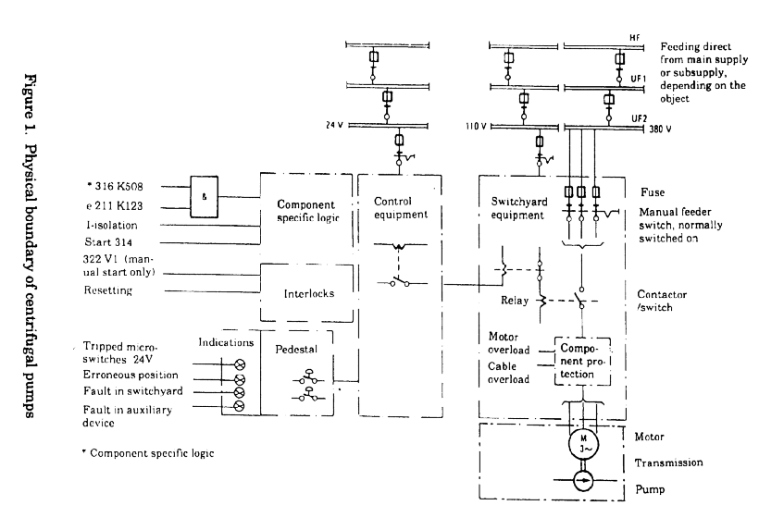
ICDE
International Common-Cause-Failure Data Exchange ICDECG02

Title: | Coding Guidelines for Motor- Operated Valves
Author(s): | Dale Rasmuson, Wolfgang Werner, Gunnar Johanson, Esther Jonsson
Issued By: | Gunnar Johanson, Marina Concepcion
Reviewed By: | WG
Approved By:
Abstract: | This report defines the component specific coding rules for Motor- Operated Valves
Doc.ref: | Coding Guidelines
Distribution | WG, Project Web Site, Project archive
Revision control: | Version |  |  | Initial
1998-03-16 | Draft 1.1 | Initial proposal |  | DR
1999-05-10 | Draft 1.2 | Corrections following the Paris meeting  CCW added and exposed population def. corrected. Component types added, Failure modes added |  | GJ, MC
2001-02-12 | Draft 2.0 | Change of old definitions in the part Coding Rules and Exceptions |  | EJ
2001-11-20 | Draft 2.1 | Change of incorrect sentence under the section “Basic unit for ICDE event collection”. |  | EJ
Jan 2004 |  | Issued as NEA/CSNI/R(2004)4 |  | GJ
2009-09-11 |  | Update in the part Functional fault modes |  | WW

Table of contents
Component Coding Guidelines for Motor-Operated Valves 78
General Description of the Component 78
Component Boundaries 78
Event Boundary 78
Basic unit for ICDE event collection 79
Time frame for ICDE event exchange 79
Coding Rules and Exceptions 79
Functional Fault Modes 79
Component boundaries 80

Component Coding Guidelines for Motor-Operated Valves

General Description of the Component

This family of valves comprises all motor operated valves in the main lines of safety relevant NPP systems listed below. Control valves are not within the scope of this data collection.

• standby liquid control system (3.AB)
• auxiliary/emergency feedwater (3.BB)
• high pressure safety injection (3.BG)
• low pressure safety injection (may include residual heat removal), PWR (3.BG)
• residual heat removal (if out of emergency core cooling function), PWR and BWR (3.BE)
• refuelling water storage tank (3.CD)
• containment spray (3.DD)
• pressurizer power operated relief valve block valves (3.AF)
• high pressure coolant injection/reactor core isolation cooling , (BWR) (3.BA)
• low pressure coolant injection (may include residual heat removal), BWR (3.BG),
• isolation condenser, (BWR) (3.DD)
• component cooling water (3.CA)
• essential SWS (3.CB)

The following component types are distinguished:

- MOV Ball valve
- MOV Gate valve
- MOV Globe valve
- MOV Butterfly valve
- MOV General type

Component Boundaries
The component for this study is the MOV, comprised of a valve with its internal piece-part components and a motor operator. The operator includes the circuit breaker, power leads, local protective devices, open/close limit switches, torque switches, and the motor. The control circuit that induces a close or open signal to an MOV is not included within the MOV boundary if it also controls other component functions, such as other valve actions, pump starts, etc. (Compare figure 1).

Event Boundary
The mission for an MOV is to allow flow of water into the primary system following a LOCA or to prevent water from leaving the primary containment system in the event of a LOCA. Some of the systems for which MOV data were reviewed serve dual purposes (low pressure injection and residual heat removal), such that the flow paths are used during normal plant evolutions. Failure of the MOV to perform its PRA mission occurs if a valve that is required to be open to allow injection or cooling flow does not open, or if a valve that is required to close to isolate secondary parts of the ECCS after a LOCA fails to close.

Basic unit for ICDE event collection
The basic set for motor operated valve data collection is the "observed population" but if appropriate the exposed population is taken (EP: set of components exposed to the same failure cause). The number of valves in an exposed population depends on the specific failure identified in the event analysis.
In general the exposed population shall be in the same system for the components identified but could be modified depending on the linkage of CCF events by failure mechanism or causal factors.
The elements of the exposed population will normally have similar test intervals. Similar in this context means a factor of not more than 2 between minimum and maximum.
The determination of the exposed population is left to the event reviewer and the reviewer’s knowledge of the relation of system design, operation and testing.

Time frame for ICDE event exchange
The minimum period of exchange should cover a period of 5 years (The initial pump exchange cover Jan. 1 1990 - Dec. 31 1994, ref. Park City protocol).

Coding Rules and Exceptions
In general, the definition of the ICDE event given in section 2 of the General ICDE Coding Guidelines applies.
Some reports discuss only one actual failure, and do not consider that the same cause will affect other MOVs, but the licensee replaces the failed component on all MOVs as a precautionary measure. This type of event will be coded as incipient impairment (0.1) of the components that did not actually fail.
In-operability due to seismic criteria violations will not be included, unless an actual failure has occurred.
Administrative in-operability that does not cause the valve to fail to function was not included as failures. An example is a surveillance test not performed within the required time frame.
Failure of the electrical operator without coincident failure of the manual operator is considered a MOV failure.
Failure of the MOV to cycle in the required time (as opposed to mission time) will not be considered a failure, either CCF or independent, if the MOV reached its intended state.

Functional Fault Modes
Essential failure modes:

Failure to open (FO)
Failure to close (FC)
(for some valves only 1 of the 2 failure modes is relevant)

Several countries also have:

Internal Leakage (IL)
External Leakage (EL)

Component boundaries
Figure 1. The schematic diagram shows the component boundaries for MOVs.

ICDE
International Common-Cause-Failure Data Exchange ICDECG03

Title: | Coding Guidelines for Emergency Diesel Generators
Author(s): | Dale Rasmuson, Wolfgang Werner, Gunnar Johanson
Issued By: | Gunnar Johanson , Marina Concepcion
Reviewed By: | WG
Approved By: | WG
Abstract: | This report defines the component specific coding rules for Emergency Diesel Generators
Doc.ref: | Coding Guidelines
Distribution | WG, Project Web Site, Project archive
Revision control: | Version |  |  | Initial
1999-01-13 | Draft 2 | Final Draft |  | GJ
Jan 2004 |  | Issued as NEA/CSNI/R(2004)4

Table of contents
Component Coding Guidelines for Emergency Diesel Generators 83
General Description of the Component 83
Component Boundaries 83
Event Boundary 83
Basic unit for ICDE event collection 84
Time frame for ICDE event exchange 84
Coding Rules and Exceptions 84
Functional Failure Modes 84

Component Coding Guidelines for Emergency Diesel Generators

General Description of the Component
Emergency diesels (EDs) drive generators that are part of the electrical power distribution system providing emergency power in the event of a LOSP to electrical buses that supply the safety systems of the reactor plant (emergency diesel generator, EDG).

At some plants, emergency diesels also directly drive safety injection pumps and/or emergency feedwater pumps. The EDs/EDGs normally are not in service when the plant is operating at power or shutdown.

. The systems for which emergency diesel generator (EDG) data are collected are (the corresponding IRS system coding is added in parentheses):

- auxiliary/emergency feedwater (3.BB)
- high pressure and low pressure safety injection, (3.BG)
- emergency power generation and auxiliaries, including supply of fuel and lubrication oil (3.EF)

Component Boundaries
The component ED/EDG for this study includes the diesel engine(s) including all components in the exhaust path, electrical generator, generator exciter, output breaker, EDG room heating/ventilating systems including combustion air, lube oil system including the device (e.g., valve) that physically controls the cooling medium, cooling system including the device (e.g., valve) that physically controls its cooling medium, fuel oil system including all storage tanks permanently connected to the engine supply, and the starting compressed air system. All pumps, valves and valve operators including the power supply breaker, and associated piping for the above systems are included.

Included within the ED/EDG are the circuit breakers, which are located at the motor control centers (MCC) and the associated power boards that supply power to any of the EDG equipment. The MCCs and the power boards are not included except for the load shedding and load sequencing circuitry/devices, which are, in some cases, physically located within the MCCs. Load shedding of the safety bus and subsequent load sequencing onto the bus of vital electrical loads is considered integral to the EDG function and is therefore considered within the bounds of this study. Also included is all instrumentation or control logic and the attendant process detectors for system initiations, trips, and operational control.

Ventilation systems and cooling associated with the ED/EDG systems are included, with the exception of the service water system (or other cooling medium) that supplies cooling to the individual ED/EDG related heat exchangers. Only the specific device (e.g., valve) that controls flow of the cooling medium to the individual ED/EDG auxiliary heat exchangers are included. (Complete failure of the service water system that results in failure of the ED/EDGs is normally explicitly modelled under the service water system.

Event Boundary
The mission for the EDs/EDGs is to 1) start and supply motive force/electrical power in the event of a LOSP and to 2) start and be ready to load in the event of a loss-of-coolant accident. The event boundary is therefore defined as any condition that does not permit the ED/EGD to start or supply motive force/electrical power in the event of loss of coolant or loss of offsite power.

Basic unit for ICDE event collection
The basic set for centrifugal pump data collection is observed population (OP). The OP size typically varies from two to eight, with the bulk ion the two to four range.

Time frame for ICDE event exchange
The minimum period of exchange should cover a period of 5 years (The initial pump exchange cover Jan. 1 1990 - Dec. 31 1994, ref. Park City protocol).

Coding Rules and Exceptions
High-pressure core spray (HPCS) diesels will be included as a separate train of the emergency AC power system. They do not have sequencers, but usually the EDG component itself is very similar to the main EDGs.
Swing EDGs will be considered to belong to each unit of a multiple unit site, such that a failure of the swing EDG will affect each unit.
In general, the definition of the ICDE event given in section 2 of the General ICDE Coding Guidelines applies.
Some reports discuss only one actual failure, and do not consider that the same cause will affect other EDGs, but the licensee replaces the failed component on all EDGs as a precautionary measure. This will be coded as incipient impairment (0.1) of the components that did not actually fail.
Failures that occur in equipment that is not needed for emergency actuation (e.g. test circuitry) will be coded as incipient component impairment (0.1)
Inoperability due to seismic or electrical separation criteria violations will not be included, unless an actual failure has occurred.
Inoperability due to administrative actions will not be included as a failure if the report states that the G could have started on an emergency signal. (Example: a surveillance test not performed within the required time frame.)
Troubleshooting start attempts that result in equipment failures will not be counted if the failed equipment is what initiated the maintenance and troubleshooting sequence. If there is a failure on the operational surveillance test following maintenance on equipment other than what was being fixed, another failure will be counted.

Functional Failure Modes
Essential failure modes:
Failure to start (FS). A successful start will be the ED/EDG start through breaker closing and full sequence of loading. If the start is a test that requires no loading, the success criteria will be only the /EDEDG start. Failure to start in the required time (per test procedures) will not be considered a failure, unless the ED/EDG did not start prior to actuation of the "fail to start" relay and subsequent termination of the start sequence.
Failure to run (FR.). The /EDEDG must be loaded (required for the current conditions) and stable prior to the failure.

Several countries also have:
Failure to stop (FC).

ICDE
International Common-Cause-Failure Data Exchange ICDECG04

Title: | Coding Guidelines for Safety Valves/Relief Valves
Author(s): | Dale Rasmuson, Wolfgang Werner, Gunnar Johanson
Issued By: | Gunnar Johanson, Marina Concepcion
Reviewed By: | WG
Approved By: | WG
Abstract: | This report defines the component specific coding rules for Safety Valves/Relief Valves
Doc.ref: | Coding Guidelines
Distribution | WG, Project Web Site, Project archive
Revision control: | Version |  |  | Initial
1999-05-10, | Draft 1.5 | Corrections following the Paris meeting  Revised component classification. |  | GJ
2000-05-01, | Draft 1.6 | Clarification failure mode example |  | GJ
2000-10-06, | Draft 1.7 | Update of component types so that they can be used for Magnox and AGR. |  | EJ
2002-10-02 | Draft 1.8 | Editorial |  | GJ
Jan 2004 |  | Issued as NEA/CSNI/R(2004)4
2010-08-23 |  | Update in the part Functional fault modes |  | GJ

Table of contents
Component Coding Guidelines for Safety Valves/Relief Valves 87
General Description of the Component 87
Component Boundaries 87
Event Boundary 87
Basic unit for ICDE event collection 88
Time frame for ICDE event exchange 88
General Coding Rules and Exceptions 88
Functional Fault Modes 88
Enclosure: Component picture of safety / relief valves 89

Component Coding Guidelines for Safety Valves/Relief Valves

General Description of the Component
The function of the Safety Valves/Relief Valves (SV/RV) is to prevent overpressure of the components and system piping. The systems for which SV/RV are installed in and data are collected for are (the corresponding IRS system coding is added in parentheses):
- Steam generators discharge headers, PWR, AGR, Magnox (3.AH)
- Pressurizer vapour volume, PWR (3.AF)
- Reactor coolant system, main steam headers, BWR, AGR, Magnox (3.BH)
Safety Valves/Relief Valves component types are the following:
- Pressurizer power operated relief valves (PWR)
- Pressurizer safety valves (PWR)
- Steam generator power operated relief valves(PWR, AGR, Magnox)
- Steam generator safety valves (PWR,AGR, Magnox)
- Power operated relief valves (PWR, AGR, Magnox)
- ADS valves (BWR)
- Primary-Side safety valves (BWR, AGR, Magnox)

Component Boundaries
The component boundary in this data analysis includes the following: local instrumentation, control equipment, power contactors and other component parts specific to the valve. Functional modules for main steam headers SV/RV are exemplified in figure 1.1. As shown can the function be combined therefore are the following component sub-types defined for detailed classification, optional.
A. Impulse operated valve (safety, relief, closing)
A.1 Main valve
A.2 Pilot valve
A.2a Impulse or spring-operated pilot valve
A.2b Electromagnetic pilot valve
A.2c Pneumatic pilot valve
A.2d Motor-operated pilot valve
B Spring- operated safety valve
C Motor-operated safety/relief valve
D Electromagnetic operated safety/relief valve
E Pneumatic operated safety/relief valve

Event Boundary
Successful operation of a SV/RV is defined as opening in response to system pressure exceeding a predefined threshold, and re-closing when pressure is reduced below a predefined threshold. Note: the opening of SVs/RVs in response to an actual system overpressure is not a failure. Subsequent failures to re-seat completely are defined as a failure to close event.

Basic unit for ICDE event collection
The basic set for SV/RV data collection is the observed population (OP). The OP size typically varies from two to twelve.

Time frame for ICDE event exchange
The minimum period of exchange should cover a period of 5 years

General Coding Rules and Exceptions
- All actual failures will be included (in either ICDE or independent event coding), even if the event report considers them to be "invalid."
- Some reports discuss only one actual failure, and do not consider that the same cause will affect other SV/RVs, but the licensee replaces the failed component on all SV/RVs as a precautionary measure. This type of event will be coded as a CCF, with a low (0.1) component degradation value for the components that did not actually fail.
- In-operability due to seismic criteria violations will not be included.

Functional Fault Modes
SV/RV malfunctions are defined as failures to open or close on demand, and failure to stay closed, including excessive leakage through the valve, or spurious opening of the valve. The failure modes used in evaluating the data are:
Essential failure modes:Failure to Open (FO): Examples are: SV/RV sticks closed or whenever a SV/RV is blocked shut.
Failure to Close (FC): Examples are: SV/RV stays open when it should close, SV/RV doesn’t fully close.
Inadvertent opening (IO). Examples are: spurious opening. Leakage past the valve seats, and if piece-part(s) is replaced to re-calibrate a set point that was too low.
(for some valves only 1 or 2 of the 3 failure modes are relevant)
Several countries also have:
Internal leakage (IL)
Spurious operation (SO). This code may be used e.g. for failure to stay open.
Others (O)
Valve operator failures are evaluated to determine the effect on valve operability. In general, if the failure causes the valve to fail to operate, it will be considered a valve failure.

Enclosure: Component picture of safety / relief valves

ICDE
International Common-Cause-Failure Data Exchange ICDECG05

Title: |  | Coding Guidelines for Check Valves
Author(s): |  | Dale Rasmuson, Wolfgang Werner, Gunnar Johanson
Issued By: |  | Wolfgang Werner, Marina Concepcion
Reviewed By: |  | WG
Approved By: |  | WG
Abstract: |  | This report defines the component specific coding rules for Check valves
Doc.ref: |  | Coding Guidelines
Distr. |  | Project archive
Revision control: |  | Version |  |  |  |  | Initial
 |  | Draft 1.2 | Components types; failure modes |  |  |  | MC
1999-05-03, |  | Draft 1.3 | Corrections following the Paris meeting |  |  |  | GJ
1999-07-08 |  | Draft 1.4 | Component types details |  |  |  | MC
2000-05-15 |  | Draft 1.5 | Clarifications, rules and exemptions |  |  |  | GJ
2000-10-18 |  | Draft 1.6 | Enclosure – Figures are included |  |  |  | EJ
Jan 2004 |  |  | Issued as NEA/CSNI/R(2004)4
2009-09-11 |  |  |  | Update in the part Functional fault modes |  | WW

Table of contents
Component Coding Guidelines for Check Valves 92
General Description of the Component 92
Systems included in the collection 93
Component Boundaries 93
Event Boundary 93
Basic unit for ICDE event collection 93
Time frame for ICDE event exchange 93
Coding Rules and Exceptions 93
Functional Fault Modes 94
Enclosure: Different Check Valves 94

Component Coding Guidelines for Check Valves

General Description of the Component
Check valves are used for the purpose of establishing or isolating flow to or from the fluid system. It is comprised of a valve with its internal piece-part components. The function of the check valve is to form a conditional boundary (i.e., one direction) between high pressure and low-pressure sections of a system during static conditions. By design, the valve will open to allow flow when the low-pressure section has experienced a pressure increase (e.g., pump start). This component is operated by system pressure overcoming gravity. Typically, there is no capability to manually open, close, or isolate these valves, however, some check valves have manual handwheels or levers (stop-check) and can be manually closed. Some check valves are "air-testable" which should not affect normal component operation and in some cases the air supply is turned off during operation as a precaution. No power is normally required for valve operation. Check valves are installed in systems in the following areas:
- Pump discharge,
- Pump suction,
- System inter- or cross-connection, and
- Pump turbine steam inlet.
The following component classification is proposed:
- Swing check valve
- Lift check valve
- General type
The following details about component can be included in general description:
Functional features:
- CKA (air testable)
- CKB (vacuum breaker)
- CKS (stop check)
- CKV (check) depending on the valve design under consideration.
More detailed type specification:
- Butterfly swing check valve
- Horizontal lift check valve
- Damped check valve

- Flat poppet check valve
- Cone poppet check valve

Systems included in the collection
The systems for which check valve (CKV) data are collected are (the corresponding IRS system coding is added in parentheses):
• auxiliary/emergency feedwater (3.BB)
• high pressure safety injection (3.BG)
• low pressure safety injection (may include residual heat removal), PWR (3.BG)
• residual heat removal (if out of emergency core cooling function), PWR and BWR (3.BE)
• high pressure coolant injection/reactor core isolation cooling, BWR (3.BA)
• low pressure coolant injection (may include residual heat removal), BWR (3.BG),
• component cooling, including reactor building closed cooling water (3.CA)
• essential SWS (3.CB)

Component Boundaries
No control circuit is included. The main component of a check valve is the valve itself. For the purposes of this study, the boundaries will encompass the valve body including valve internals (e.g. disk, spring) and in the cases of air assisted check valves, valve operators.

Event Boundary
Failure of the CKV to perform its mission occurs if a valve that is required to be open to allow injection or cooling flow does not open, or if a valve that is required to close to isolate secondary parts of the system fails to close.

Basic unit for ICDE event collection
The basic set for check valve data collection is the "observed population" but if appropriate the exposed population is taken (EP: set of components exposed to the same failure cause). The number of check valves in an exposed population depends on the specific failure identified in the event analysis.
In general the exposed population should be in the same system for the components identified but could be modified depending on the linkage of CCF events by failure mechanism or causal factors.
The exposed population will normally have a similar test interval. Similar in this context means within a factor of 2.
The determination of the exposed population is left to the event reviewer and the reviewer’s knowledge of the relation of system design, operation and testing.

Time frame for ICDE event exchange
The minimum period of exchange should cover 5 years.

Coding Rules and Exceptions
All actual failures will be included (in either CCF or independent event coding), even if the event report considers them to be "invalid."
Many reports discuss only one actual failure, but state that the other CKV would be susceptible to the same type failure. If there is a statement that the second CKV would have definitely failed, a failure is counted and a CCF is coded. If there is no evidence that the second CKV would have failed due to the same cause, but only that there is a possibility, no CCF is coded.
Some reports discuss only one actual failure, and do not consider that the same cause will affect other CKVs, but the licensee replaces the failed component on all CKVs as a precautionary measure. This type of event will be coded as a CCF, with a low (0.1) component degradation value for the components that did not actually fail.
In-operability due to seismic criteria violations will not be included, unless an actual failure has occurred.
Administrative in-operability that does not cause the valve to fail to function was not included as failures. An example is a surveillance test not performed within the required time frame.

Functional Fault Modes
Check valve malfunctions are considered to be failures to open or close on demand, and failure to stay closed, including excessive leakage through the valve. Examples of the consequences of these failures are vapour binding AFW pumps, overpressurization of pump suction piping, and system drainage. Failure modes used to analyse check valve data are:
Essential failure modes:
Failure to Open (FO)
Examples are:
Check valve sticks closed,
Check valve partially opens.
Failure to Close (FC)
Examples are:
- Check valve sticks open,
- Valve doesn’t fully close, and
• Failure to re-seat.

(for some valves only 1 of the 2 failure modes is relevant)

Several countries also have:
Failure to Remain Closed/Internal leakage (RC/IL)
- Cases where the check valve has been closed for a substantial period of time and is then discovered leaking.
External Leakage (EL)
Other (O)

Enclosure: Different Check Valves

ICDE
International Common-Cause-Failure Data Exchange ICDECG06

Title: | Coding Guidelines for Batteries
Author(s): | Marina Concepcion, Wolfgang Werner, Gunnar Johanson, Begoña Pereira Pagan, Jorge Tirira, Ian Morris, Rosa Morales, Anna Oxberry
Issued By: | Gunnar Johanson
Reviewed By: | Albert Kreuser
Approved By:
Abstract: | This report defines the component specific coding rules for Batteries
Doc.ref: | Coding Guidelines
Distribution | WG, Project Web Site, Project archive
Revision control: | Version | Date |  | Initial
2001-05-18 | Draft 2 | List of authors corrected, Final Draft |  | GJ
2001-09-18 | Draft2.1 | Figure 1 is updated several changes in appendix 1 |  | WW, BP
2002-09-10 | Draft 3 | Addition of item 8 to “Coding Rules and Exceptions” after Paris meeting 04/02 |  | AO
January 2004 |  | Issued as NEA/CSNI/R(2004)4
2009-09-11 |  | Update in the part Functional fault modes |  | WW

Table of contents
Component Coding Guidelines for Batteries 98
General Description of the Component 98
Component Boundaries 98
Event Boundary 98
Basic unit for ICDE event collection 99
Time frame for ICDE event exchange 99
Coding Rules and Exceptions 99
Functional Fault Modes 99
Enclosure 100
A1. CCF event interpretation (Field C7) and failure symptoms 101

Component Coding Guidelines for Batteries

General Description of the Component
The family of batteries is comprised of those batteries that provide DC emergency power in the event of a LOSP to DC buses that supply the safety systems of the reactor plant. The voltage to be supplied typically ranges from 24 to 500 V DC.

Battery data are collected for the systems/subsystems (the corresponding IRS system coding is added in parentheses):

Vital instrumentation AC and control AC (3.ED)

DC power system (3.EE), consisting of the subsystems
- DCS - DC System. Uninterrupted power supply for emergency DC system and secondary emergency DC system
- DCS-1 - DC System. Uninterrupted power supply for emergency DC system
- DCS-2 - DC System. Uninterrupted power supply for secondary emergency DC system
- IAS-1- Indication and alarm system
- IAS-2- Indication and alarm system of the fire protection
- IAS-3- Indication and alarm system of the control rod drive system
- TCS- Trip circuit supply

For data evaluation purposes, the family of batteries is subdivided into the four subgroups

- BVL - Very low voltage (V= 24)
- BL - Low- voltage battery (24< V< 50)
- BH - High- voltage battery (V>200)
- BM - Medium- voltage battery (50<V<200)

Component Boundaries
The component for this study is the battery, comprised of cell, casing, power leads and their respective output breakers and fuses. The component boundary is illustrated by figure 1.

Included within the Battery is the output breaker (failure to close or remain closed), which is located at the local control. In some cases batteries may have a particular automatic system

Event Boundary
The mission for a battery is to provide DC emergency power in the event of a LOSP to DC buses that supply the safety systems of the reactor plant. Failure of the battery to perform its mission occurs if a battery that is required to supply rated voltage to the DC bus bar fails to do so.

Basic unit for ICDE event collection
The basic set for Battery data collection is the observed population (OP).

Time frame for ICDE event exchange
The minimum period of exchange should cover 5 years.

Coding Rules and Exceptions
In general, the definition of the ICDE event given in section 2 of the General ICDE Coding Guidelines applies.
Complete Failure is when power is not maintained within specification
Degraded: If cells within the Batteries show major physical, electrical or chemical damage but the batteries are still able to perform within specification OR (Incipient) when slight damage is evident. If there is "no damage" proposed coding should be "working"
Some reports discuss only one actual failure, and do not consider that the same cause will affect other BTs, but the licensee replaces the failed component on all BTs as a precautionary measure. This type of event will be coded as incipient impairment (0.1) of the components that did not actually fail.
Inoperability due to seismic or electrical separation criteria violations will not be included, unless an actual failure has occurred.
Inoperability due to administrative actions that does not cause the battery to fail to function is not included as failures. An example is a surveillance test not performed within the required time frame.
Guidance for CCF event interpretation (Field C7) and failure mechanism see enclosure 1
Consideration of CCF of a single design of battery may be limited to a single location or may extend to different physical locations (e.g. different voltage battery rooms).

Functional Fault Modes
The following failure modes and criticality classifications are applicable for battery data collection.
Essential failure modes:
Failure to run (Loss of performance): failure to maintain the rated DC power within specification for the duration of the mission

Failure to start (No voltage): the power provided at the start of the mission is not within specification. Could be open circuit, high resistance, or discharged battery i.e. the rated DC power can not be delivered at the time of the demand.

Enclosure
Component boundary
Battery and casing
Fuses
Sockets
Battery bar
Figure 1. Battery components and boundary

A1. CCF event interpretation (Field C7) and failure symptoms

The CCF event description (Text description /Compulsory/) shall describe the (subjective) rationale used by the analyst to classify the event as a CCF event.
This is a proposal for description of the Failure Symptoms

Code | Failure symptom
BF | Blown fuse
BP | Breaker problem
CB | Casing break
CTP | Corrosion of the terminal plates/insufficient tightening of terminal connections
ICD | Insufficient capacity (by design)
IE | Impurities in the electrolyte
LDE | Low density of the electrolyte
LLE | Low level of the electrolyte
OL | Overloading / excessive load
PDA | Plate degradation (by aging)
RCC | Inadequate room cooling/ventilation conditions
SC | Short-circuit

Remarks:

CB Casing break
Results in electrolyte loss.

CTP Corrosion of the terminal plates / insufficient tightening of terminal connections (improper maintenance)
Results in high electrical resistance due to poor contact between the current conductors; the process leads to a high voltage drop.

ICD Insufficient capacity (by design)
The battery design capacity is inadequate for the system. The battery is working properly, but its capacity is inadequate for supporting loads (i.e. due to design modifications that increased battery loads, or because the initial capacity is insufficient and the problem was only detected in a loss of offsite power incident).

IE Impurities in the electrolyte
The most frequent cause is the use or addition of improper water. (i.e. for Pb batteries, the most common impurities are iron, chlorine, and copper. For Ni-Cd batteries, under special battery service conditions, such as high temperature or frequent cycling,the electrolyte absorbs carbon dioxide from the air and it is partially transformed in potassium carbonate, increasing the electric resistance and decreasing its capacity; in this situation it could be necessary to replace the electrolyte).

LDE Low density of the electrolyte
Results in progressive loss of the active plate area with the consequential loss of capacity, deformation and deterioration. The problem is detected by the low density of the battery electrolyte. If the sulfurisation is not significant, the battery could be recovered by one or more equalization loads until the proper value of the electrolyte density in all the elements is retained. (Pb-batteries).

LLE Low level of the electrolyte

Results in progressive loss of the active area of the uncovered plate part and the same type of problems as described for the „insufficient load“ case.

OL Overloading / excessive load
This case is characterized by loss of the active material from the plates and the corrosion of the metallic structure in the positive plates. A clear indication of the battery overloading is excessive water use and, therefore, the frequent need to refill the elements in order to maintain the electrolyte level.

PDA Plate degradation (by aging)
The battery is aged, involving capacity loss of the plate. (For Ni-Cd batteries, the aging could be due to the graphite loss: increasing the resistance, causing low voltage and a lower autonomy).

RCC Inadequate Room Cooling/Ventilation Conditions
Room Temperatures:
- too low (for Pb batteries) or too high (for alkaline batteries)
- insufficient ventilation (leading to hydrogen generation).

SC Short-circuit
When two or more plates are in touch, a sudden discharge occurs with subsequent plate destruction.
The most frequent reasons for a short-circuit are:
- accidental introduction of electrically conducting particles into the element, simultaneously contacting two plates of different polarity
- separator wear
- excessive accumulation of sediment at the bottom of the casing (i.e. for Ni-Cd elements, the process is caused by plate carbonating).

This symptom also includes the short-circuit of the power leads from the battery to the bus.

A2. Proposal for the Sub-components and subsystems

Code | Sub-component
BR | Breaker
CE | Cell (elements)
FU | Fuse
PL | Power lead
Other | Other

Notes:

- The battery cells include the connections between cells and the casing.
- The power leads are the external connections from the batteries to the cabinet buses.

ICDE
International Common-Cause-Failure Data Exchange ICDECG07

Title: | Coding Guidelines for Level Measurement
Author(s): | Albert Kreuser
Issued By: | Albert Kreuser
Reviewed By: | WG
Approved By:
Abstract: | This report defines the component specific coding rules for Level Measurement.
Doc.ref: | Coding Guidelines
Distribution: | WG, Project Web Site, Project archive
Revision control: | Version | Date | Initial
 | Final | 2006-01-31 | AK
 |  | 2009-09-11. Update in the part Functional fault modes | WW

Table of contents
Component Coding Guidelines for Level Measurement 106
General Description of the Component 106
Component Boundaries 107
Event Boundary 107
Basic unit for ICDE event collection 107
Time frame for ICDE event exchange 108
Functional Fault Modes 108
General Coding Rules and Exceptions 108
Recommendations on OPs 109
Recommendations on CCF event descriptions 110
Appendix 111

Component Coding Guidelines for Level Measurement

General Description of the Component
The function of the component “Level Measurement” is to monitor the level in safety relevant vessels, tanks and piping. The output signal of Level Measurement triggers protection signals in subsequent reactor protection logic system in case of too high or too low level. In ICDE data collection only those Level Measurement components are considered, which are part of the reactor protection system or part of the engineered safety feature actuation system. Level Measurement components which are only used for operational needs (e.g. level control) are not considered.

The vessels, tanks and piping (denoted as “vessels” in the following) at which Level Measurement is installed and data are collected are (the corresponding IRS system coding used in field G 3.1 and the IRS system names are added in parentheses):

1. Pressurizer (PWR, PHWR), (3.AF - Pressure control (includes primary safety relief valves))
2. Steam generators secondary side (PWR, PHWR), (3.AH - Steam generator, Boiler, Steam drum)
3. Accumulators (PWR), (3.BL - Core flooding accumulator (PWR with upperhead injection system))
4. Reactor refuelling water storage tanks (PWR, PHWR), (3.CD - Borated or refuelling water storage (PWR))
5. Reactor coolant lines (mid-loop operation) (PWR), (3.AE - Primary coolant (pumps and associated materials, loop piping, ...))
6. Containment sump (PWR, BWR), (3.BG - Emergency core cooling (core spray or RHR, CVCS participation))
7. Reactor pressure vessel (PWR, BWR), (3.AC - Reactor vessel (with core internals, PHWR or LWGR pressure tubes,...))
8. Suppression pool (BWR), (3.BA - Reactor core isolation cooling (BWR))
9. Reactor scram tanks (BWR), (3.AB - Control rod drive (mechanism, motor, power supply, hydraulic system, other shutdown systems))
10. Calandria (PHWR), (3.AC - Reactor vessel (with core internals, PHWR or LWGR pressure tubes,...))
11. Chemical and Volume Control System (PWR), (3.BF - Chemical and volume control (PWR with main pumps seal water, ...))

The vessels, numbered 1 through 11 in correspondence with the above list, are to be selected from the pull down menu in field G 3.2. For a chosen vessel the process engineering system of that vessel is chosen from the pull down menu of field G 3.1, for example, if Suppression pool (BWR) (#8) is chosen for vessel from G 3.2, the system 3.BA - Reactor core isolation cooling (BWR) (#8) has to be chosen from G 3.1.

Pressure transmitters/sensors are the central instrument of the component Level Measurement The following component types of transmitters/sensors are distinguished:
- pressure difference transmitter with electric output signal (Barton-cell) (PDTE)
- pressure difference transmitter of membrane type with electric output signal (PDTM)
- pressure difference sensor, Bourdon type (PDSB)
- sensor with ultrasonic measuring cell (SUMC)
- sensor with capacitance measuring cell (SCMC)
- pressure difference sensor with piezoelectric transducer (PDSP)
- sensor with resistance thermometer (SRT)
- Becker core cooling monitoring (voltage drop when measuring temperature in transmitter) (BCCM)
- Level Measurement general (LM) (transmitter/sensor type not specified)

Component Boundaries
The component boundary in this data analysis includes the following: pressure gauge lines, isolation valves, transmitter or sensor, indicating instruments, electronic limit switches. A detailed example of the electric part of Level Measurement component is given in the component boundary diagram in the Appendix.

As redundancy degrees of parts of the equipment may differ, e.g. one pair of pressure gauge lines can be connected to several transmitters, four sub-components are defined:
- pressure gauge lines including isolation valves
- transmitters or sensors
- indicating instruments
- electronic limit switches.
A separate observed population record is defined for each sub-component (analogous to SRV database). Observed population record field G1 “Definition” for transmitter (or sensor) sub-component (the central equipment of Level Measurement) should describe the relation between the sub-components of the component Level Measurement (e.g. which transmitters are connected to one pair of pressure gauge lines etc.) This description is necessary to understand the consequential failures of Level Measurement resulting from sub-component failures.

Event Boundary
Successful operation of Level Measurement is defined as monitoring the actual level and triggering limit switches if the level reaches predefined thresholds. These thresholds may be low level or high level thresholds.
Note: triggering of limit switches of Level Measurements in response to an actual high or low level is not a failure.

Basic unit for ICDE event collection
ICDE data collection for Level Measurement is done on sub-component basis. Observed failures of Level Measurement are related to the sub-component(s) which caused the failures. The basic set for Level Measurement data collection is the observed population of the affected sub-component. It is the totality of all Level Measurement sub-component equipment for one of the above defined “vessels” as far as this equipment is not completely physically diverse. E.g. diverse transmitters which are connected to the same “vessel” belong to different observed populations. Depending on the observed failure mechanism, the number of exposed components (field C04 in the CCF event record) equals the observed population size in the observed population record of the affected sub-component. E.g. for failure mechanisms concerning the pressure gauge lines, the number of pressure gauge lines is the number of exposed components.

Time frame for ICDE event exchange
The minimum period of exchange should cover a period of 5 years.

Functional Fault Modes
Level Measurement malfunctions are defined as failures to indicate level during operation and failures to trigger limit switch on demand. The failure modes used in evaluating the data are:
Failure to indicate level during operation – failure to “High” signal (FR High)
Example for complete failure: Signal rises to full scale deflection although actual level in vessel does not change
Example for degraded failure: Signal drifts from actual value for more than some level that does not compromise the safety function
Example for incipient failure: Signal drifts from actual value less than this level but more than accuracy of measuring instrument
Failure to indicate level during operation – failure to “Low” signal (FR Low)
Example for complete failure: Signal drops to zero although actual level in vessel does not change
Example for degraded failure: Signal drifts from actual value for more than some level that does not compromise the safety function
Example for incipient failure: Signal drifts from actual value less than this level but more than accuracy of measuring instrument
Failure to indicate changing level and failure to trigger limit switch on demand (FS)
Examples for complete failure:
Signal keeps its value when level in vessel changes
Transmitter or limit switch is so severely miscalibrated or drifted that specified limits would not be triggered
Example for degraded failure: Drift or set point of limit switch off the required value for more than some level that does not compromise the safety function
Example for incipient failure: Drift or set point of limit switch off the required value, not
compromising the safety function, but more than adjustment accuracy of equipment

General instrument failure (if no other failure mode is coded) (GIF)

Several countries also have:
Unstable signal (spurious activation) (IO)
Instrument inoperability (II)
Instrument out of specification (IOS)

General Coding Rules and Exceptions
1. In general, the definition of the ICDE event given in section 2 of the General ICDE Coding Guidelines applies.
2. All actual failures will be included (in either ICDE or independent event coding), if they could have occurred during a relevant operating mode or state.
3. Some reports discuss only one actual failure, and do not consider that the same cause will affect other Level Measurements, but the licensee replaces the failed equipment on all Level Measurements as a precautionary measure. This type of event will be coded as a CCF, with a low (0.1) component degradation value for the components that did not actually fail. This also applies if it was decided to implement said replacement at a later time.
4. Administrative in-operability that does not cause the Level Measurement to fail to function is not included as failures. An example is a surveillance test not performed within the required time frame.
5. In-operability due to human error or erroneous calibration/set up will be included (in either ICDE or independent event coding).
6. In-operability due to seismic criteria violations will not be included.

Recommendations on OPs
1. Use the subcomponent feature of the database to build OP records with different degrees of redundancy to describe the equipment for one system (i.e. a vessel in the level measurement database).
2. The idea for grouping should be to include all equal equipment in one OP. Examples:
- All limit switches – even if connected to transmitters of different type
- Equal equipment for level measurement of several boilers or steam generators in one plant
- Identical equipment that belongs to two different shut down systems but both systems have the same function of level measurement for one vessel (with the only difference that it is maintained by different maintenance teams) should be in 1 group because there is no significant difference between the components.
- If there are different numbers of sensors from pairs of gauge lines, define sensors in 1 OP and gauge lines in another.
- Transmitters of different types/technologies can be put in one OP, but description should justify why.
- Transmitters from different manufacturers but otherwise same type should be put in one OP. The discriminating feature “manufacturer” can be considered in the PSA model.
3. The degree of detail of the description in the OP definition field G1 is essential to understand both the technology of the equipment and the grouping of the components. The description should explain the reasons for grouping components in one OP. It is important to understand why components belong to one group.
4. If a group of components is described on subcomponent level this should be mentioned in the G1 definition field. Mention also the related subcomponent group records. The relationship between subcomponents should be defined clearly.
5. If more than one OP is set up for one type of subcomponents in one vessel, the description in the G1 definition field should explain the difference between these OPs (e.g. different function in the system).
6. The field G8 (OP Number) can be used to distinguish records if several OPs would have otherwise identical field G0 (OP Name)
7. For very complex systems (e.g. level measurement of the BWR reactor pressure vessel and the BWR reactor scram tanks) a diagram may be needed to understand the relationship of the components. Such diagrams can be added to this coding guide.
8. If equipment was changed during the data collection period (e.g. redundancy, technology of the transmitters) it is reasonable to create two sets of OPs. The definition in G1 benefits from up-front description of changes made.
9. Information about scope of tests is needed to decide about: is time factor high or low for two failures which are separated by time. An explanation should be given in the definition field G1 about the test interval (surveillance test or more thorough test with longer time interval). The coded test interval should be the shortest interval.
10. Abbreviations in descriptions should be explained.

Recommendations on CCF event descriptions
1. If a CCF event affected components that belong to 2 OPs then 2 event records should be made. Each event record should describe the observed impairments of the components of its corresponding OP.
2. In order to be able to validate the impairment coding the event description field C5 should contain information that explains the impairment coding. (E.g. the magnitude of deflection of a transmitter signal should be given if available.)
3. Latent time (field C2-2) is put to 0 for monitored failures only. If components are not permanently monitored but are checked regularly (e.g. on walk downs), latent time is e.g. 1 day. It is possible that an event with latent time 0 has a time factor “High” (e.g. multiple failures to run during mission time). Latent time can be larger than the shortest test interval (which is indicated in field G5-1 of the OP record) if a failure cannot be detected in e.g. 3 monthly routine testing, only in e.g. 3 yearly intensive testing. This should be explained in the event description field C5.
4. It has to be recognized that for some events the information given is all information available from the original records but description may not be clear enough to understand e.g. the detection means or the degree of impairment.
5. Event cause coded in field C9 is a high level classification. The value list of field C9 does not represent “real” root causes. These are only described in the event description field C5.
6. If some but not all components failed in a system containing several vessels (e.g. steam generators) it matters to know whether the failures were on the same or on different vessels. This information may be important to know how to prevent or to protect.
7. If not obvious, additional information is needed to understand number of exposed components.
8. If available, event description should mention the safety consequences of the observed failure to the component, e.g. is the signal deflection to the high or low side
9. If not obvious, event description should clarify reasoning for event cause coding, corrective action coding etc.

Appendix

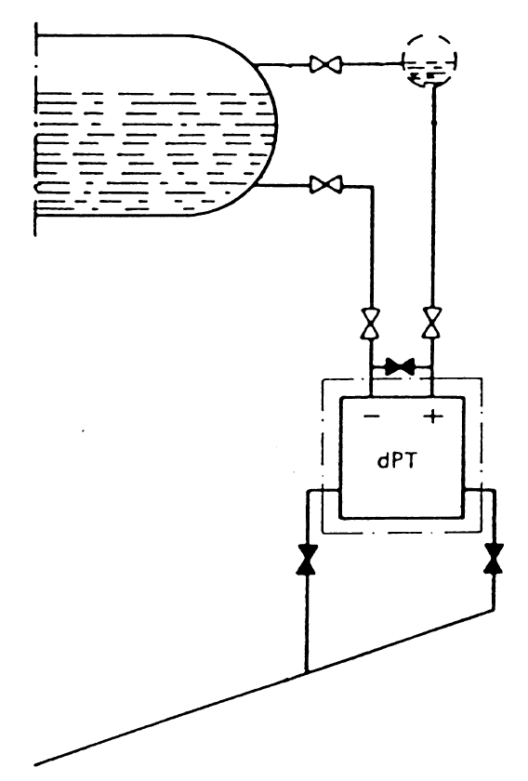
Sub-component boundary for level transmitters (within dotted line) and pressure gauge lines (from T-Book 5th edition, Chapter 11, Figure 9)
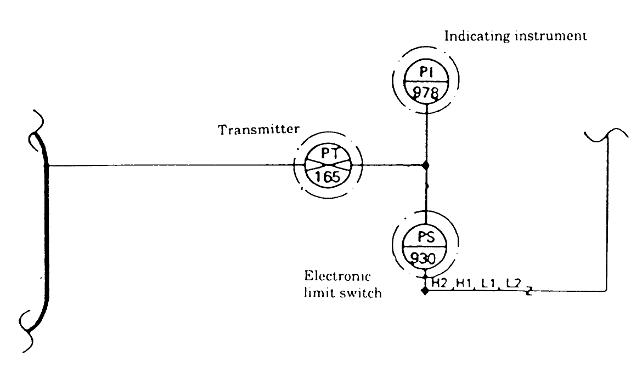
Sub-component boundary of transmitters, electronic limit switches and indicating instruments (from T-Book 5th edition, Chapter 11, Figure 5)

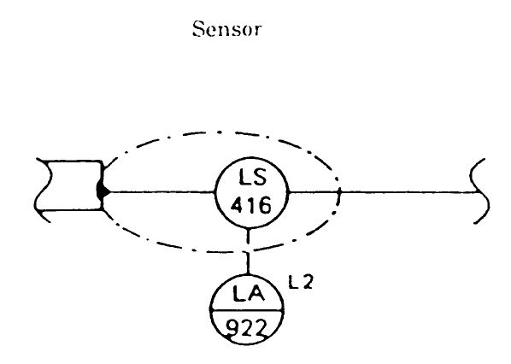
Sub-component boundary of sensors (from T-Book 5th edition, Chapter 11, Figure 5) 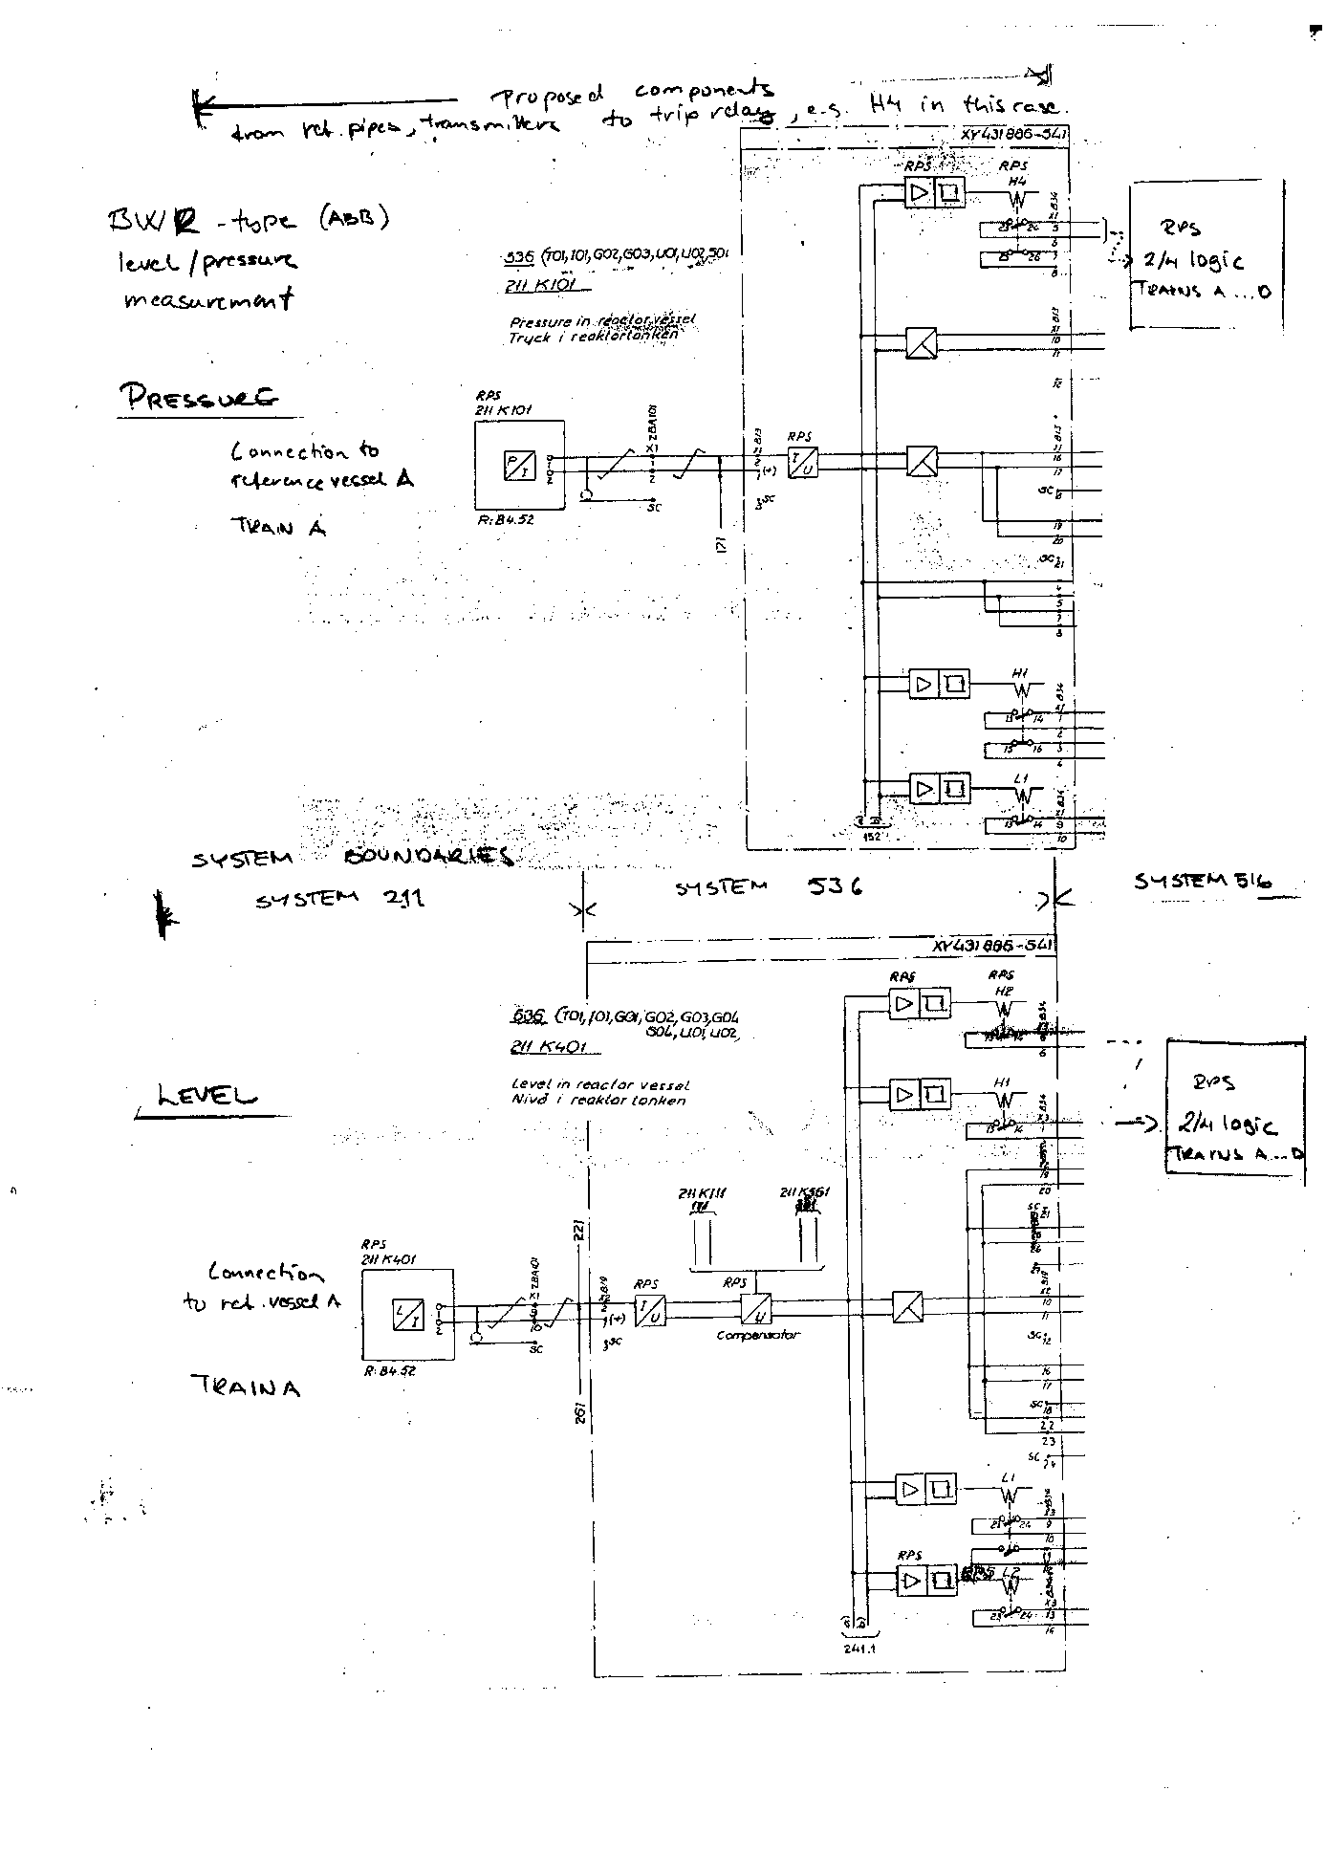
Component boundary for the electric part of Level Measurement component (from TVO BWR plants)

Observed Population examples:

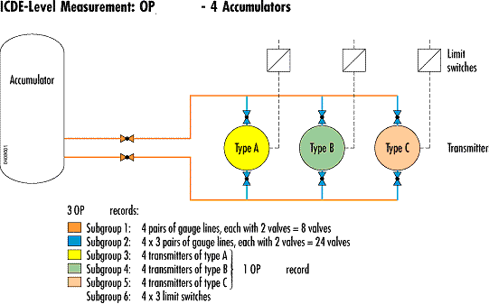

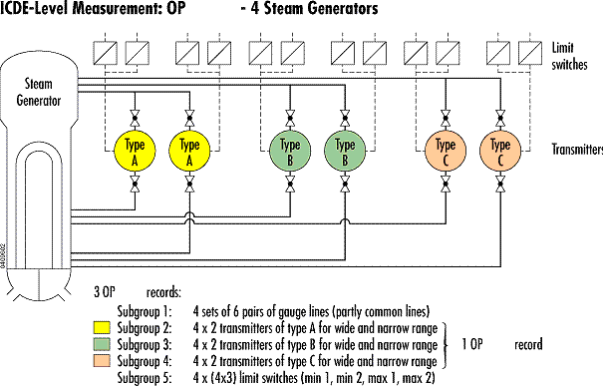

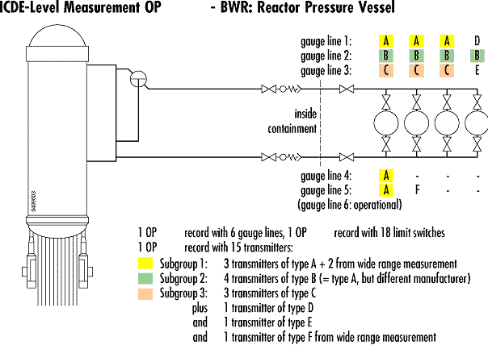

ICDE
International Common-Cause-Failure Data Exchange ICDECG08

Title: |  | Coding Guidelines for Switching Devices and Circuit Breakers
Author(s): |  | Begoña Pereira; María Rosa Morales; Ian Morris; Fritiof Schwartz; Rafael Cid; Dale Rasmuson; Anna Oxberry
Issued By:
Reviewed By: |  | Wolfgang Werner
Approved By:
Abstract: |  | This report defines the component specific coding rules for Switching Devices and Circuit Breakers
Doc.ref: |  | Coding Guidelines
Confidentiality control: |  | Confidential under OECD/NEA agreement
Distribution |  | WG, Project Web Site, Project archive
Revision control: |  | Version |  | Date |  |  | Initial
 |  | Draft 1.1 |  | 2002-04-12, Initial draft  2002-10-22, 2nd draft |  |  | BP, RM, IM, FSZ
 |  | Draft 1.2 |  | 2002-11-15 Coding rules and exceptions modified, Failure Criteria and Definitions included.  2003-01-27 Reactor Trip Breaker Definition included  2003-03-24 QA comments included.  2003-04-23 First Draft.  2003-06-24 2nd Draft  2003-08-22 2rd Draft (SG comments included). Figure 1-1 changed. |  |  | BP, RM, RC, DR, WW, AO, AK, JT
 |  | Draft 1.3 |  | 2005-03-17 Air Circuit Breaker definition included in Appendix A. |  |  | RM, BP
2009-09-11 |  |  | Update in the part Functional fault modes |  |  | WW

Table of contents
Component Coding Guidelines for Switching Devices and Circuit Breakers 119
General Description of the Component 119
Event Boundary 121
Basic Unit for ICDE Event Collection 121
Time frame for ICDE event exchange 121
Coding Rules and Exceptions 122
Functional Fault Modes 122
Appendix A 124
A1. CCF event interpretation (Field C7) and failure symptoms 124
A2. Proposal for the Sub-components and subsystems 127
A3. Switching Devices and Circuit Breaker Classifications 129
Appendix B 132
B1. Failure Examples 132

Component Coding Guidelines for Switching Devices and Circuit Breakers

General Description of the Component
The switching devices and circuit breakers of interest are those that belong to (Low/Medium Voltage) Electrical Distribution Systems (busbar/MCC feeder and load breaker) and Reactor Trip Breakers.

Diesel Generator (DG), Motor Operated Valve (MOV), and Motor Pump (MP) breakers are included within their equipment boundaries.

The reactor trip breakers (RTBs) are part of the reactor protection system (RPS), and supply power to the control rod drive mechanisms. Both AC and DC breakers are used for the RTBs. On a reactor trip signal, the breakers will open, removing power from the control rod drive mechanisms. The control rods will then unlatch and drop into the reactor core due to gravity.

The following systems are to be evaluated. Their chosen voltage ranges match the voltage ranges of the IRS coding only approximately. Therefore the correspondence with the IRS system coding, added in parentheses, is only approximate

:

1. Emergency Distribution System:

- AC Low voltage, up to 1000V (3.EC up to 600V)

- AC Medium voltage, 1KV – 11KV (3.EB 600V to 15KV)

- DC Low voltage (up to 600V) (3.EE)

2. AC Onsite Power Distribution System:

- AC Low voltage, up to 1000V (3.EC up to 600V)

- AC Low voltage, up to 1000V (3.EC up to 600V)

- DC Low voltage (up to 600V) (3.EE)

3. Reactor Protection System (Reactor Trip Breakers, low voltage) (3.IN)
Component Boundaries
The switching devices / circuit breakers include the contactors, actuator, latching mechanism, control and instrumentation installed on the switching device, enclosures, compartments (containing for example SF6, oil or vacuum), and the power terminations which are either electrical terminations or pneumatic lines.

The component boundary is illustrated in figure 1-1.
COMMAND CABIN & SIGNALLING PANEL
(Lamps, lights, local/remote indicators, converters/transformers of measurement, limit switches…)
Circuit breaker boundary
LOAD
BUS / MCC CONNECTIONS
(Connector/wiring to bus/MCC)
BREAKER MODULE
(Breaker, operating mechanisms, arc suppression, lockout/interlock mechanisms, bushings…)
MANUAL ORDER
CONTROL CIRCUIT (Protection logic / systems)

Figure 1-1. Physical boundary of breakers

The component, RTB, is defined as the breaker itself as well as the undervoltage and shunt trip devices. The circuitry that provides input power to the breakers is not viewed as part of the breaker.

Figure 1-2 shows the RTB arrangement for various vendors and designs.

Figure 1-2. Reactor trip breakers.

Event Boundary
The mission for the switching device / circuit breaker is to maintain, make or break electrical current as demanded. Failure of switching device / circuit breaker occurs if it fails to maintain, make or break electrical current.

Basic Unit for ICDE Event Collection
The basic set for switching device / circuit breaker data collection is the observed population (OP).

Time frame for ICDE event exchange
The minimum period for the exchange should cover a period of at least 5 years, beginning no earlier than 1990.

Coding Rules and Exceptions
1. In general, the definition of the ICDE event is given in Section 2 of the General ICDE Coding Guidelines.

2. Some reports may discuss only one actual failure, and do not consider that the same cause will affect other Switching Devices / Circuit Breakers, but the licensee replaces the failed component on all switchgears / breakers as a precautionary measure. This event will be coded as incipient impairment of the components that did not actually fail.

3. Inoperability due to seismic or electrical separation violations will not be included, unless an actual failure has occurred.

4. Inoperability due to administrative actions will not be included as a failure if the report states that the component could have operated when it is required. (Example: a surveillance test not performed within the required time frame).

5. Guidance for CCF event interpretation (Field C7) and failure mechanism are in appendix A1.

6. A proposal for switching device / circuit breaker sub-components and subsystems is included in appendix A2.

7. In appendix A3, there are three classifications of switching devices and circuit breaker, according to the interrupting medium, function and voltage.

8. In appendix B1, there are some examples for complete, degraded and incipient failures, and situations without failure.

Functional Fault Modes
Essential failure modes

Failure to Open (FO).

Failure to Close (FC).

Spurious Operation (SO).

(for some breakers only 1 or 2 of the 3 failure modes are relevant)

Successful RTB response to a reactor trip demand requires that the RTB open. The RTB is also required to remain closed until such a demand.
Failure to Open | Closed breakers that have a demand to open and fail to open. This includes manual operation, automatic operation such as load sequencing circuitry, RPS scram, and overcurrent/undervoltage conditions where the breaker fails to open.
Failure to Close | The breaker did not close or would not have been able to close if a close signal had been generated.  In the case of RTB, they are tested to determine the closing time. If the closing time is too slow, the breakers must be worked on and re-tested. How far off of allowable closing time is considered a failure. The usual guidance here is if parts are indicated to be broken/worn/failed, and/or the closing time is greater than 10% over, a failure is recorded.
Failure to Remain Closed (Spurious Operation) | The breaker opened when it should have stayed closed or closed inadvertently, because of a breaker fault within the component boundary. Some reports state that the breaker was found in the tripped condition; these are considered spurious operation. Also included are spurious operations of the breaker due to personnel error, bumping the cabinet, or radio interference.
For the purposes of this CCF study, a personnel error resulting in more than one functionally inoperable RTB is considered a CCF failure, even if there is no component malfunction and the component is not demanded.
Some event reports indicate that breakers have spuriously actuated due to a system fault, which causes an overcurrent or undervoltage condition, and the breaker trips as designed for protective function. Any situation where the breaker acts as designed will not be coded as a failure. However, a fault within the circuit breaker component boundary that causes an inadvertent trip or closure would be a Spurious Operation.

Appendix A

A1. CCF event interpretation (Field C7) and failure symptoms
The CCF event description (Text description /Compulsory/) shall describe the (subjective) rationale used by the analyst to classify the event as a CCF event.
This is a proposal for description of the Failure Symptoms
Code | Symptom
CO | Corrosion (loss of insulation)
IEEC | Impairment due to Extreme Environmental Conditions
LDL | Loss/Deficiency of Lubricant
LSM | Loss/Deficiency of dielectric media (for ex. loss of SF₆, oil or vacuum)
PD | Pollution/Dirt (Loss of Insulation)
RMS | Relaxation of Mechanical Springs
SS | Spurious Signal in breaker auxiliary circuits Protection Systems
ST | Stress
TC | Thermal Cycling
WE | Wear
WF | Wiring Faults

Remarks:

CO – Corrosion
Examples:
Contacts
The metallic surface of the current-carrying contacts can suffer pitting and corrosion. This corrosion can lead to an increase in contact resistance, high heating and, consequently, contact deterioration.
Operating Mechanism
Metallic pieces of operating mechanisms can suffer chemical attack, preventing an adequate performance.
Metallic Frame
The corrosion can affect the metallic frame/enclosure/case outside/inside surface should paint or other surface treatments fail

IEEC – Impairment due to Extreme Environmental Conditions
- Outdoors / in the open air: storm, lightning, snow, rain, hail, ice, and salty atmosphere.
- Indoors: inadequate room cooling (higher or lower temperature than appropriate), moisture.
This mechanism affects electric connections and insulators.
Example:
Contacts or Operating Mechanisms
The metallic surfaces can be affected by moisture, temperature or salt ingress; even by the arcing process. These situations lead to corrosion, erosion, loss of conductivity (or electric resistance increase) and loss of electrical insulation.

LDL – Loss / Deficiency of Lubricant
Example:
Operating Mechanisms
Lubricants used in these mechanisms suffer ageing (e.g. grease hardening). This can prevent appropriate operation.

LDM – Loss / Deficiency of dielectric media
Example:
Loss of SF6 in a gas-filled interrupter compartment will lower the breaking capacity and can also cause a breakdown across open pole.

PD – Pollution / Dirt (Loss of insulation)
This mechanism affects electrical connections, arc chutes, bushings, insulators, etc.
Examples:
Contacts, Operating Mechanisms
In general, the switching devices are well protected against ingress of dust or dirt. Dust accumulation inside the breaker produces a loss of electric insulation and, specifically in the contacts could lead to an increased resistance, which contributes to ageing by resistive heating. The presence of moisture could increase the rate of accumulation of dirt on the contacts. If, under these circumstances, the breaker is left for a long period without operating, this could cause the breaker to operate incorrectly.

RMS – Relaxation of Mechanical Springs
Vibrations, produced by opening/closing operations, can lead to an inadequate adjustment and slackness (even loss of mechanical engagement).

SS – Spurious Signal in Breaker Protection Systems
Example:
A malfunctioning auxiliary contact in the circuit breaker.

ST – Stress
Significant stress can be produced by opening/closing operations. A high number of cycles can damage internal components. Failure of the damping device will enhance this damage; porcelain insulators are particularly prone to this.

TC – Thermal Cycling
Examples:
Contacts
The thermal cycling of the breaker conductor is caused by the varying currents experienced in normal and fault conditions. This cycling affects contacts if they are not adjusted, cleaned and lubricated correctly.
Spring Charging Motor
This element can be subjected to thermal cycling of insulation materials, because of a high temperature due to insufficient cooling in the breaker compartment. The most frequent failure is produced between the motor and the brush.
Coils
The high temperatures cause degradation of coil insulation materials in such way that perforation of the insulation occurs.
Joints / Bellows
The thermal ageing of joints (particularly those made in elastomeric materials) can produce a loss of insulation causing the joint to become less well fitting. Consequently, dust, water or dirt may enter, causing a decrease in insulation resistance and, probably, corrosion.

WE – Wear
Each time the breaker opens, the electric arc created cause deterioration of the contact area. The deterioration caused by the arc depends on the magnitude of interrupted current and the duration of the arc. Wear is also exhibited on the moving parts (i.e., the shaft).
Wear, of course, can also affect other components such as compressor, solenoid, instrumentation, motor, etc.

WI – Wiring Faults
Failures of the cables and wires can lead to incorrect operation.

A2. Proposal for the Sub-components and subsystems

Code | Sub-component | Sub-classification
AS | Arc Suppression | a. Arc Chutes  b. Spring  c. Magnetic Blow Coil  d. Deflector Plates  e. Plunger/Piston/Puffer/Bellow  f. Cylinder  g. Breaking Media Oil Tank  h. Operating Media Air Tank  i. Compressor
BE | Bearing
BU | Bushings
CB | Circuit Board
CM | Closing Mechanisms | a. Spring  b. Spring load motor  c. Solenoid /coil  d. Lever, handle wheel  e. Electro-pneumatic devices  f. Stored-energy devices  g. Relays  h. Latching mechanism
CO | Contacts | a. Main fixed contact  b. Auxiliary fixed contact  c. Main mobile contact  d. Auxiliary mobile contact  e. Arcing fixed contact  f. Arcing mobile contact
CW | Connector/Wiring
EN | Enclosure/Case/Frame
IC | Interrupter Compartment | a. Oil  b. SF6  c. Vacuum  d. Air
IMR | Instrumentation/Monitors/ Recorders
LIM | Lockout/Interlock Mechanism
LMS | Load Motor Switch
OM | Opening Mechanism | a. Spring  b. Latching mechanism  c. Solenoid/coil  d. Lever, handle wheel  e. Electro-pneumatic devices  f. Stored-energy devices  g. Relays
PS | Protection Systems | a. Relays  b. Solenoids  c. Fuses/switches  d. Alarms  e. Sensor elements
TE | Terminals
VA | Valves

A3. Switching Devices and Circuit Breaker Classifications

Interrupting Medium
- AIR BLAST CIRCUIT BREAKER: A circuit breaker using compressed air to force the extinction of the arc through an arc chute system. These breakers are used for switching protection & control application.

Several characteristics:
In general, air blast circuit breakers are high technology and robust equipment, with great electrical and mechanical endurance. Contact wear is low due to the short arc duration and low arc voltage.

- AIR MAGNETIC CIRCUIT BREAKER: A circuit breaker that uses air as insulating medium, and arc-chute system for dissipating the arc, a method of generating a magnetic field which forces the arc into the arc chute, and with possible assistance from an air puffer system to blow the arc into the arc chutes.

- AIR CIRCUIT BREAKER: This breaker is the most common type found in low voltage, relatively low current circuits for which the air serves as a suitable dielectric, preventing continued arcing between the contacts after they have parted. The contacts open and close in air at atmospheric pressure.

- GAS INSULATED SWITCHGEAR (GIS): GIS equipment is a type of metal-clad switchgear construction where all the switchgear components are located inside a sealed metal envelope filled with a gas. These components are used in switchyards of power plants. GIS has small space requirements and it is impervious to atmospheric contaminants.

Several characteristics:
High reliability; compactness; safety of operation; elimination of periodic maintenance & inspection; reduced installation time and costs; environmentally benign.

The most common GIS is the following:

SF6 GAS CIRCUIT BREAKER: An arc extinguishing technology involves the use of Sulphur Hexafluoride gas. They are much smaller than any other type of circuit breaker of equivalent power and are far less noisy than air circuit breakers.

Types:
Two Pressure System: This breaker works by blasting high-pressure SF₆ gas across the arcing contacts during the interrupting process. SF₆ at a much lower pressure is used as the insulating medium for the interrupter tanks, columns and bushings.
Single Pressure System: The puffer type breaker uses a moving piston or cylinder to compress the gas that is forced across the parting contacts during the trip sequence.

- VACUUM INTERRUPTER: An arc extinguishing technology. Features a pair of separable contacts enclosed in a vacuum-tight envelope. Since the environment inside the interrupter envelope is a vacuum, an arc cannot be sustained easily. These breakers operate on a principle different from other breakers because there is no gas to ionize when the contacts open. They are hermetically sealed; consequently, they are silent and never become polluted. They are used for switching protection & control applications.

Several characteristics:
Excellent interrupting property (arcing time is less than 0.5 cycle).
Compact design minimizes the installation space.
Constant dielectric.

- OIL CIRCUIT BREAKER: These breakers are composed of a steel tank filled with insulating oil.

Types:
Minimum oil circuit breaker
Bulk oil circuit breaker

- NO INTERRUPTING MEDIUM.

Functions
- Switchgear/Bus/MCC Tie Breaker.

- Switchgear/Bus/MCC Feeder Breaker.

- Switchgear/Bus/MCC Load Breaker.

- Reactor Trip Breaker.

Note: the DG breaker is included within its component boundary

Voltage
Medium voltage: These components consist of air-magnetic, oil, and vacuum circuit breakers which operate in the range of 1000Vac to 11KVac.

Low voltage: Low voltage circuit breaker typically operates at 1000Vac and at 600Vdc and below. There are three types:

Molded Case Circuit Breakers: These components are available in a wide range and are generally used for low-current, low energy power circuits. The breakers have self-contained overcurrent trip elements.

Insulated Case Circuit Breakers: These components are molded case breakers using glass-reinforced insulating material for increased dielectric strength. In addition, they have push-to-open button, rotary-operated low-torque handles with an independent spring charged mechanism providing quick-make, quick break, protection.

Heavy Duty Power Circuit Breakers: These components employ spring operated, stored energy mechanisms for quick-make, quick-break manual or electric operation. Generally, they have draw-out features whereby individual breakers can be de-energized for maintenance purposes.

Appendix B

B1. Failure Examples

Complete Failures
Failure to Open / Close:

Switchgears / Breakers in general:

- Auxiliary contacts fail preventing the actuation of the switchgear / breaker or contacts fail to change the switchgear / breaker position (extracted / inserted).

- Opening / closing mechanism (spring, latching mechanism, solenoid / coil, lever, handle wheel, electro-pneumatic devices, stored-energy devices, relays) fails preventing the actuation of switchgear / breaker.

- Incorrect wiring in the power supply or in the control circuit of the component preventing its actuation.

- Misadjustment, breakdown or deterioration of the limit switches preventing the operation of the component.

- In a specific NPP design, loss of function of electronic-logical cards / modules (e.g. modules for priority control or for control interface in KWU NPP’s) necessary for opening/closing operations.

Reactor Trip Breakers. In addition to the above examples, the following cases apply to the failure to open for these components:

- Electrical failures: continuity fault in the trip circuit, fuse blown, shunt trip coil burned or opened, inadequate operation of the undervoltage trip coil (out of the voltage limit).

- Mechanical failures: opening pawl seized up, break of opening springs.

Spurious Operation

- Failures in contacts, relays, closing coils (that must be energized) leading to the opening of the component when it is closed.

- Actuation of the protections not required (e.g., overcurrent due to adjustments) or spurious open/closure of the component when it is closed/opened.

- In a specific NPP design, loss of function of electronic-logical cards / modules (e.g. modules for priority control or for control interface in KWU NPP´s) causing a spurious actuation.

Degraded / Incipient Failures

- Time exceeded in opening/closing process over the normal observed, without endangering its function. (A recommended criterion is the following: If parts are indicated to be broken/worn/failed, and/or the closing time is greater than 10% over, a failure is recorded).

- Spring charging motor is continuously operating, but the detection of event is before the motor failure.

- Not simultaneous closure of the contact of all phases.

- Detection of fires or defective contacts before the component failure.

- Failures in the interlock mechanism (contacts or relays) which generate permissive signal or actuations for other equipments.

- Inadequate contact surface (hot spots or flaring areas due to contacts bent, dirty or burnt), without endangering its function.

Situations without failure

- Failures in signalling lights, such as those signalling the component state or failures of the manoeuvring meter.

- Failures induced by the PMs are not failures until the equipment is placed back in service, i.e., unable to rack the breaker back in, stab pins bent on closing, etc.

- Preventive maintenance (PM) actions such as cleaning, painting or grease replacement are clearly not failures.

- Spurious Indication (e.g. indicates wrong state)

ICDE
International Common-Cause-Failure Data Exchange ICDECG09

Title: Coding Guidelines for Reactor Protection System: Control Rod and Drive Assemblies (CRDA)
Author(s): J.Tirira, A. Voicu, D. Rasmuson, T. Wierman, J. Dewailly, A. Oxberry, T. Mankamo and A. Kreuser
Issued By:
Reviewed By:
Approved By:
Abstract: This report defines the component-specific coding rules for Reactor Protection System : Control Rod and Drive Assemblies (CRDA)
Doc.ref: Coding Guidelines
Confidentiality
control: Confidential under OECD/NEA agreement
Distribution: WG, Project Web Site, Project archive
Revision control: Version Date
Draft 1.1 2002-11-15
Draft 1.2 2002-11-30
Draft 1.3 2003-03-13
Draft 1.4 2003-04-22
Draft 1.5 2003-09-11
Draft 1.6 2003-10-15
Draft 1.7 2004-01-21
Draft 1.8 2004-04-14
Issue 1 2004-05-17

Table of contents
Component Coding Guidelines for Reactor Protection System : Control Rod and Drive Assemblies (CRDA) 136
1. INTRODUCTION 136
2. PRESSURISED WATER REACTOR 137
2.1. General Description of the Component 137
2.2. Component Boundaries 137
3. BOILING WATER REACTOR 138
3.1. US design 138
3.2. Nordic design 141
4. MAGNOX REACTORS 143
4.1. General Description of the Component 143
4.2. Magnox Component boundaries 143
5. ADVANCED GAS COOLED REACTOR 144
5.1. General description of the component 144
5.2. AGR Component boundaries 146
6. SPECIFIC CODING RULES FOR CRDA DATA COLLECTION 147
6.1. Event Boundary 147
6.2. Basic unit for ICDE event collection 147
6.3. Time frame for ICDE event exchange 147
6.4. General Coding Rules and Exceptions 147
6.5. Functional Safety Mission Fault Modes 148
6.6. Guidance to describe and codify CCF events 152
7. REFERENCES 152
Appendix 1 PWR Schemas 153
Appendix 2 BWR Schemas 156
Appendix 3 Magnox Schema 161
Appendix 4 AGR Schema 162

Component Coding Guidelines for Reactor Protection System: Control Rod and Drive Assemblies (CRDA)

INTRODUCTION
The purpose of the Control Rod and Drive Assembly (CRDA, IRS code 3.AB) is to control reactivity when the reactor is in normal operating conditions and during rapid transients, and to provide sufficient additional negative reactivity for emergency operating conditions. The consequences related to the failure of the CRDA system depends on the initiator, plant state before scram and the needed effectiveness of the control rod population which is expressed by the minimal number of control rod clusters required at the position in the core cross section where the control-rod clusters failed to insert.
The nuclear power plant types concerned by collection of data on the Control Rod and Drive Assembly are :
- Pressurized water reactors (PWR) ;
- Boiling water reactors (BWR) ;
- Magnox reactors ;
- Advanced gas-cooled reactors (AGR).

The Coding Guideline describes selected basic designs that can be grouped according to the following tree:

CRDA systems |  |  | Gravity insertion systems |  |  | PWR / French  Control rods in clusters
AGR, MAGNOX / UK
Chain connected control rod
 |  |  | Non-gravity insertion systems |  |  | BWR / US  Hydraulic insertion both for scram and operational function
BWR / Nordic, German
Hydraulic insertion for fast scram
Motor-driven screw for operational function

In the opening sections of this document, the general description and component boundary of the different designs above are handled separately. As there are significant design differences among the reactor types, respectively, the general description of the component may not cover all possible variants in detail.
General aspects, which are common for the different designs will be discussed globally in a unique section providing general guidelines for data coding.
It is important to notice that CRDA system constitutes an ultra-highly redundant system, which places special requirements on the CCF analysis and event analysis. In order to conveniently use the foreign data, it is recommended to add a short system description document for each design in similar lines as the selected cases described here. If the CCF event has important design or operational factors outside the description in the guideline, they should be included in the event description to the extend available.

PRESSURISED WATER REACTOR

2.1. General Description of the Component
In view of the complex design and the impossibility to cover the substantial differences between manufacturers and design generations, this general description is focused on a generic description of French PWR designed by Framatome.
Control rods are cylindrical rods located inside control-rod channels in various locations in the fuel element assembly, in place of fuel rods. A cluster of control rods fastened to a spider at the top may have as few as five or as many as twenty absorbent rods. One control rod drive package is attached to each cluster of control rods.
The control-rod clusters enter the reactor pressure vessel through the top head. They withdraw upward and drop into the core by gravity during a scram.
All the control-rod clusters may be of the same type, or there may be two types with different types of absorbent rods :
- black control-rod clusters consisting of only absorbent rods and
- grey control-rod clusters, less absorbent than the black ones since some of the absorbent control rods are replaced by stainless-steel rods.
In addition, there may be two different functional sets of control-rod clusters :
- the shutdown set, made up of black control-rod clusters only and
- the control set, made up of both black and grey control-rod clusters.

Basically, the shutdown set is used to scram the reactor whereas the control set allows the control of nuclear power in operational state.
Control rod drives are mechanical, and depending on the manufacturer, are either continuously positionable or move in a series of discrete steps. All PWR rod drives, regardless of the manufacturer, incorporate a magnetic device, which is de-energized (via the scram or trip breakers) for scram.
The example drive mechanism in Figure 1 consists of stationary and movable grippers and electromagnetic control coils ; it moves the control-rod clusters step-by-step and allows all of them (both control and shutdown sets) to drop under their own weight for shutdown. Additional details are shown in Appendix 1.
Other designs of drive mechanisms involve the rotating of a magnetic field around the drive mechanism, which rotates the drive mechanism and moves the rod by a leadscrew. The rod is dropped by removing the field and unlatching the rod.
There are typically two or more methods of rod position indication : one basically counts the number of steps or turns of the drive mechanism although another independent system measures position by switches placed at intervals along the rod channel. These two methods are checked for agreement. In addition, most reactors have a separate "rod bottomed light", which indicates that the control-rod cluster has passed a position in which it is considered bottomed. This can be as much as twelve inches above the actual bottom [1].

2.2. Component Boundaries
Control rod drive & rod components
 | ROD | Control absorbent rod
 | CRC | Control rod cluster
 | CRD | Control Rod Drive

The CRDA system studied consists of two parts : all the control rod clusters (CRCs, themselves constituted by control absorbent rods (RODs)) and their drive mechanisms (CRD).
The number of CRDAs in the reactor core may vary from thirty-two to seventy depending on the design of the different plant series.
Figure 1 - PWR CRDA component boundaries
For clarification : the trip breakers are the first elements outside of the component boundary of the CRDA.

BOILING WATER REACTOR
There are different realisations of the control rod drive system by different manufacturers. The description in chapter 3.1 is based on a US system. The description in chapter 3.2 is based on the Nordic design, which is similar to the general German design.

3.1. US design

3.1.1. General Description of the Component
The control rod drives enter the reactor vessel through the bottom head. The rods withdraw in the downward direction and so have a completely powered scram stroke against the force of gravity. Drives are hydraulic, and basically, they are hydraulic cylinders controlled by a «four-way valve with a closed center». The hydraulic fluid is demineralised water. The «closed center» permits the control rod to be locked in any position.
The four «withdraw» and «insert» valves together make up the «four way valve» referred to above. Drive water pressure is 250 psi higher than reactor pressure. The cooling water pressure is 20 psi higher than reactor pressure and is adjusted to leak about 0.29 gpm, through each drive seal into the reactor. To insert a rod, the two insert valves are opened and high-pressure drive-water is then admitted beneath the drive piston. Speed is controlled by the insert speed-control valve. When the control rod reaches the desired location, the insert valves are closed again, and the latch is driven into place by its spring. Coolant flow continues to leak into the reactor vessel. The control rod is now locked into place both hydraulically and mechanically.
Rod withdrawal, however, is more complicated and is, therefore, programmed automatically. The insert valves are opened momentarily, the rod lifts, clearing the latch, and then the high drive-pressure, acting on the collet piston, drives the latch back out of the way. The insert valves close, the withdraw valves open and the rod now withdraws to the new position.
The safety function required of the drive packages is to scram the reactor. For this action, the drives are independent of any outside power source; all the necessary power is contained in the accumulator and the reactor vessel. On a scram signal the top of the piston is vented to an atmospheric header (Scram Discharge Volume) and the liquid in the accumulator, at 1500 psig (about 500 psi higher than the reactor vessel pressure), is admitted beneath the piston. The piston accelerates in the insert direction dropping the pressure in the accumulator. When the accumulator pressure drops below reactor pressure, the ball in the check valve shifts, closing off the accumulator, admitting reactor vessel pressure to complete the scram stroke. Accumulators are charged with nitrogen from gas cylinders and experience has shown that they need topping off about every six months; the actual recharging requires only ten minutes and does not interfere with plant operation. Nitrogen pressure is monitored and a pressure switch actuates an alarm whenever the accumulator needs recharging.
The accumulator, operating valves and interconnecting piping for each drive package are preassembled, and are tested at the factory. Each assembly shipped to the field then needs only pipe and electrical connections at the site. Additional details are shown in Appendix 2.
Control rod position indication is not continuous. Position is indicated every three inches by a series of glass-reed switches actuated by a magnet on the main drive piston.
Hydraulic fluid is supplied by one of two 100 percent capacity pumps. Excess fluid, not required for drive motion or cooling, is discharged into the reactor vessel. The fluid is supplied from the condensate storage tank.

3.1.2. Components and Component Boundaries for the US design
Control rod drive & rod components
 | SOV | Solenoid-operated valve
 | AOV | Air-operated valve
 | ACC | Scram accumulator
 | SDV | Scram discharge volume
 | ROD | Control rod
 | CRD | Control rod drive

The CRDs are hydraulic pistons connected to the bottom of the control rods. There is one hydraulic control unit (HCU) for each CRD/control rod. Some GE plants have a single, dual-coil SOV rather than two single-coil scram pilot SOVs. In addition, the number of scram discharge volumes can be either one or two.
Figure 2 - General Electric RPS simplified diagram (mechanical)
Figure 2 shows a functional diagram of the mechanical portion of the General Electric RPS. Within each of the HCUs there are two scram pilot SOVs, two scram inlet/outlet AOVs, a scram accumulator, and various other components. If both of the scram pilots SOVs in an HCU are de-energized, then the air supply to the AOVs is bled off. Given loss of air, both the scram inlet and outlet AOVs open, allowing a path for scram accumulator water to flow to the closing side of the piston (forcing the control rod into the core) and the opening side of the piston water to drain to the SDV. As a sensitivity case, opening of only the scram outlet AOV was analysed. In such a case, reactor vessel water pressure (rather than accumulator water pressure) forces the control rod into the core. However, the rod insertion time is longer for this type of operation.
Figure 3 shows the SDV and associated level instrumentation and the backup scram SOVs. As discussed previously, either of the two backup scram SOVs can cut off the instrument air supply to the scram air header and bleed off the header. These SOVs require electrical power to energize to accomplish this.
Figure 3 - General Electric RPS simplified diagram (SDV and backup scram SOVs)
The CRD water above the hydraulic piston is exhausted to the SDV. All of the CRDs exhaust to this volume. During normal operation, the SDV drain valves are open and the volume contains no water. However, if for some reason, during normal full-power operation, the drain valves were to close and the SDV started to fill with water, level switches (one-out-of-two-twice logic) trip the reactor before enough water collects to impact the CRDs. If the SDV were full of water before a reactor scram, then none of the CRDs could exhaust water above the hydraulic pistons, and none of the control rods would insert [1].

3.2. Nordic design
This section describes the control rod and drive system of the Nordic BWR design, exemplified with the system description for Olkiluoto 1 and 2 plants. The design of the control rod and drive in German BWRs is similar (there are several variants both in the Nordic and German design). However, Nordic and German designs have some significant differences in the system providing the hydraulic driving force (high pressure water) to rod drives regarding internal configuration and redundancy, but components are similar. Figure 10 shows a schema of the hydraulic part of the reactor scram system of a German BWR. Figure 13 shows a schema of the corresponding system of a Nordic BWR, where it is a separate plant system named as Hydraulic Scram System (HSS), see Appendix 2.
The CRDAs of the Nordic BWR design are described in the next subsection, and HSS thereafter. The third subsection summarizes the component and boundary definitions.

3.2.1. Control Rod and Drive Assembly (CRDA)
In the Nordic BWR design the CRDA is constituted of a single absorbent rod (acronym ROD) along with drive unit (acronym CRD), see Figures 11-12 in Appendix 2.
The absorbent rod has a horizontal cross-section like a cross (+) and moves in the gap between four adjacent fuel channels. It is steered within the gap of the fuel channels and was separated in the original design from the fuel channels by guide plates, attached by screws. This design was changed because the detached screws and guide plates have caused jamming of control rods.
The control rod is inserted from bottom upwards into the core. The control rod shaft penetrates the bottom of the reactor vessel. The penetration is equipped with multistage sealing. The number of control rods varies between 109 and 169 in the Nordic BWRs. They are spread evenly across the core.
Briefly described, the drive has dual functions:
- Hydraulic piston function for fast insertion (fast reactor scram)
- Motor-driven screw insertion/withdrawal function (power regulation, normal reactor shutdown and start-up)
The normal full stroke time is about 4 seconds for hydraulic insertion and about 4 minutes for screw insertion. The screw insertion is credited for reactivity shutdown in slower transients.
The piston tube is connected to the rod shaft with a bayonet coupling, see Figure 11. The lower end of the piston tube rests on the drive nut by the weight of the control rod. The drive nut can be moved upwards/downwards by the drive motor, which rotates the drive screw, providing the fine motion and accurate positioning of the control rod. In hydraulic insertion the piston tube is locked in the uppermost position. The latch is unlocked when the drive nut is driven up and reaches the lower end of the piston tube. The fast scram signal, so called SS-signal from the Reactor Protection System (RPS), which primarily actuates the hydraulic insertion, is automatically followed by an actuation command to screw insertion. The drive nut is then driven up to reach the lower end of the piston tube after a hydraulic insertion. In the case of failed hydraulic insertion the screw function may complete the insertion. However, the screw insertion is weaker in most jamming mechanisms in comparison to the hydraulic insertion. The hydraulic force of insertion is about ten times the weight of the control rod.
The drive motor is protected by slip coupling (so-called moment trip) against overloading in case of high friction or jamming).
The electric power supply to the drive motors is divided over four redundant diesel-backed buses. The electric power supply to the instrumentation and control circuits is divided over four redundant battery-backed buses. The CRDA component boundary with respect to electric power supply systems is as standard : the local contactors and protective devices are counted as part of the CRDA.
The scram signal bypasses any power regulation commands, minimizing the contribution of the Control System of Motor Drives with respect to failure of screw insertion in demand. The control circuits after RPS end relays are considered as part of the CRDA.
The position measurement serves power regulation and operational/test purposes, with practically no direct impact on the safety functions of the CRDA. The position of the control rod can be indicated with an accuracy of 1 %. Additional indications are provided to verify the fully inserted position and inform about the separation of the drive nut from the lower end of piston tube. The latter one is particularly important (for operational aims) in order to notice conditions when the control rod will not follow the drive nut but is jammed at withdrawal.

3.2.2. Hydraulic Scram System (HSS)
HSS provides hydraulic driving force to rod drives, see Figure 13 in Appendix 2. It is constituted of identical redundant trains: the number of trains varies from 14 to 28 in Nordic BWRs. The CRDA groups connected to HSS trains are called “scram groups”. The CRDAs are selected to scram groups with the aim to have an efficient as possible distribution throughout the core, in order to minimize the influence of the failure of any single scram group.
The components of HSS are placed outside the reactor containment, except the internal isolation valve, which facilitates test and maintenance actions during normal power operation.
The only more specific design feature is the diversified configuration of the pilot valves in the scram valve: the four solenoid pilot valves are connected as 2 out of 4 logic in each scram valve. Consequently a problem with one pilot valve is not critical. The pilot valves receive signals from the RPS end relays that are outside the HSS boundary.

3.2.3. Components and Component Boundaries for the Nordic design
The CRDA is constituted of a single absorbent rod (ROD) and dual-function drive (CRD). The component boundary of the CRDA is described in Figure 12.
Because HSS has different degree of redundancy, it has to be handled separately from the CRDAs in the Nordic BWR design (one HSS train is connected to many CRDAs, and the concerned rods are dispersed across the reactor core). The main components of the HSS train are the following, see Figure13 in Appendix 2 :
- Nitrogen pressure tank and scram water tank, and the connecting nitrogen and water supply lines, and local control equipment
- Air-operated scram valve (normally closed) between nitrogen pressure and scram water tanks
- Non-return valve
- Manual closing valve (normally open)
- Air-operated external isolation valve (at the containment boundary, normally open)
- Non-return, internal isolation valve (at the containment boundary)
The HSS trains have shared equipment for nitrogen supply and water makeup/outlet. Owing to fail-safe design and efficient on-line monitoring these shared parts have only a very small contribution to the reliability of scram function. The component boundaries for HSS and connected systems follow the standard definition for the valves, and instrumentation and control equipment [2]. The interface of the HSS train and the CRDAs is at the scram water inlet pipe, see Figure13. The non-return valve at the inlet of rod drive is a part of CRDA, see Figure 11.

The component definitions and corresponding failure mode definitions are summarized in Section 6.5.2 in a harmonized way covering Nordic, German and US BWR designs.

MAGNOX REACTORS

4.1. General Description of the Component
Control rods are cylindrical rods located inside control rod channels in various locations in the core. Unlike PWRs, the control rod channels are entirely separate from the fuel assemblies.
For Magnox reactors, control rods enter the pressure vessel through the top head. Each reactor is equipped with control rods which are essentially of two types; “black” rods (also called “bulk” or “coarse” rods) and “grey” rods (also called “trim”, “sector” “regulating” or “zone” rods). Black rods are more absorbing than grey rods. Rods of both types are used to control the reactor. However, when the reactor is at steady load, black rods are not normally moved and fine control of reactivity is achieved by movement of the grey rods. The rods in each group are distributed throughout the core. All control rods can be driven manually from the control room. Some grey rods on some plants can also be driven automatically. Some stations break down the sets of rods further, for example Oldbury differentiates between “trim” control rods and “sector” control rods, both of which are grey.
All black and all grey rods are inserted into the core to trip.
Figure 14 in Appendix 3 shows a schematic of a control rod and average dimensions ; actual dimensions vary according to core depth. The (wire) “rope” or chain, used to suspend the rod can be seen at the top of Figure 14.
There are a number of different designs of actuator used in Magnox plants. Each control rod is raised and lowered by motor-operated winding gear driving through a gearbox. The actuator also contains one or more clutch mechanisms and an adjustable brake. The braking mechanism varies between different reactor designs.
The trip system consists of contactors located in the supply lines to the windings of the control rod motors. These contactors are held closed (energised) during normal reactor operation. If the contactors are de-energised (automatically, manually or through loss of power), the rods drop into the core under gravity to trip the reactor.
The reactor is protected by a number of reactor protection circuits known as guardlines. The rod trip relays provide the link between the guardlines and the control rod trip contactors. The relays de-energise the control rod trip contactors if the normal guardline 2oo3 trip logic or the diverse guardline trip logic is satisfied, or the manual trip push button is operated.
Magnox reactors have another rod shutdown mechanism, (“safety” rods) which is entirely independent of the black and grey control rods. The set of safety rods have sufficient neutron absorption properties to shutdown the reactor and hold it shutdown. They are not used to control the reactor or for planned controlled shutdown. They are normally latched out of the core including during reactor shutdown periods. Various diverse mechanisms are associated with the latches, so that the occurrence of certain properties cause de-latching and the drop of rods into the core under gravity. Some of these latch mechanisms are mechanical, such as bellows, causing trip on loss of reactor pressure. Safety rods may be inserted into the core during shutdown conditions when black or grey control rods are removed for maintenance.

4.2. Magnox Component boundaries
Control rod drive & rod components
 | ROD | Control absorbent rod
 | CRD | Control rod drive / actuator

For control rods, the CRDA system studied consists of two parts : all rods (RODs) and all control rod drives (CRDs). CRDs are constituted of all ropes or chains (ROPEs) and all actuators.
The trip contactors can be said to be within the boundary of the CRD. The guardlines and the guardline end relay, which control the removal of power from the contactors of the motor are outside the component boundary.
There are approximately 100 CRDAs in a reactor core, but this number varies with the individual plant design and size.
For safety rods, the CRDA system studied consists of two parts : all rods (RODs) and all control rod drives (CRDs). CDRs are constituted of all ropes or chains (ROPEs), all latches (LTCHs) and all latch mechanisms (LMs).
The number of safety rods in a reactor core varies from 10 to 20.
The component boundary is shown in Figure 4.
Rope/Chain
Contactor
Actuator
Control Rod
Boundary
Relays
Rod trip relays (controlled by guardlines)

Figure 4 - Magnox CRDA Component Boundary

5. ADVANCED GAS COOLED REACTOR

5.1. General description of the component
Control rods are cylindrical rods located inside control rod channels in various locations in the core. Unlike PWRs, the control rod channels are entirely separate from the fuel assemblies.
In AGRs, control rods enter the pressure vessel through the top head. Each reactor is equipped with black and grey control rods. Black rods are more absorbing than grey rods. Both black and grey rods are the same dimensionally and structurally, except that black rods contain an extra boron insert.
Groups of control rods are assigned names which reflect their use. When the reactor is at steady load, “bulk” or “coarse” rods are not normally moved and fine control of reactivity is achieved by movement of the “regulating” or “trim” rods. Rods of both types are used to control the reactor during start up and controlled shutdown. Bulk / coarse rods are black and regulating / trim rods are grey. At Dungeness B (the first design of AGR), one rod per reactor zone is under direct automatic control to counteract the minute to minute perturbations of the reactor. These rods are named “sector” or “zone” rods. The remaining grey rods (termed "trim" rods) are under manual control. All later AGRs have full automatic control of all regulating rods, individual rod positions being determined by averaging a number of local channel outlet temperatures.
The control rods usually consist of a number of cylindrical steel sections linked axially by articulating joints (see Figure 15 in Appendix 4). These joints would allow the control rods to enter in an extreme condition in which the core became slightly distorted. Some stations have “sensor” rods, which have fewer articulating joints. Sensor rods are inserted into and withdrawn from the core periodically to detect any gradually developing guide tube misalignment. Sensor rods are a subset of the bulk or coarse black rods.
In AGRs, a subset of the normal control rods may be designated as “safety” rods. These are grey rods, and function as regulating rods while the reactor is on load.
To trip, all control rods drop into the core under gravity, by the main guardlines, diverse guardlines, or manual push-button. Following successful shutdown, the safety rods are withdrawn from the core. The remaining rods provide ample shutdown margin. If following shutdown, reactivity unexpectedly starts to rise again (eg due to incorrect refuelling), the safety group will trip into the core, initiated by the shutdown guardlines.
Each control rod is raised and lowered by motor-operated winding gear driving through a gearbox. The actuator also contains a torque-limiting clutch, an electromagnetic clutch, suspension chain storage, rod position indication and limit switches (see Figure 5). A hand wind drive is fitted to lift the rod when the power supplies are removed prior to maintenance.
To trip the reactor, power supplies are removed from the electromagnetic clutches within the control rod drive mechanisms such that the control rods drop into the core under gravity.
When the clutch is de-energised, the insertion rate of the rod is controlled by a brake. Braking limits the stress in the chain suspension and gearing.
The reactor is protected by a number of reactor protection circuits known as guardlines. If the guardline logic is satisfied, power supplies to the control rod clutches are removed.
Two AGR stations (Dungeness B and Hinkley Point B) also each have a secondary system, called the Enhanced Shutdown System whereby the grey and sensor control rods are motored into the core if they fail to fall in under gravity. This system is designed to mitigate failure of the clutch to release, either mechanically or due to electrical faults, and the motors effectively double as the braking mechanisms. The normal control rod motors are used in the Enhanced Shutdown System, although at Dungeness B the motors are run at twice their normal speed. The grey rods alone provide sufficient absorbency for short term shutdown. Long term hold-down is provided by a vaporised nitrogen system which may take as much as an hour to start up. The sensor rods are included in the Enhanced Shutdown System as a back-up to allow more time to start up the Nitrogen system.
The other AGRs do not require Enhanced Shutdown Systems as they have rapid-acting secondary shutdown systems using nitrogen gas under pressure, backed up by longer term tertiary systems using boronated glass beads.

5.2. AGR Component boundaries
Control rod drive & rod components
 | ROD | Control absorbent rod
 | CRD | Control rod drive / actuator

For control rods, the CRDA system studied consists of three parts: all rods (RODs) and all control rod drives (CRDs). CRDs are constituted of all ropes or chains (ROPEs) and all actuators (CRDs). The electromagnetic clutches are within the boundary of the CRD. The guardlines and the guardline end relay, which control the removal of power from the coils of the electromagnetic clutch are outside the component boundary.
There are approximately 100 CRDAs in a reactor core, but this number varies with the individual plant design and size.
The AGR component boundary is shown in Figure 5.

Motor
Gear Box
Torque Limiting Clutch
Electro-magnetic Clutch
Rod Chain
Control Rod
Boundary
Clutch Coils
Clutch Coil control is outside of the boundary
Actuator
Figure 5 - AGR Component Boundary

SPECIFIC CODING RULES FOR CRDA DATA COLLECTION

Event Boundary
The CRDA system has two separate and distinct missions: safety and operational missions. The safety mission of the CRDA system is to insert a substantial quantity of absorbent material into the reactor core, by allowing it to drop under the effect of gravity (PWR, Magnox and AGR) or driving the rods into the reactor vessel under hydraulic pressure (BWR) when there is an automatic or manual reactor shutdown signal, in order to terminate the nuclear reaction and make the reactor sub-critical.
The operational mission of the CRDA system is to ensure an acceptable distribution of power in reactor core during the operational state. This data collection effort is concentrated on the data collection for the safety mission. Nevertheless, most of the CRDA components are involved in both safety and operational mission. The failures having affected the operational mission being related to failure mechanisms which can affect also the safety mission should be collected.
Failure of the component CRDA to fulfil its safety mission involves non-insertion or delayed insertion of one control-rod cluster into the reactor core.

Basic unit for ICDE event collection
The basic set for control rod and drive assembly event collection is the observed population of all CRDAs and the optionally covered components of the systems or system parts providing the hydraulic driving force in the BWRs.

Time frame for ICDE event exchange
The minimum period of exchange should cover a period of 5 years. The recommended screening time window for the CCFs in reactor scram is the time cycle defined by the refuelling outages and/or overhaul outages.

General Coding Rules and Exceptions
In general, the definition of the ICDE event given in section 2 of the General ICDE Coding Guidelines Revision 4 applies.
Plant state at the event detection should be described in event description because it can have a substantial bearing for the significance of the failure in scram systems. The failure cases observed in post-maintenance tests in overhaul outage or in subsequent start-up tests may not be relevant for the power operation state.
All actual failures will be included (in either ICDE or independent event coding), even if the event report considers them to be "invalid”.
Some reports discuss only one actual failure, and do not consider that the same cause will affect other CRDAs, but the licensee replaces the failed equipment on all CRDAs concerned as a precautionary measure. This type of event will be coded as a CCF, with an incipient failure value for the components that did not actually fail.
The length of the impairment vector could be equal to the size of the exposed population; however, in view of the high number of CRDAs, only the information on the impairment status of each failed component should be coded using the usual ICDE codes (C, D, and I).
Administrative in-operability that does not cause the control rods to fail to function will not be included as failures. An example is a surveillance test not performed within the required time frame.
In-operability due to human error or erroneous calibration/set up will be included (in either ICDE or independent event coding).
In-operability due to seismic criteria violations will not be included.

Functional Safety Mission Fault Modes
This section describes separately the mission failure modes for both gravity insertion systems (PWR, Magnox and AGR) and the hydraulic / screw insertion systems (BWR). The system dysfunctions preventing the system from fulfilling its safety missions and their possible causes are described in section 6.5.3

Gravity insertion systems (PWR, Magnox and AGR)
Failure of the system to fulfil its safety mission involves non-insertion or delayed insertion of one control-rod cluster/rod into the reactor core.
The two failure modes considered are:
Essential failure modes:
Failure to completely insert (FCI)
Several countries also have:
High (large) control-rod cluster/rod insertion time exceeding Technical Specifications (HIT-G)

For gravity insertion systems the data can be collected for the main components, using the specifications of components, component types and corresponding failure modes as summarized in the following table :
System part | Component | Component type | Failure modes
CRDA  (Gravity) | ROD: Absorbent rod | General  (All designs) | FCI  HIT
CRDA  (Gravity) | CRC: Control rod cluster | General  (PWR) | FCI  HIT
CRDA  (Gravity) | CRD: Control rod drive | General  (All designs) | FCI  HIT
Table 1 : PWR Components and failure modes

Non-gravity insertion systems (BWR)
The considered failure modes for the CRDAs of BWR are the same two as those described for gravity insertion systems (FCI and HIT). In particular, for BWRs with dual-function drives the failure modes related to insertion are decomposed as following [2]:
Hydraulic insertion
Essential failure modes:
Failure of the hydraulic insertion function (FCI-H),
Several countries also have:
High insertion time (HIT-H)
Electromechanical insertion
Essential failure modes:
Failure of the electromechanical insertion function (FCI-M)
Several countries also have:
High insertion time (HIT-M)
Hydraulic and electromechanical insertion
Essential failure modes:
Failure of both hydraulic and electromechanical insertion function (FCI-B)
Several countries also have:
High insertion time (HIT-B)
The data can be collected separately for the rod component (ROD) and drive component (CRD), or optionally the CRDA (ROD+CRD) can be handled as one functional component (a usual practice in PSA modelling). In the latter option the event description should tell the failure location for qualitative analysis aims.
The data collection for BWRs can be extended to comprehensively cover the hydraulic part of the scram system, i.e. hydraulic driving force supply. In this part the data can be collected for the main components, using the specifications of components, component types and corresponding failure modes as summarized in the following table :
System part | Component | Component type | Failure modes
CRDA  (Non-gravity) | ROD: Absorbent rod | General | According to CRD type
CRDA  (Non-gravity) | CRD: Control rod drive | HH: Hydraulic both for fast insertion and operational function | FCI-H  HIT-H
CRDA  (Non-gravity) | CRD: Control rod drive | HM: Hydraulic fast insertion and motor-driven screw for operational function | FCI-H, M, B  HIT- H, M, B
Hydraulic driving force supply | PIV: Pilot valve | SOV: Solenoid operated valve  AOV: Air-operated valve | FO, FC
Hydraulic driving force supply | SCV: Scram valve | AOV: Air-operated valve  HOV: Hydraulic operated valve | FO, FC
Hydraulic driving force supply | CLV: Closing valve | AOV: Air-operated valve  HOV: Hydraulic operated valve  MCV: Manual closing valve | FO, FC,  also IC for normally open CLV
Hydraulic driving force supply | ISV: Isolation valve | AOV: Air-operated valve  NRV: Non-return valve | FO, FC,  also IC for normally open ISV
Hydraulic driving force supply | ACC: Accumulator | SCW: Scram water tank  NTR: Nitrogen pressure tank | Failure to supply hydraulic driving force
Hydraulic driving force supply | SDV: Scram discharge volume | General type | Failure to supply hydraulic driving force
Table 2 : BWR components and failure modes
Essential failure modes for the valves are :
1. Failure to open (FO)
2. Failure to close (FC)
3. Inadvertent closure (IC)
(depending on component type only one or more of these failure modes are relevant)
Due to the differences in the configuration and internal redundancy of hydraulic scram system the consequences of component failures and multiple failures may need to be specifically described with respect to rod insertion function. Depending on the case this information can be provided in the separate system description notebook, in OP definition field G1 or in event interpretation field C7.

In the case of a design such as Nordic BWR where the hydraulic scram system is a separate system (HSS) constituted of redundant, largely independent trains, the data can be collected in train-wise manner, i.e. a HSS train can be considered as one functional component (a usual practice in PSA modelling). The functional failure mode applicable to HSS train is “failure to supply hydraulic driving force”. This practice is recommended because not many CCF events have affected the HSS in Nordic BWRs. The closer location of failure can be described in the event text for qualitative analysis aims. The shared parts of the trains (nitrogen supply and water makeup/outlet) can be handled as a special source location of CCFs (very unlikely to significantly affect reactor scram function owing to fail-safe design and efficient monitoring).

System failure causes
Described below are the system dysfunctions preventing the system from fulfilling its safety missions (FCI and HIT), as well as their possible causes.
Code | Failure cause | Applies to | Failure mode | Event cause
 |  |  |  | Code | Description
DEF | Deformation of fuel assemblies | PWR BWR | HIT / FCI | C | State of other components
MIS | Misalignment between the reactor core and the steel structure above it | AGR MAGNOX | HIT / FCI | C | State of other components
ARS | Broken anti-rotation screw | PWR | FCI | D | Design manufacture, construction inadequacy
SFM | Sticking of the freewheel mechanism in the control rod actuator | AGR MAGNOX | FCI | D  P | Design manufacture, construction inadequacy  Procedure inadequacy
CSR | Contact shoulder/drive rod | PWR | FCI | P | Procedure inadequacy
SCC | Swelling/cracking of control rod casings | PWR  AGR MAGNOX | FCI / HIT | A | Abnormal environmental stress
CRB | Control rod breakage | All designs | FCI | A | Abnormal environmental stress
FOB | Foreign object | All designs | FCI | O | Other
DEC | Decrease in rod neutron absorbency | AGR MAGNOX | FCI | D  A | Design manufacture, construction inadequacy  Abnormal environmental stress
IAR | Incorrect adjustment of rope length | AGR MAGNOX | FCI | P | Procedure inadequacy
IAB | Incorrect adjustment of brake | AGR MAGNOX | HIT | P | Procedure inadequacy
MTR | Moment trip of electromechanical drive function (slip coupling or overcurrent protection) | BWR (CRD type HM) | FCI-M | I | Internal to component, piecepart
Table 3 : CRDA failure causes

Deformation of fuel assemblies
Fuel assemblies may deform due to creep induced by irradiation, thermal, mechanical and hydraulic loading, and their mutual interaction. Assemblies with significantly deformed guide tubes are likely to have longer rod drop times (HIT), or even to have rods jam before reaching the bottom (FCI).

Broken anti-rotation screw on stationary gripper of control-rod drive mechanism
The screw is to prevent rotation of the two parts of the articulated section of the stationary gripper. Screw breakage and ejection of the screw head into the space between the plunger and the housing can jam the stationary gripper. If the gripper jams, it prevents the control rods falling when they are required to (FCI).

Contact between the shoulder of the protective sleeve of the drive rod and the lower edge of the upper bevel of the rod support plate
This risk (FCI) concerns only clusters in very high positions, i.e. inserted only into the edge of the core, and whose drive rods are curved (i.e. within the manufacturing tolerance); it disappears when the protective sleeve of the drive rod is inserted into the bore of the support plate (a modification of the Technical Specifications prohibiting to place the control rods in a very high position resulted in elimination of the discrepancy).

Swelling and/or cracking of control-rod casings
This example of failure cause may result from the behaviour of the neutron absorber. This may eventually cause loss of part of the neutron absorber or jamming of one or more control-rod clusters (FCI).

Control-rod breakage
Control rod clusters can start vibrating as a result of complex flows inside the upper internals. Because of these vibrations, the control rods come into contact with the guide system (guide plate, continuous guidance, etc.). This causes wear of the control rods and some guide parts. Excessive wear of a control rod can result in breakage due to fatigue cracks initiating in and propagating from the zone affected. The piece of broken rod may jam at any altitude across the tube guide and prevent the insertion of the intact piece of rod. Also, a ruptured control rod which stays in the core when the control-rod cluster is withdrawn reduces the amount of available anti-reactivity of the control-rod cluster (FCI).

Jamming due to detached component parts
Foreign objects, for example detached component parts such as slide plates/bolts/screws and fuel channel screws, have caused several insertion failures when migrated in a position between rod and guide tube, or between rod and fuel channel in the Nordic BWRs. These cases include a few critical failures of the hydraulic insertion (FCI-H) and many critical failures of screw insertion (FCI-M), and one event where both functions failed (FCI-B) according Nordic BWR experience up to 1995 [4].

Moment trip of electromechanical drive function
The most frequent failure type of screw insertion (FCI-M) is the moment trip, i.e. slip coupling or overcurrent protection has stopped the operation. There have been many different causes such as accumulation of crud and component wearout, which often have contributed in combination, and also caused actual CCFs in the Nordic BWRs [4].

Example of failures not to be collected
Events with insignificant risk for the CRDA safety mission shall not be included in the data collection. Those events affecting only the operational functions, with no or negligible implications for the safety insertion should be screened out, as for example :
- Control rod (or control rod cluster) is jammed at fully inserted position, and the failure mechanism does not have potential to cause failure to insert. An example of a shared failure mechanism in this regard is foreign object such as a detached screw head.
- Failure to withdraw, again with the condition that the failure mechanism does not have potential to cause failure to insert. An example of a failure mechanism which can affect both insertion and withdrawal is foreign object such as a detached screw head.
- Failures in the instrumentation such as position measurement without impairing the safety insertion.
- The monitored failures in BWR Hydraulic Scram System (separate system), e.g. external leakages, can be screened out, assuming that they have insignificant impact on the safety insertion function.

Guidance to describe and codify CCF events
The event description should always clearly indicate the position of jamming with respect to the fully inserted position and the insertion time if slow, with respect to the required insertion time, as well as the type of CRDAs concerned (black/ grey, shutdown/control) when there is diversification among CRDAs. The event description should further give information on the relative position of impaired rods such as e.g. “neighboured rods” or “only outer rods concerned” or “no radial core-position related correlation between impaired rods”.
Regarding event codification the following examples are given for the failure mode “failure to completely insert”:
- Complete failure : control rod incompletely inserted before entering in the dashpot,
- Degraded failure : control rod incompletely inserted in the dashpot,
- Degraded failure : broken head of anti-rotation screw is detected in close circuit television inspection and removed in vessel head replacement
- Incipient failure : control rod is dropping without bounce in a drop time test

7. REFERENCES
[1] Keneth C. Lish, Nuclear Power Plant Systems and Equipment, Industrial Press, Inc.
[2] T-BOOK 5th edition, Reliability data for Components in Nordic Nuclear Power Plants, edited by the TUD Office SwedPower, AB in 2000
[3] Reliability Study: General Electric Reactor Protection System, 1984-1995. Prepared by S.A.Eide, et.al., Idaho National Engineering and Environmental Laboratory. USNRC Report NUREG/CR-5500, Vol.3., February 1999.
[4] Common Cause Failure Analysis of Hydraulic Scram and Control Rod Systems at the Swedish and Finnish BWR plants. Prepared by T.Mankamo, Avaplan Oy for the SKI. SKI-Report-96:77, December 1996.

Appendix 1 PWR Schemas

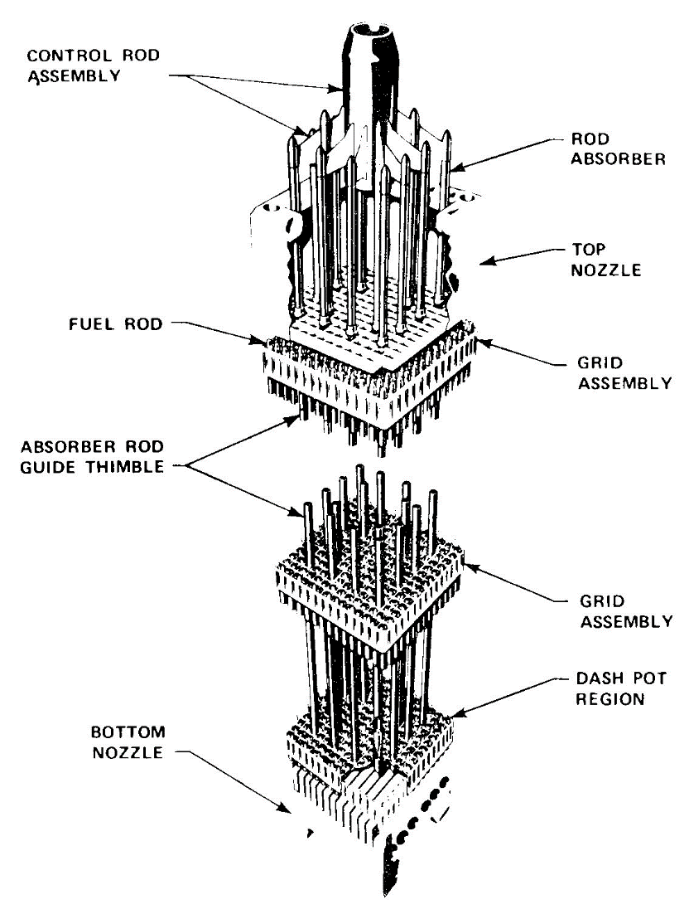
Figure 6. - Cutaway view of a PWR control rod assembly.

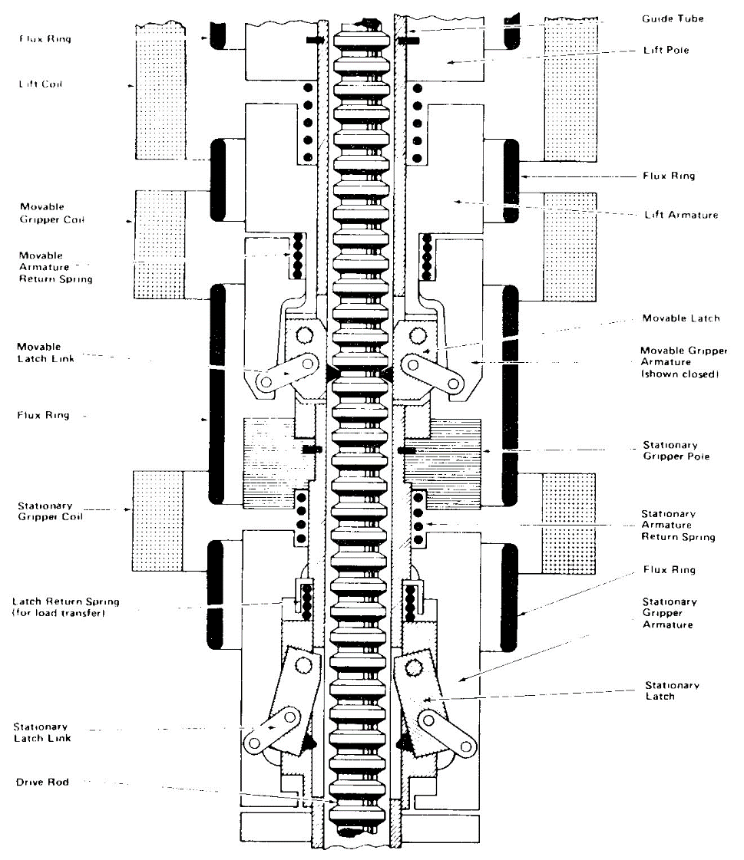

Figure 7 - PWR CRDM magnetic jack arrangement

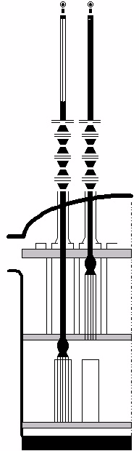
Ring-slotted drive rod
Control-rods fully withdrawn
Movable gripper and coil
Control rods
Reactor core
Control rods
fully inserted
Upper internals
Reactor vessel head
Control-rod drive mechanisms
Stationary gripper and coil
Operating coil
Fuel assembly
Figure 8 - View of PWR rod drives and control rods

Appendix 2 BWR Schemas

Figure 9 - View of A BWR control rod drive

Figure 10 - Hydraulic part of a German BWR reactor scram system
Figure 11 Schematic diagram of the Control Rod and Drive Assembly in Olkiluoto 1 and 2.
Figure 12 Component boundary definition of the Control Rod and Drive Assembly as used in the Nordic component data collection [T Book].

Figure 13 Simplified process diagram for a train of Hydraulic Scram System in Olkiluoto 1 and 2. Internal isolation valve (non-return valve) and manual closing valves (used in maintenance)
are omitted in this schematic picture.

Appendix 3 Magnox Schema
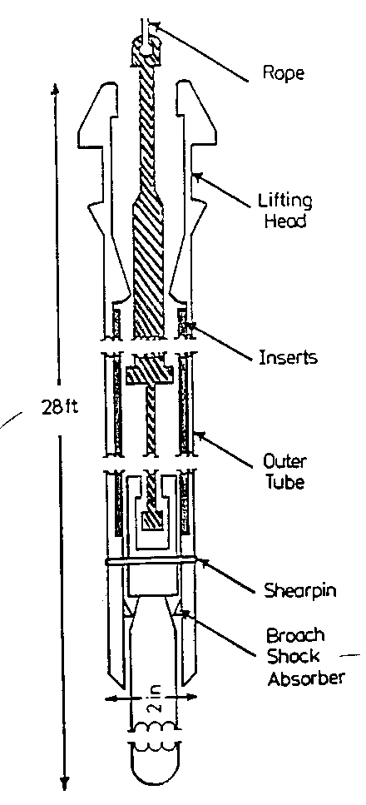
Figure 14 - Control Rod Schematic (Magnox)

Appendix 4 AGR Schema
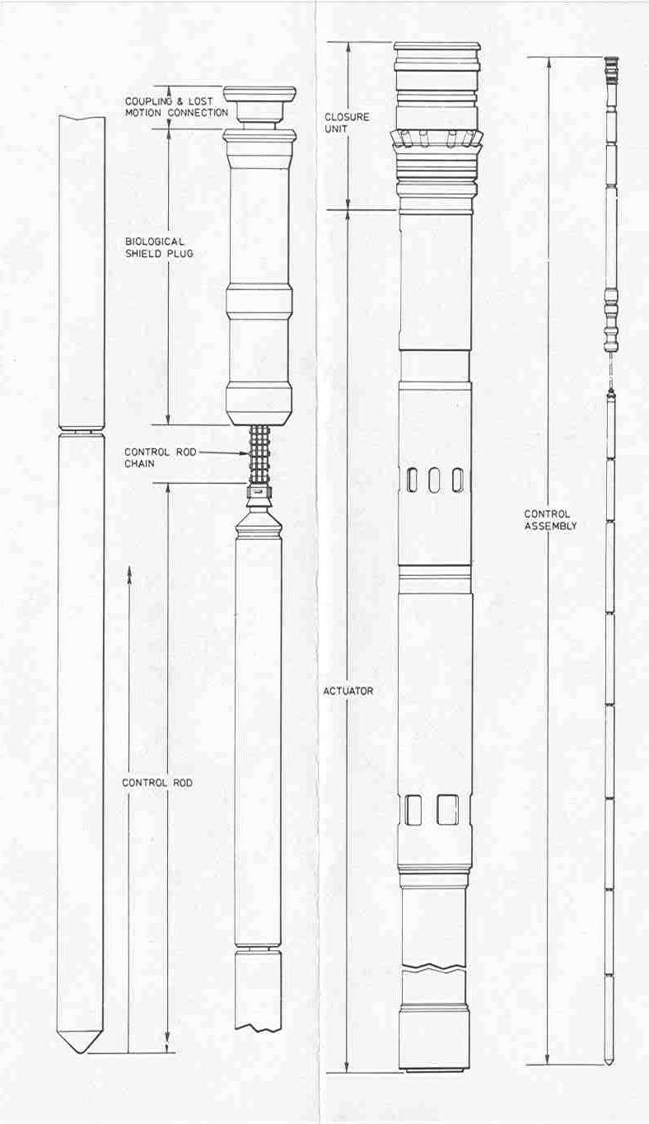
Figure 15 - Control Rod Assembly (AGR)

ICDE
International Common-Cause-Failure Data Exchange ICDECG10
Title: | Coding Guidelines for Heat Exchangers
Author(s): | Ralph Nyman
Issued By: | Ralph Nyman
Reviewed By: | WG
Approved By:
Abstract: | This report defines the component specific coding rules for Heat Exchangers.
Doc.ref: | ICDECG10 – Heat Exchanger Coding Guidelines
Distribution: | SG, Swedish ICDE Working Group, Project Web Site, Project archive
Revision control: | Version | Date | Initial
 | Draft 1.0  ……  Draft 1.11 | 2006-04-11  2010-08-17 | RNy  RNy
Version control table
Comments control: | Ver | Date | Actions taken by
#1. Dr AK and WW and from NPP OKG | 3 | 2006-04 | Almost all comments accepted – mostly language correction. Some open questions was discussed at the Zurich meeting. OKG comments on the need of de-gasing of HE (ch 4.1 + table 6.3.2-1) considered.
#2. SG | 3 | 2006-04-22 | Comments given by SG on the Zurich meeting considered
#3. RNy | 4 | 2006-05-02 | Comments #1 and #2 respected and version 4 created
#4. RNy | 4 | 2006-05-02 | This comments control table added to the CG v4
#5. Dr Albert K, German comments | 4 | 2006-06-07 | AK comments considered in version 4
#6. Mr Phillip H and Göran H (FKA) comments | 4 | 2006-08-22 | PH, GH comments considered in version 4
#7. T Mankamo comments | 4 | 2006-09-11 | TM, comments considered in version 4
#8. Mrs LB Nilsson OKG comments | 4 | 2006-09-18 | Lilly Burel-Nilsson OKG comments considered
#9. Dr Albert K comments | 4 | 2006-10-19 | RNY: Comments accepted.  Some open questions are still open (yellow marked)
#10. RNy | 5 | 2007-04-13 | RNY: Ver 5, the impairment low-I (0,01) is introduced. Appendix 4 and smaller editorial changes. Ver 5 is presented at ICDE meeting #25 in Stockholm (070424_26)
#11. RNy | 6 | 2007-07-17 | RNY: Ver 6, comments given by the 30 June are considered
#12. RNy | 7 | 2007-10-30 | RNY: Ver 7, comments given by Dr Albert K, Mr Philippe H., Mr Kalle J.are considered.
#13. RNy | 8 | 2008-02-21 | RNY: Ver 8, comments given by Dr Albert K 080207 are considered
#14. RNy | 9 | 2008-04-30 | RNY: Ver 9. Comments given at the 27th ICDE meeting are considered
#15. RNy | 10 | 2009-09-14 | RNY: Ver 10. Some clarifying text added and table 7.2-2 adjusted with new column names for Failure symptom and Failure mechanism.
#16. Rny | 11 | 2010-08-17 | RNY: Ver 11 - Some missed IRS systems codes added to the section 1.3. HE failure analysis procedure and -codes added to a new appendix 5.  An Appendix 6, prepared for documentation of experiences from the HE study.
#17. OA | 12 | 2016-08-22 | Appendix 5 and 6 removed.

Table of contents
Component Coding Guidelines for Heat Exchangers 166
1. Component Coding Guidelines for Heat Exchangers 166
1.1 General Description of the Component 166
1.2 Heat exchangers not included in this data exchange 166
1.3 Heat Exchangers data are collected from the following systems 167
1.4 Plant types affected 167
1.5 Heat Exchangers of interest in this data exchange are of the following types 167
2. Component Boundaries 171
3. Heat exchanger glossary 172
4. Population record 172
4.1 Event boundary 172
4.2 Basic unit for ICDE event collection 172
5. Time frame for ICDE event exchange 173
6. Compliance with the general Coding Guidelines. 173
6.1. General Coding Rules and eventual exceptions 173
7. Heat exchanger malfunctions 174
7.1 General 174
7.2 Failure mode of heat exchangers 174
7.3 Loss of or degraded cooling capacity 176
8. Experiences from the first Heat exchanger data analysis, in 2010 176
Appendix 1. Component boundary for heat exchangers 177
Appendix 2. A heat exchanger glossary 181
Appendix 3. Observed Population records - examples 183
Appendix 4. Summary of the Heat Exchanger Coding Guideline 184

Component Coding Guidelines for Heat Exchangers

1. Component Coding Guidelines for Heat Exchangers

1.1 General Description of the Component
A Nuclear Power Plant is equipped with a diverse amount of cooling systems with different kind of operational demands. The purposes of cooling systems are described in General Design Criterion 44 (GDC) follows - Cooling water. A system to transfer heat from structures, systems, and components important to safety, to an ultimate heat sink shall be provided. The system safety function shall be to transfer the combined heat load of these structures, systems, and components under normal operating and accident conditions. Suitable redundancy in components and features, and suitable interconnections, leak detection, and isolation capabilities shall be provided to assure that for onsite electric power system operation (assuming offsite power is not available) and for offsite electric power system operation (assuming onsite power is not available) the system safety function can be accomplished, assuming a single failure.

Heat exchangers are vital components in cooling system described in above.

A heat exchanger is a device built for efficient heat transfer from one fluid to another, where the fluids are separated by a solid wall so that they never mix. They are widely used in refrigeration, air conditioning, space heating and power production.

Typical functions of heat exchangers are to heat or to cool.

Types of heat exchangers
“Shell and tube” and “plate” heat exchangers are considered in this coding guideline and in the ICDE heat exchanger data exchange.

Shell and tube heat exchangers
As its name implies, this type of heat exchanger consists of a shell (a large tube) surrounding a bundle of tubes. Two fluids, of different inlet temperatures, flow through the exchanger. One fluid flows through the tubes and the other flow through the shell. Heat is transferred from one fluid to the other.

There can be many variations of the shell and tube design. Most heat exchangers are of either 1, 2, or 4 pass designs. This refers to the number of times the fluid in the tubes passes through the fluid in the shell.

Plate heat exchanger.
This type of heat exchanger uses metal plates to transfer heat between two liquids.

Terminology
The medium that carries the transferred heat (the cold side) in a heat exchanger is also called the refrigerant.
The cooling capacity (the heat transfer capacity, also called k-value) of a heat exchanger, is usually expressed in kW/m² °C. The k-value is very dependent on how clean the tube/plate surfaces are.

1.2 Heat exchangers not included in this data exchange
The following heat exchangers are not part of the data collection

- Steam generators in PWRs and PHWRs
- Heat exchangers that cool gases (steam, air, nitrogen, hydrogen gas, oxygen), glucose, boric acid
- Heat exchangers that are within the boundaries of other components (such as motors, pumps or diesels)

1.3 Heat Exchangers data are collected from the following systems
In this data exchange heat exchanger data have to be collected from the systems listed below if the heat exchangers in these systems are part of PSAs of the member country. These systems may be either safety or operational systems. Further systems can be included in the data exchange if considered as appropriate by a country. The system on the primary side of the heat exchangers shall be assigned in the Observed Population records. E.g., heat exchangers on the interface of the nuclear service water system and the component cooling water system are assigned to the component cooling water system.The proposed IRS system coding is added in brackets.
- Moderator and auxiliaries (PHWR, ...) (3.AD)
- Component cooling water system (including closed cooling water) (salt / sea water / river / well / lake water) (3.CA)
- Essential raw cooling or service water (3.CB)
- Core cooling system
  - High pressure systems (3.BG)
  - Low pressure systems including residual heat removal systems (3.BE, 3.BG)
- Chemical and Volume Control System (Letdown system) (3.BF)
- Auxiliary or emergency feed water (3.BB)
- Standby liquid control (BWR) (3.BD)
- Fuel pool cooling system (3.DA)
- Containment spray system (3.DD)
- Containment cooling water system (sump cooling) (3.DE)
- Reactor water cleanup (BWR, PHWR, LWGR,...) (3.WK)

1.4 Plant types affected
Data is collected from the following types of nuclear power plants – BWR (Boiling Water Reactor), PWR (Pressurized Water Reactor), PHWR (Heavy Water moderated, Pressure tube Reactor), GCR (Gas Cooled Reactor (graphite or heavy water moderated); includes Magnox AGR, HTGR and HWGCR.

1.5 Heat Exchangers of interest in this data exchange are of the following types
Different types of heat exchangers are expected to be included in the data exchange, and their coding in the heat exchanger coding guideline is described in this section. These codes are identifiers to be used for the G4 – component type codes.

The proposal is to group heat exchangers into “plate”, “tube” and “mixed” types. If a more detailed subdivision of HEs would be used, it might be difficult to collect the necessary information. Important construction details can be given in the G1 definition field, if available.

Table 1.5-1 – Heat exchanger types
Heat exchanger object types | Code, new codes | Comment
HE, plate | HE - Pl | Heat exchanger type, plate
HE, tube | HE - Tu | Heat exchanger type, tube
HE, mixed | HE - Mx | Heat exchanger type, mixed (both Pl and Tu)

Table 1.5-2 - Function of the heat exchangers
Types of main refrigerants | The cooled medium | What is cooled
Raw cooling medium  Sea, lake, well or river water | Secondary cooling water (desalted) | - Water  - Rotating machineries (if not within the component boundaries of these machineries)  - engines (if not within the component boundaries of these machineries)
Filtered or pure cooling medium  Secondary cooling water (desalted) | Process water  Oil | - Water (contaminated)  - Rotating machineries (1)  - engines, generators (1)  - Lubrication oil (1)  - Bearings (1)  - Seal water, e.g., return-flow from RCP  (1) if not within component boundaries of these machineries

Figure 1.5.1 – Principal scheme of a Salt Water system and a sweet water (secondary) cooling system.
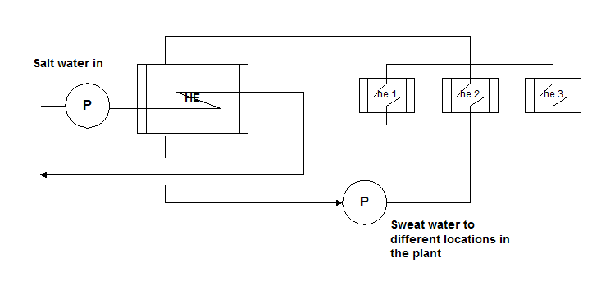

Other interesting aspects to be considered in the heat exchanger data collection and data exchange
Heat exchangers are passive components and the HEs also operate in different ways.
The heat transfer failures on HEs are often caused by design weaknesses and organic impurities and corrosion. In the sections below, some “Advice to analyst” is given.

Data collection
In this data collection the relevant failure mode is “failure of heat transfer”. As explained below, special attention should be given on external/internal leakages.

- In the data collection, failures or degradations of heat exchangers should be collected, as a minimum, from safety systems that are regulated in a plant’s Technical Specifications (TS).
- The participants have to decide on the borderline between operational and safety systems.
- The collection of non safety related heat exchangers should strengthen the data collection and also broaden its basis
- In the data collection it is important to collect heat exchanger failures that have led to a capacity degradation in violation of the licensing basis.
- Importance of internal leaks in heat exchangers are expressed in this section: Information on experiences related to the integrity of heat exchanger tubes is valuable for PSA purposes, not only as a cause of heat transfer failure but as such. A leakage or crack does not necessarily fail the heat transfer. Are there observations about multiple tube failures (leakages, cracks) in heat exchangers, they should be considered in the data collection. This information could be very important for PSA purposes. The coding guideline do therefore consider internal and external leakages as separate failure mechanisms.

Internal leakage can be important because of interfacing system LOCA and because of reactivity transients. The severity of the interfacing system LOCA depends sometimes strongly on the size of the leakage, i.e. on the number of leaking tubes.

Internal leakage can lead to an accumulation of pure water from component cooling water system into primary system e.g. into emergency core cooling system. This can lead to a reactivity accident if too large slug of pure water is fed into the reactor. The amount of the potential accumulated pure water depends on several things (leakage size, ways of detection) so that a small leakage can be more dangerous, and a CCF may not be an issue.

To be able to trace external/internal leakages, it is valuable to know the causes to that kind of failures (thermal transients leading to fatigue, overload on HE/pipe connection welds, changes in water chemistry leading to erosion, hydraulic transients, fluid induced vibration causing tube leaks and ruptures, changed operational practices causing erosion, vibration and wear). A common feature of these failures is that they may have existed for a long time, before the failure becomes evident. The detailed analyses of these failures are the base for planned corrective maintenance activities. If analysts find information like that in the historical data/-references it is of great value for the maintenance departments at NPPs.

Advice to analyst
Describe complementary information on specific data collection matters and findings in the C5 field (event description).

Failures affecting several plants at a site
It is obvious that a CCF of heat exchangers can simultaneously occur and affect several NPPs at a nuclear site, via a coupling factor in a common service or cooling water system. This leads to a discussion about how to use the code G2 (Plant) and also the code G6 (Observed Population Size).

This raises a question of whether the observed population should include the heat exchangers in all of the reactors at a site that have a common service water supply. The current ICDE database requires the selection of a specific reactor in the G2 field for plant.

Advice to analyst
Two types of system design are distinguished:
1. Each NPP at a nuclear site has its own set of HEs. These HEs can be connected individually to one common service or cooling water system for all NPPs at the site.
2. The HEs at a nuclear site belong to one common system and each plant can be connected individually to this common service or cooling water system.

In case 1 it is recommended that an Observed Population (OP) record is set up for each of the affected NPPs, each OP record identifying one of the n plants at the site in the field G2 as well as the actual OP size (code G6). G6 represents the number of heat exchangers of the identified plant that can be connected to the common service water supply. Also, the analyst has to describe this situation carefully in the G1 field (OP definition) of each OP record. (In this case the ICDE pump database will contain only one common OP record for all pumps in the common service or cooling water system at the site.)
CCF events on HEs occurring in such systems are recorded separately for each affected plant, e.g. if n plants are affected by one failure mechanism in the common service or cooling water, n CCF event records are created. Each event record describes the impairments of the HEs of one of the plants. Also, the analyst has to describe this situation carefully in the C5 field (event description).

In case 2 it is recommended that one Observed Population (OP) record is set up for all HEs in the common system (similar as for pumps in case 1). This OP record should be assigned in the field G2 to one of the plants at the site, e.g. unit 1. The OP size (code G6) contains all HEs in the system. CCF events on HEs occurring in such systems are recorded once for the plant that is identified in field G2. The event record describes the impairments of all HEs in that system at the site.

Degree of redundancy
HEs can be more vulnerable to CCFs if located in the same flow circuit as compared to those located in physically separated flow circuits. This aspect usually is more pronounced in sea water circuits due to many sea-based phenomena which can attack HEs. Therefore, it is important that the failure reports describe the degree of flow circuit separation as part of the CCF OP record. See scheme in appendix 3.

Advice to analyst
Describe the system design in the G1 field (OP definition) of the OP records. Alternatively, give information about the location of HEs in the C5 field (event description) of the CCF event record in case a CCF event is recorded for this system.

About the output
- It is important to be able to search for the heat exchangers that have contact with the sea, lake or river water apart from those inside the plant.
- It is important to be able to search for the collected events that are pure heat exchanger failures apart from failures considered as Initiating Events, thereby constituting input for IE-frequencies.

Advice to analyst
Give clear information on how the data is interpreted and considered in the C5 field (event description).

Testing and procedures of heat exchangers (G5.1 and G5.2)
It is expected that there are situations with absence of testing typical of standby safety components and the absence of direct monitoring of the heat exchangers for detection of developing failures.

Degraded capacity with 10-20% is probably not discovered without testing. Therefore qualitative information about the level of capacity degradation is of interest in this data collection. Also, at which HE operational mode a failure is discovered, e.g., continual or intermittent operation, stand-by.

The reporting thresholds for heat transfer failures in the Technical Specifications are dependent on the safety margins for different safety systems. Testing according to the TechSpecs is assumed to be monitoring of parameters such as of sub-cooling margins that would indicate a beginning deterioration in heat exchanger performance.
In the data collection it is of interest to know how the capacity of a heat exchanger is tested and monitored.

Advice to analyst
Analyst is advised to clearly identify in the C5 (event description) field in the database the information needed as a complement to the fields G5.1 and G5.2.
- TechSpecs demands on reporting according to reduced heat transfer in HEs
- testing practices and -intervals of a certain type of HEs in an OP
- monitoring practices of a certain type of HEs in an OP
- operating practices and modes of a certain type of HEs in an OP (e.g., continual, intermittent, stand-by)
- maintenance policy of a certain type of HEs in an OP (e.g., cleaning at demand, twice a year)

2. Component Boundaries
The component boundary in this data analysis includes the following:
- The heat exchanger itself
  - inlet and outlet chambers
  - shell
  - tubes, plates
- piping system between the heat exchanger shell and inside of closest valve
- local valves
Eventual control equipment belonging to the heat exchanger boundary is judged not to be a part of the data collection if malfunction of such equipment has no influence on the function of the heat exchanger.

A detailed example of the boundaries given for heat exchangers in the T-Book version 6 is given in the scheme in the Appendix 1. In appendix 1, also some examples of typical designs of heat exchangers are given.

3. Heat exchanger glossary
In appendix 2, a heat exchanger glossary is presented.

4. Population record
A separate observed population record is defined for each group of redundant heat exchangers.

In appendix 3, a scheme is presented that describes how to create population records.

4.1 Event boundary
Operation of the heat exchanger is successful if there is no indication of component wear out, mechanical degradation or malfunction and a sufficient cooling capacity is present at normal flow.

4.2 Basic unit for ICDE event collection
The ICDE data collection for heat exchangers is done on component basis.
The basic set for Heat Exchangers data collection is the observed population of the affected components and it is the total of all redundant heat exchanger components in the systems of interest in this data exchange. If there are diversified heat exchangers in one observed population, the number of exposed components (field C4 in the CCF event record) may be less than the population size in the observed population record of the affected components, depending on the observed failure mechanism.

Advice to analyst
Analyst is advised to make a clear note in the C5 field in the database how the redundant heat exchangers in redundant trains are arranged as complementary information for the field S1, due to the fact that there may also be situations like 2 HEs in series in one train and parallel HEs in on other train.

Analyst should also be aware of the fact that the system design may have changed during the operating history of a NPP. Earlier system design may have led to more trains and installation of more effective heat exchangers. In that case there is a need for several OPs with different lifetime (different start and end times).

5. Time frame for ICDE event exchange
The minimum period of exchange should cover a period of at least 5 years in the first exchange round. It is suggested that data is collected for the time period 2000 – 2005.

At the end of the ICDE Project period 2006-2008 an update is suggested to be performed on heat exchanger events between the years 1990 to 1999.

6. Compliance with the general Coding Guidelines.

6.1. General Coding Rules and eventual exceptions
1. In general, the definition of the ICDE event given in section 2 of the General ICDE Coding Guidelines applies.

2. All actual failures will be included (in either ICDE or independent event coding), if they could have occurred during a relevant operating mode or state.

3. It is very likely that there are diversified heat exchangers installed in separate redundant trains, e.g., a shell-tube type (HE-1) in train A and a plate type (HE-2) in train B. If the function is to cool redundant safety related components in those trains, then HE-1 and HE-2 shall be treated and counted as belonging to the same group record, in this particular case as HEs of type “mixed”. This should be indicated in the OP definition field G1. If in such cases a CCF affects only one type of heat exchangers, e.g., the shell-tube type, this should be indicated in the CCF description field C1.

The ICDE database structure does not allow to code different types of components or different manufacturers in one population record, this can in fact be the reality in the heat exchanger data collection. Heat exchanger type “mixed” is therefore recommended to be used in this data collection.

It should also be indicated in the OP definition field G1, if multiple HEs in different trains are installed in parallel and/or in series, and what capacity they have.
It is also of importance to know how the HEs are operated (stand-by, intermittent, continual operation). The HEs failure modes and degradations are judged to depend on how they are operated.

4. Some reports discuss only one actual failure, and do not consider that the same cause also affects other heat exchangers, but the licensee maintains or replaces the equipment on all heat exchangers of the observed population. This type of event will be coded as a CCF, with a low (Incipient 0.1) component degradation value for the components that did not actually fail.

5. Administrative in-operability that does not cause the heat exchanger to fail to function is not included as failure. An example is a surveillance test not performed within the required time frame

6. In-operability due to external event situations (blockage of salt / sea / river water flow) shall be included.

7. In case of intermittently used heat exchangers (such as RHR heat exchangers), field S6 (component exposure) must report the time the heat exchangers have been in operation and field S-7 (number of demands) must report the number of times the heat exchanger has been put into service.

In appendix 4, a summary of the whole Heat Exchanger Coding Guideline is presented.

7. Heat exchanger malfunctions

7.1 General
The message in this section is a general discussion about the possible malfunctions on heat exchangers. There are no codes created for these kinds of failures in the coding guideline. However, if the analyst finds these failures in the data collection, it is recommended that an explanation is given in the text fields in the database, for justifying the coding and enabling the reader to understand what has happened.

Cooling capacity failures
- blockage of cooling water
- too dirty cooling water
- external event conditions

Component failures
- flow resistance too high
- fouling
- scaling
- clogging
- external leak
- tube rupture
- mechanical degradation
- corrosive attack

Administrative in-operability, human errors
- not correctly restored after overhaul, maintenance

A frequent problem of some heat exchangers is fouling. As cooling water from rivers or the sea is frequently used, a lot of biological and human debris enters the heat exchanger and builds layers, decreasing the heat transfer coefficient. Another possible problem is scale, which is a chemical deposit layer such as calcium carbonate or magnesium carbonate. In case of plate heat exchangers they need to be cleaned periodically. To do this they will be disassembled and re-assembled. In case of tube heat exchangers there are possibilities like acid cleaning, bullet cleaning etc., (on-line or off-line cleaning). In large-scale cooling water systems for heat exchangers, water treatment such as purification, addition of chemicals, and testing, are used to minimize fouling of the heat exchange equipment

7.2 Failure mode of heat exchangers
In the ICDE data collection only the failure mode “failure of heat transfer” should be considered.

Table 7.2-1 – Heat exchanger failure mode
Failure mode | C3 code  (same codes apply also for S1)
Failure of heat transfer (HT) | HT-general

The impairment vector gives information on the impairment status of each heat exchanger of the exposed population, i.e. information about the impairment of the heat transfer function.

Examples for complete failure of heat transfer:
Plugging or internal leakage is so important that no significant heat transfer is possible

Example for degraded failure of heat transfer:
Plugging or internal leakage is important enough to reduce heat transfer capacity significantly but the safety function "heat transfer" is not compromised yet.

Example for incipient failure of heat transfer:
Plugging or internal leakage is small and has no safety significance, e.g. only few tubes out of the large number of tubes in a tube heat exchanger are plugged or have leakages and there are much more tubes in the heat exchanger than are necessary to fulfil the safety function "heat transfer"

The failure analysis procedure
The heat exchanger failure analysis procedure is performed according to the procedure described in figure 7.2-1 in below.

Figure 7.2-1. The failure analysis procedure.

The failure analysis process followed in this study is as follows;
- ICDE component – failure mode – failure mechanism – failure symptom - failure cause category – piece-part.
- Information from the CCF Event and Observed population module have to be linked around the common key, the CCF event id code.

7.3 Loss of or degraded cooling capacity
Loss of cooling capacity and of the heat exchanger function causing heat sink failures can occur e.g., due to an Initiating or External Event. If the cooling capacity failures are revealed to be due to one of these causes, they should be considered in this data collection, if they have affected redundant cooling systems. Table 7.3-1 presents examples.

Table 7.3-1 – Examples on blockage and external events
- Blockage of water intake (clogging of screens in screen house)
- External event (e.g., bad weather conditions)
- Ship traffic
- Organic or chemical pollution can also be a cause for a component failure
- Piping failure, tunnel failure
- Filter, screen, strainer failure

8. Experiences from the first Heat exchanger data analysis, in 2010
The first heat exchanger data workshop was held in September 2009. The main heat exchanger data analysis was performed during 2010. Database version in this analysis was – “Sweden 2010-06-16_14-20-45_G12_Replica”.

Database content:
- 46 approved heat exchanger CCF event records.
- 2 not approved heat exchanger CCF event records.

Appendix 1. Component boundary for heat exchangers

T-Book 6th edition
Tillförlitlighet, Underhåll och Drift
Figure 26 in the T-book v 6.
Physical boundary of
heat exchangers

Sub-component boundary for heat exchangers (within dotted line) is piping systems, local valves. Please do note that eventual control equipment is not part of this data collection.
Reference: Figure 26 in chapter 11 in the T-Book 6th edition.

Figure. Heat Exchanger component boundary example from EIREDA

Figure. Example of a heat exchanger – shell and tube

Figure. A typical oil heat exchanger

Appendix 2. A heat exchanger glossary
Source: http://www.heatexchangertypes.com/glossary.htm

Baffle Plate. Also called support plate. Tubes pass through this plate for support. Provides a blocked path for the shell-side medium, forcing the medium across the tubes for better heat exchanger performance.

Baffle Spacing. The space between baffle plates on a tube bundle. Baffle spacing is adjusted to achieve maximum heat exchanger performance.

End Plate. A cover that has been welded to the heat exchanger. Most end plates are used on bonnet assemblies.

Fixed Tube Sheet. A non-removable tube sheet; the tube sheet on a core assembly or any tube sheet that is an integral part of the shell assembly.

Floating Tube Sheet. The tube sheet at one end of a removable-tube bundle. The floating tube sheet always has a smaller diameter than does the stationary version. The floating tube sheet moves freely with the expansion and contraction of the tube bundle due to temperature changes in operation.

Gasket. A sealing device used between two parts to prevent leakage. Types include inside-the-bolt circle (no bolt holes) and full face (with bolt holes and the same diameter as the flange).

Impingement Plate. A small perforated- -plate or bar assembly placed inside the shell-side nozzle, usually a dome-type nozzle. The plate also can be attached directly to the bundle by being tack-welded to the tie rods. The impingement plate protects and prolongs tube life by breaking up and slowing down the shell side fluid, which otherwise would erode the tubing.

Nipple. A short piece of pipe threaded on both ends.

Design Pressure. Also called maximum allowable operating pressure. Used by engineers to calculate part thickness and heat exchanger design. Generally, it is slightly higher than the most severe condition or highest operating pressures seen by the heat exchanger.

One, Two, Four Pass. The number of times the fluid passes through the tube bundle. In a one-pass unit, the tube-side medium passes through all the tubes once. In a two-pass unit, it passes through one-half of the tubes and returns through the other half. A four-pass unit goes through approximately one-quarter of the tubes, down and back four times. Greater-than-one pass heat exchangers are referred to as multipass units.

Operating Pressure. The pressure a heat exchanger is actually operating at while in use.

Outer-Tube Limit (OTL). The diameter created by encircling the outermost tubes in a tube layout. Engineers use the design OTL to calculate clearances between bundle parts. The actual OTL is usually a few-thousandths less than the design OTL.

Test Pressure. Generally 1.5 times the design pressure. It is used during a hydrostatic test that detects leaks at any joint on the heat exchanger.

Removable Bundle. A type of heat exchanger in which the tube bundle can be removed from the shell pipe. This provides easy cleaning of the shell side and a less expensive way of replacing worn out tubes.

Shell Assembly. The assembly into which the tube bundle fits. The shell also contains the shell-side connections.

Shell Head. A formed plate welded to the shell, or bonnet, pipe. It can be many styles or shapes, including flanged and dished, elliptical, ellipsoidal and hemispherical. Generally, as a head gets flatter, it gets weaker; therefore, designers can use a flat-end plate or a thinner formed head to do the same job.

Shell Side. The side of a heat exchanger where the fluid circulates around the outside of the tubes.

Stationary Tube Sheet. The tube sheet at one end of a removable bundle. It has a larger diameter than the floating tube sheet and is held together in a permanent position between the bonnet and shell flanges.

Tube Sheet. A plate that secures both ends of the tube in a heat exchanger. Both the shell-side and tube-side mediums come in contact with it.

Appendix 3. Observed Population records - examples
In appendix 3, a scheme is given, that describes how to create population records.

Below is an example from the CANTEACH library, http://canteach.candu.org/aecl.html#TDAI244) .

The population size in this case is two.

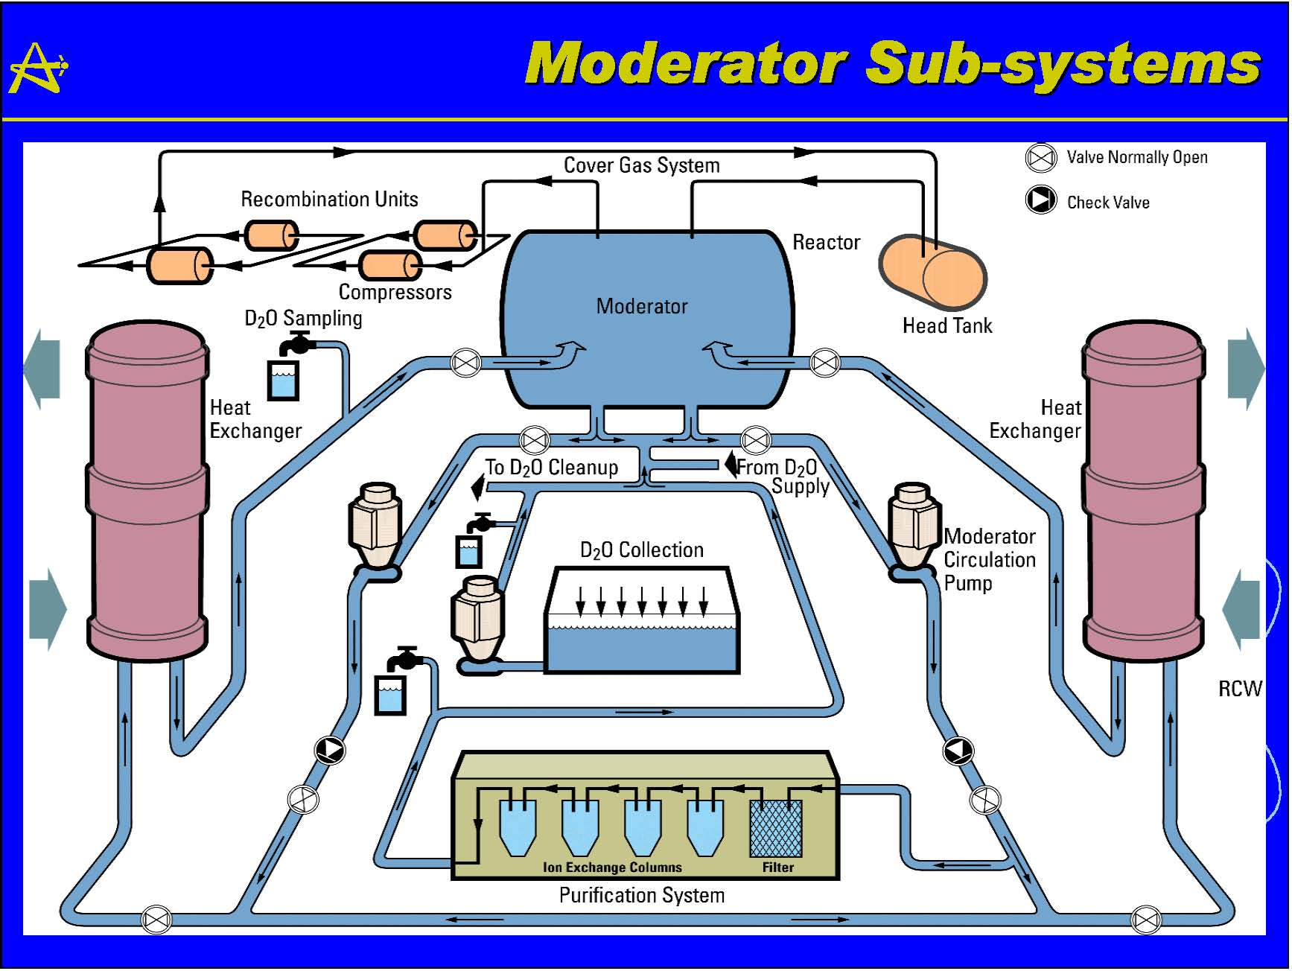

Appendix 4. Summary of the Heat Exchanger Coding Guideline

ICDE
Heat Exchanger data collection
Code | Source
1. Common Cause Component Group (CCCG) Identification Record
G0 CCCG identifier | GCG
G1 CCCG definition | GCG
G2 Plant(s) | GCG
G3 System type / function | GCG
G4 Component type | GCG
* HE-Pl | HE CG
* HE-Tu | HE CG
* HE-Mx | HE CG
G5 Testing
G5-1 Test interval | GCG
G5-2 Test procedure | GCG
G6 Group size | GCG
G7 Manufacturer | GCG
G10 Exposed population | GCG
2. Common Cause Component Group (CCCG) Statistical Record
S1 Component failure modes | HE CG
S2 Number of CCCGs | GCG
S3 Start of CCCG observation time (date of first entry for CCCG) | GCG
S4 End of CCCG observation time (date of last entry for CCCG) | GCG
S5 Number of independent failure events | GCG
S6 Time exposure | GCG
S7 Demand cycles/Number of demands | GCG
3. CCF Event Record
G0 CCCG identifier | GCG
C1 CCF event identifier | GCG
C2 Date(s) of event(s) | GCG
C2-1 / Date(s) and time(s) of detection | GCG
C2-2 / Latent time (Time from occurrence to detection) | GCG
C3 Failure mode | HE CG
* HT-General | HE CG
C4 Number of exposed components in the CCCG | GCG
C5 Event description | GCG
C6 Detection | GCG
C7 CCF event interpretation | GCG
C8 Component impairment vector | GCG
* C | GCG
* D | GCG
* I | GCG
* W | GCG
C9 Event cause | GCG
C10 Coupling factor(s) | GCG
C11 Shared cause factor | GCG
C12 Corrective actions | GCG
C13 Other | GCG
C14 Time factor | GCG

ICDE
International Common-Cause-Failure Data Exchange ICDECG11
Title: | Coding Guidelines for Fans
Author(s): | Jean Dewailly, Michel Balmain
Presented By: | Jean Dewailly, Michel Balmain
Reviewed By: | Will be review by the French representative (G. Georgescu)
Approved By:
Abstract: | This report defines the component specific coding rules for Fans
Doc.ref: | Coding Guidelines
Distribution: | SG
Revision control: | Version | Date | Initial
 | Draft 1.0  ……  Draft 1.1  Draft 1.2  Draft 1.3. | 2008-08-11  2009-01-15  2009-04-08  2010-01-29 | JDe  JDe  JDe  JDe
 | Draft 1.4  Draft 1.5  Draft 1.6  Draft 1.7 | 2010-02-08  2010-07-29  2011-03-08  2012-05-02 | FD  JDe  JDe  MB
Version control table
Comments control: | Ver | Date | Actions taken by editor JDe, MB
 | 1 | 2008-08-11 | Initial version
#1. Dr AK and SG | 2 | 2009-01-15 | Comments given by Dr Albert K 080827 and by SG at the Bethesda meeting considered
#2. Dr AK and SG | 3 | 2009-04-08 | Comments given by Dr Albert K 090313 and by SG at the OECD/NEA meeting (Spring 2010) considered
#3. SG, BPP and Dr AK | 4 | 2010-01-29 | Action ICDE 30-11 taken into account  Integration of information from Begoña Pereira 091120 and Dr Albert K 091201, 100114 and 100122
#4. FD | 5 | 2010-02-08 | multiples small corrections made by NC
#5. SG | 6 | 2010-07-29 | Action ICDE 31-12 taken into account
#6. Japan and SG | 7 | 2011-03-08 | Comments given by Japan  Action ICDE 32-8 taken into account
#7.Dr AK and AB | 8 | 2012-05-02 | Action 34-12: include list of buildings, add page numbers
Table of contents
Component Coding Guidelines for Fans 188
General Description of the Component 188
Systems included in the collection 188
Component Boundaries 189
Event boundary 189
Basic unit for ICDE event collection 189
Time frame for ICDE event exchange 189
General Coding Rules and exceptions 190
Functional Fan failure modes 190
Example of failures to be collected 190
Example of failures not to be collected 190
Guidance to describe and codify CCF events 191
General Documentation 192
Appendix A Fan illustrations 193
Appendix B: Japanese List of safety relevant fans 194
List of Fans for BWRs 194
List of Fans for PWRs 196
Appendix C: CCF event interpretation (Field C7) 199
Recording of failure symptoms and mechanism in C7 199

Component Coding Guidelines for Fans

General Description of the Component
The general function of a fan is to ensure the circulation and distribution of air for buildings and rooms (e.g., Emergency Diesel Generator rooms, electrical rooms and electronic equipment rooms). The component operation is running/alternating or standby.
The chapter 4 of the EPRI Document TR-112170 “HVAC Fans and Dampers Maintenance Guide” mentions about the types of fans. There are three basic types: Centrifugal, VaneAxial and Propeller (VaneAxial and Propeller are helicoid).
Fans are also called ventilators, exhausters, and blowers. Compressors are not covered by the fan component type.
In appendix A, some examples of typical designs of fans are given.
For data evaluation purposes, the family of fans is subdivided into subgroups characterised by coupling (Belt transmission or Direct transmission), type (helicoid, centrifugal), operation (continuous running, alternated running, standby) and finally electrical motor power input (equal or above 10 kW, below 10 kW). The classification is shown in table 1.
Fans that are within the boundaries of other components (such as motors, pumps or diesels) are not part of the data collection.
Table 1. Definition of fan subgroups
 | Belt transmission | Direct transmission
Centrifugal type | Belt transmission, centrifugal  FA-BT-Ce- CR- continuous running  FA-BT-Ce-Alt-alternated running  FA-BT-Ce-SB-Standby | Direct transmission, centrifugal  FA-DT-Ce- CR- continuous running  FA-DT-Ce-Alt-alternated running  FA-DT-Ce-SB-Standby
Helicoid type | N/A | Direct transmission, helicoid  FA-DT-He-CR- continuous running  FA-DT-He-Alt-alternated running  FA-DT-He-SB-Standby

Systems included in the collection
Fan data are being collected for the inlet air, extracted air and recirculating air systems of the safety important buildings.
Examples:
Reactor building, Switch gear building (including cable ducts), Emergency Diesel Generator building(s), the building(s) for plant auxiliary systems, the emergency building and (for BWR only) the turbine hall.
PUMP ROOM fans (i.e.: AFWS)
I&C COMPONENT ROOM fans in CONTROL ROOM
COOLING TOWER fans. These fans belong to Service (or Circulating) Water System and are inside cooling tower boundary. The primary function of this System is to provide cooling water to the condenser for condensing steam turbine exhaust steam. The System rejects heat to the atmosphere using a cooling tower.
ICE CONDENSER fans. (e.g.: Air Return Fans) Air Return Fans are located in the upper compartment (e.g.: Ohi) or the lower compartment (e.g.: Watts Bar) to circulate the air from the upper compartment to the lower compartment. Air Return Fans are to reduce the pressure of the containment to circulate the air through the ice condenser after an accident such as LOCA.
The ventilation system that directly belongs to the emergency diesel generator is already included in the EDG component boundary. So for the fan data exchange only the general fans of the emergency diesel generator building(s) are included. The fans that can be assigned to a single EDG are within the component boundary of the EDG and included in the EDG data exchange.
Data is collected from the following types of nuclear power plants – BWR (Boiling Water Reactor), PWR (Pressurized Water Reactor), PHWR (Heavy Water moderated, Pressure tube Reactor), GCR (Gas Cooled Reactor (graphite or heavy water moderated); includes Magnox AGR, HTGR and HWGCR).
The Japanese list of safety relevant fans is given in Appendix B.

Component Boundaries
The component boundary in this data analysis includes the fan, motor, component circuit breaker, local lubrication or cooling systems, and local instrumentation and control circuitry. The component boundary is illustrated by figure 1.
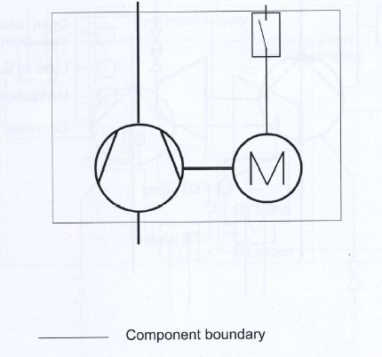

Figure 1: Component boundary of fans

Event boundary
Operation of the fan is successful if there is no indication of component wear out, mechanical degradation or malfunction.

Basic unit for ICDE event collection
The basic set for fan data collection is the observed population (OP).

Time frame for ICDE event exchange
The minimum period of exchange should cover a period of at least 5 years in the first exchange round. It is suggested that data are collected for the time period 2001 – 2006.

General Coding Rules and exceptions
- In general, the definitions of the ICDE event given in section 2 of the General ICDE Coding Guidelines apply.
- All actual failures will be included (in either ICDE or independent event coding), if they could have occurred during a relevant operating mode or state.
- Some reports discuss only one actual failure and do not consider that the same cause also affects other fans, but the licensee maintains or replaces the equipment on all fans of the observed population. This type of event will be coded as a CCF with a low (Incipient 0.1) component degradation value for the components that did not actually fail.
- Administrative in-operability that does not cause the fan to fail to function is not included as failure. An example is a surveillance test not performed within the required time frame

Functional Fan failure modes
The following essential failure modes and criticality classifications are applicable for fan data collection.
- Failure to start: failure before nominal operating conditions is reached (FS).
- Failure to run: failure after nominal operating conditions is reached (FR).
The impairment vector gives information on the impairment status of each fan of the exposed population, i.e. information about the impairment of the ventilation function.

Example of failures to be collected
Fan dysfunctions preventing the fan from fulfilling its safety missions, as well as their possible causes, shall be included in the data collection.
For the failure mode "Failure to run", these events meet the main criteria below:
- Any spurious stop on internal fault;
- Deficiencies found during an inspection show a latent fault that may lead to malfunction of the fans;
- High temperature bearings (criterion maintenance) if maintenance is necessary;
- High level of vibration (criterion maintenance);
- Human errors not detected during a maintenance task (requalification for example) which may then cause the fan malfunctions during normal operation.
For the failure mode "Failure to start", these events meet the main criterion below:
- Any refusal to start.

Example of failures not to be collected
Events with insignificant risk for the fan safety mission shall not be included in the data collection. Those events, with no or negligible implications for the fan safety mission should be screened out, as for example: failures brought to light during the equipment requalification before its return to operation (only if the failures were introduced during the maintenance activity).

Guidance to describe and codify CCF events
Regarding event codification the following examples are given for the failure modes considered:

Noise and Vibration
Complete failure | Where the vibration level led to the loss of the fan or the degradation suggests that the fan will break within the PSA mission time.
Degraded failure | Repair or replacement is done while the fan could still achieve its mission in a degraded way
Degraded failure | A vibration criterion requires maintenance in the immediate future (this can also be a complete failure if the vibration is so strong that it could lead to a failure of the fan during mission time).
Degraded failure | Information is incomplete: the degree of impairment should be assessed case by case depending on the available information.
Incipient failure | The state of the fan does not require maintenance in the immediate future

Bearings and thrusts
Complete failure | Fan operation is no longer guaranteed
Degraded failure | Repair or replacement is done while the fan could still achieve its mission in a degraded way
Degraded failure | A temperature criterion requires maintenance in the immediate future (this can also be a complete failure if the increase of temperature is so strong that it could lead to a failure of the fans during mission time).
Degraded failure | Information is incomplete: the degree of impairment should be assessed case by case depending on the available information.
Incipient failure | The state of the fan does not require maintenance in the immediate future

Belts
Complete failure | Failure of all the belts
Degraded failure | Failure of a part of belts does not result in loss of coupling
Degraded failure | Information is incomplete: the degree of impairment should be assessed case by case depending on the available information.
Incipient failure | The state of the belt does not require maintenance in the immediate future
Comment: When the information is incomplete, it’s quite usual in France to consider a degraded failure. With the information available in the four examples below, a degraded failure is considered.
Example 1: Important noise leading to stop the fan to check bearings state.
Example 2: Important vibrations noticed by an analysis.
Example 3: Excessive lubrication of bearings. Bearings cleaned and replaced.
Example 4: Faulty bearings. Replacement of belts and inspection of the bearings.
Proposed failure symptoms and failure mechanisms should be provided (see Appendix C).

General Documentation
[1] T-Book 6th edition, Reliability data of component in Nordic Nuclear Power Plants, edited by The TUD office, SwedPower AB.
[2] Industry-Average Performance for Components and Intiating Events at U.S. Commercial Power Plants, NUREG/CR-6928, INL/EXT-06-11119
[3] Centralized Reliability and Events Database (ZEDB), Reliability Data for Nuclear Power Plant Components: Analysis for 2004, published by VGB PowerTech e.V.
[4] EiREDA 1998, European industry reliability data bank, CUP, Crete University Press.
[5] HVAC Fans and Dampers Maintenance Guide, EPRI, Palo Alto, CA: 1999. TR-112170.

Appendix A Fan illustrations

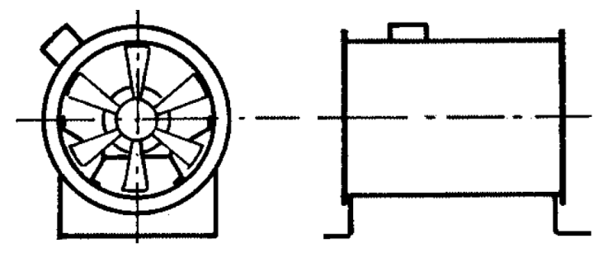

Figure A1. – Fan, helicoidal

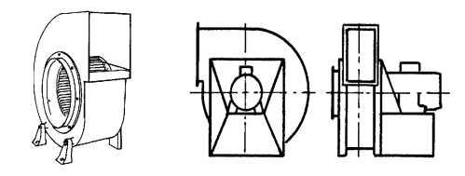

Figure A2 – Fan, centrifugal

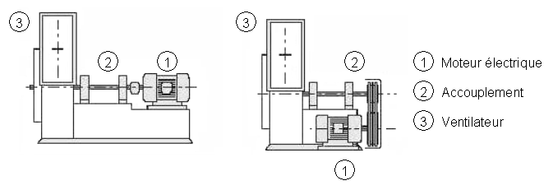

Figure A3. – Drivetrain fans (left, direct and right, drive belts)

Appendix B: Japanese List of safety relevant fans

List of Fans for BWRs

 | Name | Capacity (%)  * # of System | Reactor  Type | Place | Comments
1 | STAND BY GAS TREATMENT SYSTEM FAN | 100% * (2 fans) * 2 | BWRs | R/B
2 | FLAMMABILITY CONTROL SYSTEM BLOWER | 100% *(2 fans) *2 | BWRs | R/B | Some plant shares 1 of 2 systems between 2 units.
2 | FLAMMABILITY CONTROL SYSTEM BLOWER | 50% *(4 fans) *4 | BWR 5 | R/B | Some plant shares 1 of 2 systems between 2 units.
2 | FLAMMABILITY CONTROL SYSTEM BLOWER | 100% *(2 fans) *1 | BWR 4 | R/B | Some plant shares 1 of 2 systems between 2 units.
3 | MAIN CONTROL ROOM HVAC SUPPLY FAN | 100% *(2 fans) *2 | BWR 4  BWR 5  ABWR | Depends on plant | Some plant has 50% * (4 fans) * 2.
3 | MAIN CONTROL ROOM HVAC SUPPLY FAN | 50% *(6 fans) *3 | BWR 4 | C/B | Because the control room is shared between 2 units, the systems are shared between 2 units.  Some shares 50% * (6 fans) * 3 for 2 units, and some shares 100% * (3 fans) * 3 for 2 units.
4 | MAIN CONTROL ROOM HVAC EXHAUST FAN | 100% *(2 fans) *1 | BWR 5  ABWR | Depends on plant | Some plant, for example BWR 4, doesn't have this fan.
5 | MAIN CONTROL ROOM HVAC RECIRCULATION FAN | 100% *(2 fans) *1 | BWR 4  BWR 5  ABWR | Depends on plant | Some plant has 100% * (1 fans) * 1.
5 | MAIN CONTROL ROOM HVAC RECIRCULATION FAN | 100% *(3 fans) *2 | BWR 4 | C/B | Because the control room is shared between 2 units, the systems are shared between 2 units.
6 | STAND BY D/G ROOM SUPPLY FAN | 33% *(3 fans) *1 | BWR 4  BWR 5  ABWR | Depends on plant | Some plant has different number of fans because of the capacity of D/G.
6 | STAND BY D/G ROOM SUPPLY FAN | 100% *2 | BWR 2  BWR 3  BWR 4 | Depends on plant | Some plant has different capacity of fans such as 100% (1 fan), 50% (2 fans) or 33% (3 fans).
6 | STAND BY D/G ROOM SUPPLY FAN | 100% *3 | BWR 5  ABWR | Depends on plant | Some plant has different capacity of fans such as 50% (2 fans) or 33% (3 fans).
7 | ＨＰＣＳ D/G ROOM SUPPLY FAN | 50% *(2 fans) *1 | BWR 5 | R/B
8 | STAND BY D/G ROOM EXHAUST FAN | 25% *(4 fans) *1 | BWR 4  BWR 5 | Depends on plant | Some plant has different number of fans because of the capacity of D/G.
9 | ＨＰＣＳ D/G ROOM EXHAUST FAN | 25% *(4 fans) *1 | BWR 5 | R/B | Some plant has different number of fans because of the capacity of D/G.

List of Fans for PWRs
 | FAN | Capacity (%)  * # of System | Reactor  Type | Place | Comments
 | Name
1 | Main control room recirculation fan | 100% * 3 | 2 LOOP DRY | A/B
 |  | 100% * 2 | 3 LOOP DRY | I/B
 |  |  | 4 LOOP DRY | C/B
 |  |  | 4 LOOP ICE | A/B
2 | Main control room emergency supply fan | 100% * 2 | 2 LOOP DRY | A/B
3 | Min control room emergency recirculation fan | 100% * 2 | 3 LOOP DRY  4 LOOP ICE | A/B
 |  |  | 4 LOOP DRY | C/B
4 | Main control room air handling fan | 100% * 3 | 2 LOOP DRY | A/B
 |  | 100% * 2 | 3 LOOP DRY | I/B
 |  |  | 4 LOOP DRY | C/B
 |  |  | 4 LOOP ICE | A/B
5 | Annulus exhaust fan | 100% * 2 | 2 LOOP DRY | A/B
6 | Annulus cleanup fan | 100% * 2 | 3 LOOP DRY  4 LOOP ICE | A/B
 |  |  | 4 LOOP DRY | E/B
7 | Air return fan | 100% * 2 | 4 LOOP ICE | C/V
8 | Chilled water pump area cooling fan | 100% * 2 | 4 LOOP ICE | A/B
9 | Auxiliary building charcoal exhaust fan -Elevation 4.9M and 11.3M | 100% * 2 | 4 LOOP ICE | A/B
10 | Auxiliary building charcoal exhaust fan -Elevation 23.8M | 100% * 2 | 4 LOOP ICE | A/B
11 | Safeguard component room air handling fan | 100% * 2 | 2 LOOP DRY | A/B
12 | Safeguard component room supply fan | 100% * 2 | 3 LOOP DRY | A/B
13 | Safeguard component room exhaust fan | 100% * 2 | 3 LOOP DRY | A/B
14 | Safeguard component room cooling fan | 100% * 2 | 4 LOOP DRY | E/B
15 | Safety injection pump room cooling fan | 100% * 2 | 4 LOOP ICE | A/B
16 | Residual heat removal (RHR) pump room cooling fan | 100% * 2 | 4 LOOP ICE | A/B
17 | Containment spray pump room cooling fan | 100% * 2 | 4 LOOP ICE | A/B
18 | Nuclear steam supply system (NSSS) component cooling water pump room cooling fan | 100% * 2 | 4 LOOP ICE | A/B
19 | Balance of plant (BOP) component cooling water pump room cooling fan | 100% * 2 | 4 LOOP ICE | A/B
20 | Battery room and switchgear room air handling unit | 100% * 2 | 4 LOOP ICE | A/B
21 | SWGR room air handling fan | 100% * 2 | 2 LOOP DRY | A/B
 |  |  | 3 LOOP DRY | I/B
 |  |  | 4 LOOP DRY | C/B
22 | RCC room supply fan | 100% * 2 | 2 LOOP DRY | A/B
23 | RCC room exhaust fan | 100% * 2 | 2 LOOP DRY | A/B
24 | AFWP supply fan | 100% * 2 | 2 LOOP DRY | A/B
25 | Motor drive AFWP room supply fan | 100% * 2 | 3 LOOP DRY | I/B
26 | AFWP exhaust fan | 100% * 2 | 2 LOOP DRY | A/B
27 | Motor drive AFWP room exhaust fan | 100% * 2 | 3 LOOP DRY | I/B
28 | Motor drive AFWP room cooling fan | 100% * 2 | 4 LOOP DRY | E/B
29 | Auxiliary feedwater pump room cooling fan | 100% * 2 | 4 LOOP ICE | A/B
30 | DG room supply fan | 50% * 4 | 2 LOOP DRY  3 LOOP DRY | DG/B
 |  |  | 4 LOOP DRY | E/B
31 | Diesel generator (D/G) area exhaust fan | 50% * 4 | 4 LOOP ICE | A/B
32 | Charging pump room air handling fan | 100% * 2 | 2 LOOP DRY | A/B
33 | Boric acid pump air handling fan | 100% * 2 | 4 LOOP DRY | E/B
34 | IA compressor room supply fan | 100% * 2 | 3 LOOP DRY | I/B
 |  |  | 4 LOOP DRY | E/B
35 | IA compressor room exhaust fan | 100% * 2 | 3 LOOP DRY | I/B

Appendix C: CCF event interpretation (Field C7)

Recording of failure symptoms and mechanism in C7
The CCF event description (Text description /Compulsory/) shall describe the (subjective) rationale used by the analyst to classify the event as a CCF event. This is a proposal for description of the Failure Symptoms and Failure Mechanism
Failure Symptom (TBD based on trial exchange)
- Vibration
- Temperature
- Noise
- Etc…..
Failure Mechanism (TBD based on trial exchange)
- Corrosion (loss of insulation)
- Impairment due to Extreme Environmental Conditions
- Loss/Deficiency of Lubricant
- Loss/Deficiency of dielectric media (for ex. loss of SF₆, oil or vacuum)
- Pollution/Dirt (Loss of Insulation)
- Relaxation of Mechanical Springs
- Spurious Signal in breaker auxiliary circuits Protection Systems
- Stress
- Thermal Cycling
- Wear
- Wiring Faults
- Etc…

ICDE
International Common-Cause-Failure Data Exchange ICDECG13
Title: | Coding Guidelines for Main Steam Isolation Valves
Author(s): | Albert Kreuser, Dagmar Sommer
Issued By:
Reviewed By: | SG
Approved By:
Abstract: | This report defines the component specific coding rules for Main Steam Isolation Valves (MSIVs).
Doc.ref: | Coding Guidelines
Distribution: | SG
Revision control: | Version | Date | Initial
 |  | 2010-02-09 | DS
 |  | 2010-05-20 | SG

Table of contents
Component Coding Guidelines for MSIVs 202
General Description of the Component 202
Systems included in the collection 202
Component Boundaries 202
Event Boundary 202
Basic unit for ICDE event collection 203
Time frame for ICDE event exchange 203
Functional Fault Modes 203
Coding Rules and Exceptions 203
Recommendations on OP descriptions 204
Recommendations on CCF event descriptions 204
Appendix A: CCF event interpretation (Field C7) 206
Recording of failure symptoms and mechanism in C7 206
Appendix B: Interface between the General and Component Coding Guideline 207

Component Coding Guidelines for MSIVs

General Description of the Component
Main Steam Isolation Valves (MSIV) are fast closing impulse operated valves. The purpose of main steam isolation valves is to isolate the containment or the steam flow to the turbine unit and interfacing auxiliary systems (depending on the plant design). Some plants use separate sets of fast closing impulse operated steam isolation valves with safety relevant functions in the main steam or in the auxiliary steam system for isolation of, e.g. auxiliary steam, main steam relief valves or main steam safety valves. These valves are also covered in this data collection.
Main steam isolation valves consist of the main valve and several pilot valves.
The following types of main steam isolation valves are distinguished:
- Impulse operated
- other
The following types of pilot valves are distinguished:
- Solenoid operated
- Air operated
- Motor operated
- Spring operated
- other

Systems included in the collection
The system for which main steam isolation valve (MSIV) data and pilot valve data are collected is (the corresponding IRS system coding is added in parentheses):
- Main steam (3.FA)

Component Boundaries
The main steam isolation valve (MSIV) component boundary includes the valve, the valve operator, the pilot valves, associated control lines, the pilot valve operators and local instrumentation and control circuitry (compare figure 1). Data collection is done separately for main valves (valve, valve operator) and pilot valves (pilot valve, associated control lines, pilot valve operators and local instrumentation and control circuitry).

Event Boundary
Failure of an MSIV to perform its mission occurs if a valve that is required to be closed to isolate secondary parts of the system from steam flow fails to close.
Failure of a pilot valve occurs if a pilot valve that is required to open in order to close the main steam isolation valve fails to open or if a pilot valve that is required to close in order to close the main steam isolation valve fails to close.

Basic unit for ICDE event collection
The basic set for main steam isolation valve data collection is the "observed population" (OP).
(If necessary the exposed population can be used (EP: set of components exposed to the same failure cause). The number of valves in an exposed population depends on the specific failure identified in the event analysis. In general the exposed population shall be in the same system for the components identified but could be modified depending on the linkage of CCF events by failure mechanism or causal factors. The elements of the exposed population will normally have similar test intervals. Similar in this context means a factor of not more than 2 between minimum and maximum. The determination of the exposed population is left to the event reviewer and the reviewer’s knowledge of the relation of system design, operation and testing.)

Time frame for ICDE event exchange
The minimum period of exchange should cover a period of at least 5 years in the first exchange round.

Functional Fault Modes
MSIV malfunctions are defined as failures to close on demand, including excessive leakage through the valve, or spurious closing of the valve. The failure modes used in evaluating the data are:
The essential failure mode is
- Failure to close (FC).
Additional failure mode is
- Failure to remain in position, Spurious operation (SO)
Pilot valve malfunctions are defined as failures to open on demand, failures to close on demand, or spurious operation.
The essential failure mode is either
- Failure to open (FO) or
- Failure to close (FC)
Additional failure mode is
- Failure to remain in position, Spurious operation (SO)

Coding Rules and Exceptions
- In general, the definition of the ICDE event given in section 2 of the General ICDE Coding Guidelines applies.
- Some reports discuss only one actual failure, and do not consider that the same cause will affect other MSIVs, but the licensee replaces the failed component on all MSIVs as a precautionary measure. This type of event will be coded as incipient impairment (0.1) of the components that did not actually fail.
- Runtime exceed of MSIVs is considered in the component impairment as incipient or degraded failure for failure mode FC.
- In-operability due to seismic criteria violations will not be included, unless an actual failure has occurred.
- Administrative in-operability that does not cause the valve to fail to function is not included as failure. An example is a surveillance test not performed within the required time frame.
- The length of the impairment vector is equal to the size of the exposed population; however, only the information on the impairment status of each impaired component should be coded using the usual ICDE codes (C, D, and I).
- In-operability due to human error or erroneous calibration/set up will be included (in either ICDE or independent event coding).

Recommendations on OP descriptions
- The field G8 (OP Number) can be used to distinguish records if several OPs would have otherwise identical field G0 (OP Name)
- If equipment was changed during the data collection period it is reasonable to create two sets of OPs. The definition in G1 benefits from up-front description of changes made.
- Information about scope of tests is needed to decide about: is time factor high or low for two failures which are separated by time. An explanation should be given in the definition field G1 about the test interval (surveillance test or more thorough test with longer time interval). The coded test interval should be the shortest interval.
- Abbreviations in descriptions should be explained.

Recommendations on CCF event descriptions
- If a CCF event affected components that belong to 2 OPs, e.g. in twin units, then 2 event records should be made. Each event record should describe the observed impairments of the components of its corresponding OP.
- In order to be able to validate the impairment coding the event description field C5 should contain information that explains the impairment coding.
- Latent time (field C2-2) is put to 0 for monitored failures only. Latent time can be larger than the shortest test interval (which is indicated in field G5-1 of the OP record) if a failure cannot be detected in e.g. 3 monthly routine testing, only in e.g. yearly testing under realistic demand conditions. This should be explained in the event description field C5.
- It has to be recognized that for some events the information given is all information available from the original records but description may not be clear enough to understand e.g. the detection means or the degree of impairment.
- Event cause coded in field C9 is a high level classification. The value list of field C9 does not represent “real” root causes. These are only described in the event description field C5.
- If not obvious, additional information is needed to understand number of exposed components.
- If not obvious, event description should clarify reasoning for event cause coding, corrective action coding etc.

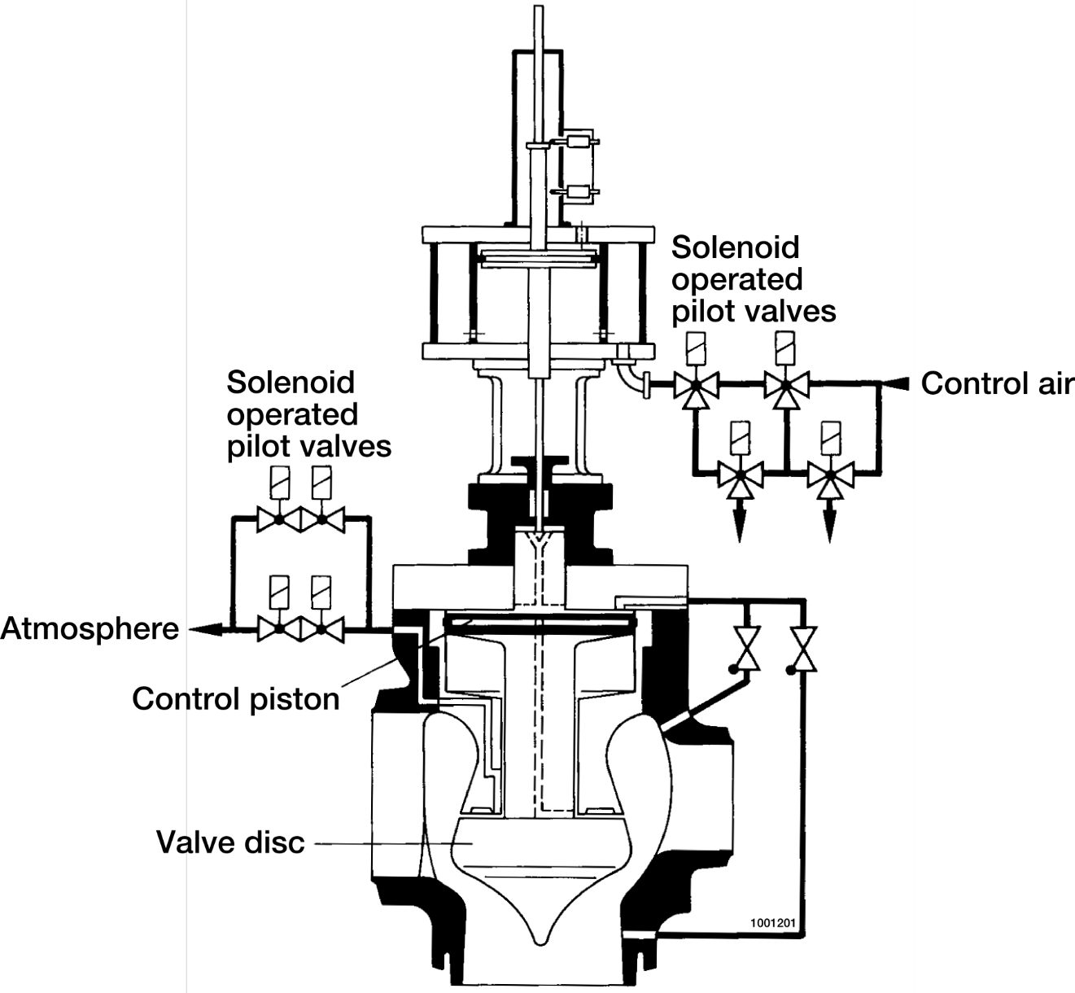

Figure 1. The schematic diagram shows an example of the construction of a MSIV .

Appendix A: CCF event interpretation (Field C7)

Recording of failure symptoms and mechanism in C7
The CCF event description (Text description /Compulsory) shall describe the (subjective) rationale used by the analyst to classify the event as a CCF event. This is a proposal for description of the Failure Symptoms and Failure Mechanism
Failure Symptom (TBD based on trial exchange)
- Valve movement problems
- Internal leakage
- Noise
- Etc…..
Failure Mechanism (TBD based on trial exchange)
- Corrosion
- Impairment due to Extreme Environmental Conditions
- Loss/Deficiency of Lubricant
- Pollution/Dirt
- Relaxation of Mechanical Springs
- Stress
- Thermal Cycling
- Wear
- Wiring Faults
- Etc…

Appendix B: Interface between the General and Component Coding Guideline
ICDE
Code | Source | Comment
1. Common Cause Component Group (CCCG) Identification Record
G0 CCCG identifier | GCG
G1 CCCG definition | CCG
G2 Plant(s) | GCG
G3 System type / function | CCG
G4 Component type | CCG
G4.1 Component sub type | CCG
G5 Testing | GCG
G5-1 Test interval | GCG
G5-2 Test procedure | GCG
G6 Group size | GCG
G7 Manufacturer | GCG
G8 OP Number | GCG
G10 Exposed population | GCG
2. Common Cause Component Group (CCCG) Statistical Record
S1 Component failure modes | CCG
S2 Number of CCCGs | GCG
S3 Start of CCCG observation time (date of first entry for CCCG) | GCG | CCG time frame
S4 End of CCCG observation time (date of last entry for CCCG) | GCG | CCG time frame
S5 Number of independent failure events | GCG
S6 Time exposure | GCG
S7 Demand cycles/Number of demands | GCG
3. CCF Event Record
G0 CCCG identifier | GCG
C1 CCF event identifier | GCG
C2 Date(s) of event(s) | GCG
C2-1 / Date(s) and time(s) of detection | GCG
C2-2 / Latent time (Time from occurrence to detection) | GCG
C3 Failure mode | CCG
C4 Number of exposed components in the CCCG | GCG
C5 Event description | GCG
C6 Detection | GCG
C7 CCF event interpretation | GCG | CCG App A
C8 Component impairment vector | GCG
C9 Event cause | GCG

ICDE
International Common-Cause-Failure Data Exchange ICDECG14
Title: | Coding Guidelines for Digital Instrumentation and Control Equipment
Author(s): | Albert Kreuser, Jan Stiller
Issued By: | Jan Stiller
Reviewed By: | SG
Approved By: | SG
Abstract: | This report defines the component specific coding rules for Digital Instrumentation and Control (I&C) Equipment.
Doc.ref: | Coding Guidelines
Distribution: | SG
Revision control: | Version | Date | Initial
 | 1.0 | 24.04.2013 | JS
 | 1.1 | 14.05.2013 | JS
 | 1.2 | 16.07.2013 | JS

Table of contents
Component Coding Guidelines for Digital I&C 210
General Description of the Component 210
Systems included in the collection 210
Component Boundaries 211
Event Boundary 212
Basic unit for ICDE event collection 212
Determination of the number of redundant components 212
Time frame for ICDE event exchange 216
Functional Failure Modes 216
Coding Rules and Exceptions 216
Recommendations on OP descriptions 216
Recommendations on CCF event descriptions 217
Recommendations on Component Impairments 218
Appendix A: Interface between the General and Component Coding Guideline 219

Component Coding Guidelines for Digital I&C

General Description of the Component
Digital instrumentation and control (I&C) systems are used in different safety related and safety systems of nuclear power plants, such as the reactor trip system (RTS), the engineered safety feature actuation system (ESFAS), limitation systems or fire detection systems.
They are characterized by the fact that discrete values are used to represent information, e.g. physical parameters. To process the information, they typically comprise computers (which run system and application specific software), microprocessors, microcontrollers, field programmable gate arrays (FPGA) or other complex electronic devices like application specific integrated circuits (ASIC). In many cases, different devices are connected by digital busses.

Systems included in the collection
The data collection for Digital I&C comprises safety systems and safety related systems.
Systems for which Digital I&C data shall be collected are in the nomenclature of the system classification of the IAEA International Reporting System (IRS) /1/ (the corresponding IRS system coding is added in parentheses):
- Reactor protection (3.IN)
- Engineered safety features actuation (including emergency systems actuation) (3.IP)
- In-core and ex-core neutron monitoring (including BWR reactor stability monitoring) (3.IF)
- Leak monitoring (reactor coolant boundary, containment and auxiliary buildings) (3.IG)
- Reactor power control (e.g. control rods and boration/dilution systems) (3.IK)
- Feedwater control (3.IM)
- Fire detection (3.IB)
- Seismic instrumentation (3.IS)
- Vibration monitoring (3.IT)
- Other safety and safety related plant and process monitoring (including main and remote/supplementary control room equipment and various remote control functions outside above mentioned systems) (3.IE)
Typically, different functions are integrated into one system, e.g. Reactor protection (3.IN) and Engineered safety features actuation (3.IP).
Remark: Events in non-safety related systems which involve I&C equipment that is also used in safety related systems (e.g. a CCF event in a two-train turbine control systems realized in Teleperm XS) can also be included in the scope of the data collection upon decision of the responsible national coordinator.

Component Boundaries
In general, the ICDE Digital Instrumentation and Control Component includes I&C equipment from analogue to digital converters (so-called measurement level) to actuation level including priority control. Regarding control room equipment, it includes both input devices like push buttons and output devices like annunciation indicators or digital displays.
However, to be consistent with other ICDE data collections all equipment which can clearly and uniquely be assigned to an individual technological component should be covered in the component boundary of that component. The digital I&C component begins at the boundary of the other ICDE component type. Digital equipment that lies within the boundary of the technological component might include for example digital component protection (e.g. overvoltage, overcurrent) or analogue to digital converters and digital bus interfaces if e.g. level measurement transmitters are connected to RTS/ESFAS by a digital bus.
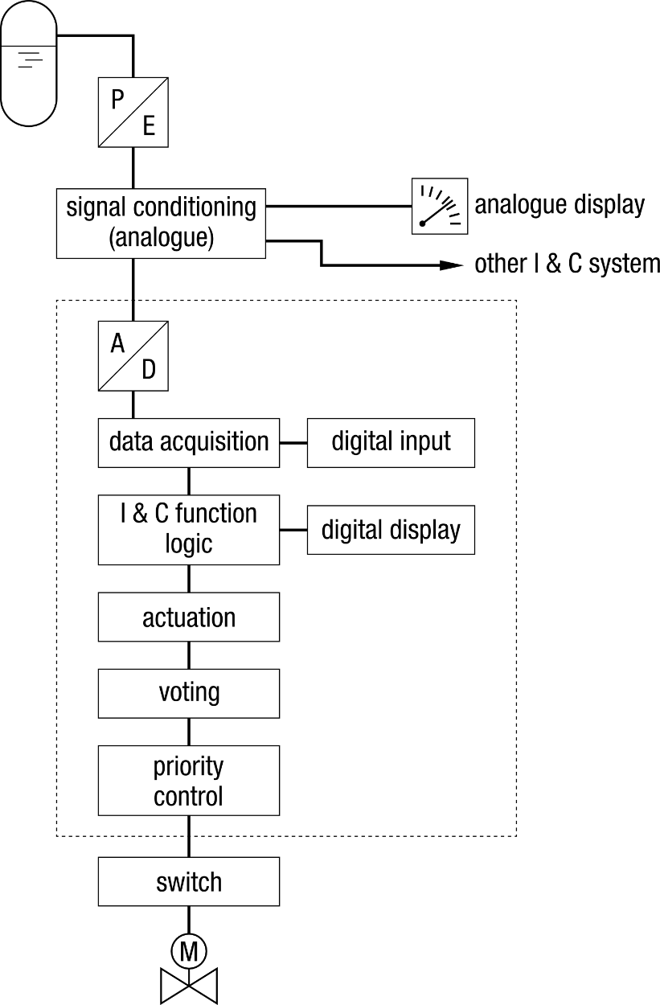
Figure 1. Boundary of equipment included in a digital I&C component.
The schematic diagram in figure 1 shows the boundary of the equipment considered. Devices within this boundary are included only if they correspond to the general description given above. If e.g. voting units and priority control is implemented using relays, it is not considered for data collection.

Event Boundary
Failures of digital I&C to perform its mission occur if the ability to perform a required function within the previously specified limits terminates or is absent. Both failures to actuate and spurious actuations are included.
Events that meet the criteria of CCF events or ICDE events should be included even if they are no reportable events according to a country’s local definition. This is to comprehensively include all dependent failure events of interest as described as project scope in the ICDE Terms and Conditions.

Basic unit for ICDE event collection
The basic set for digital I&C data collection is the "observed population" (OP).

Determination of the number of redundant components
Unlike for conventional components, the determination of the size of the observed population is not straightforward in all cases. Therefore the determination of the most appropriate value needs to be left to the experts’ discretion. Often the degree of redundancy on the highest level of hierarchy will be a reasonable choice. In many cases it equals the number of divisions. To illustrate different architectures and suggested coding, examples of digital I&C systems are shown in the following figures. The separation of divisions is indicated by dashed lines.
If the determination of the number of redundant components is not obvious the rationale should be given in Field G1 of the observed population record.

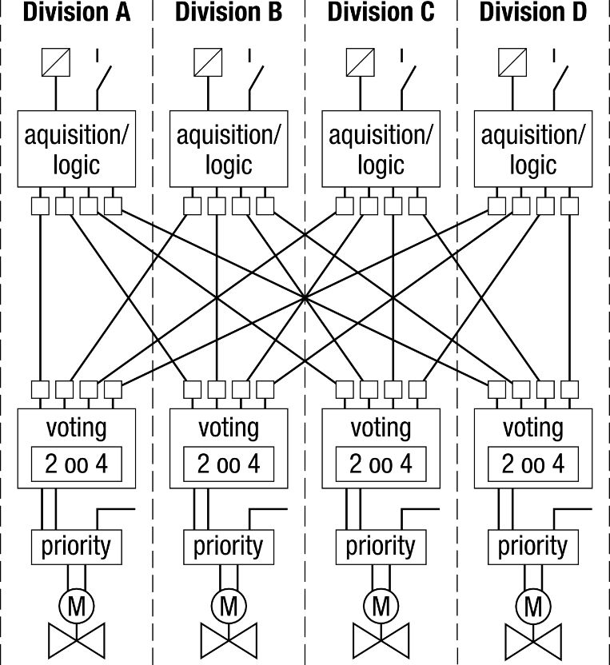
Figure 2. Schematic layout of a typical software based digital I&C RTS/ESFAS system. The system comprises 4 interconnected divisions. All divisions are identical regarding hard- and software. The suggested size of the observed population is 4.

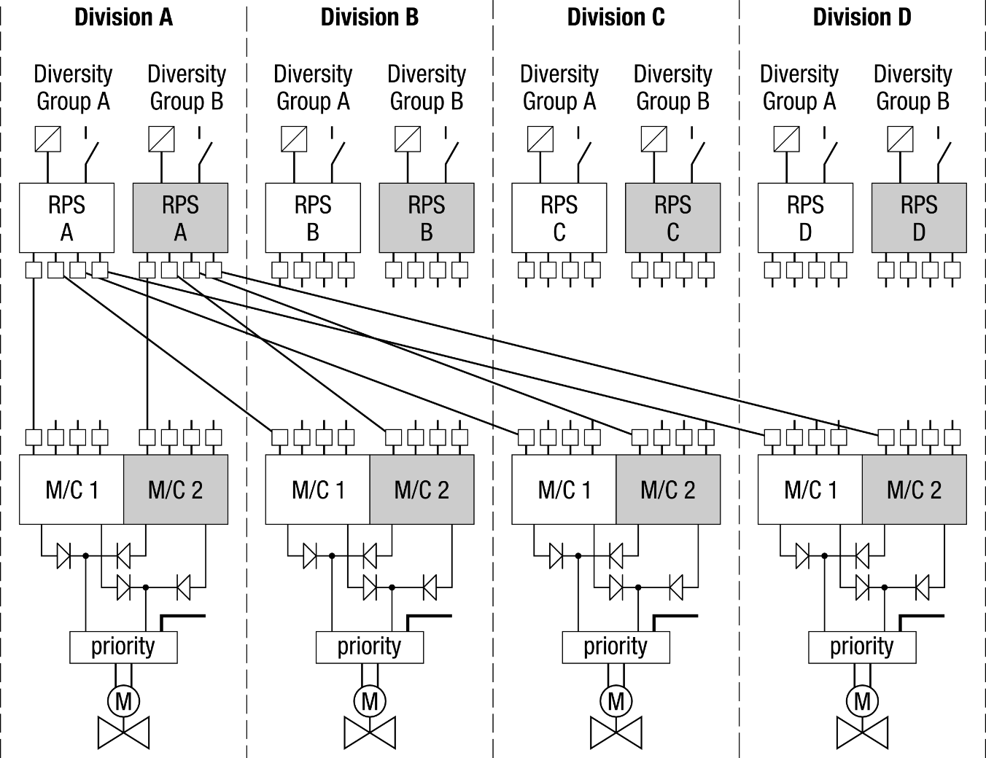
Figure 3. Schematic layout of a software based digital I&C RTS/ESFAS system incorporating so called functional diversity. Each division contains two trains composed of identical hardware and system software, but different application software. The suggested size of the observed population is 4.

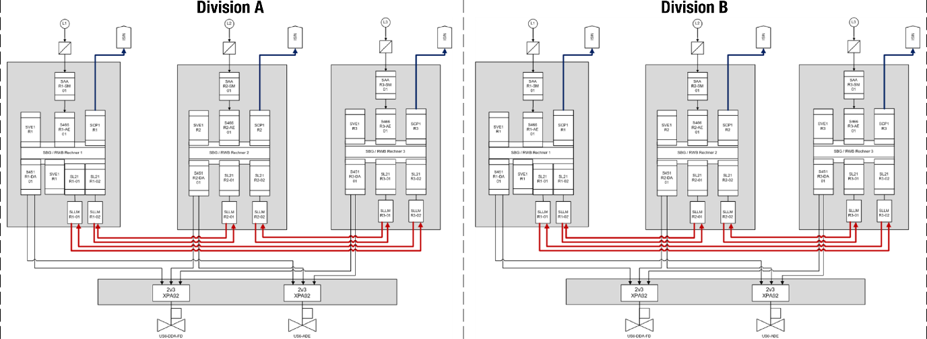

Figure 4. Schematic layout of a software based digital I&C system for beyond design basis accidents. The system comprises two independent divisions each of which is composed of three interconnected subdivisions. All subdivisions are identical regarding hard- and software. The suggested size of the observed population is 6.

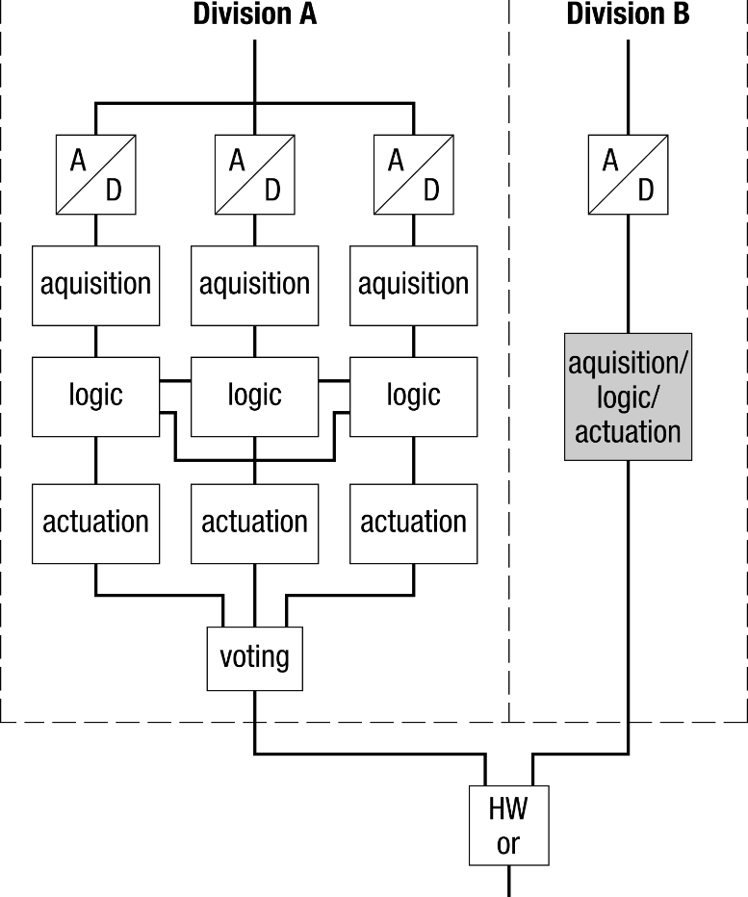
Figure 5. Principal layout of a software based digital I&C system for the implementation of I&C safety functions for lifting equipment. The system is composed of two diverse subsystems, of which one contains internal redundancy. The suggested size of the observed population is 2.
Information necessary to understand the system structure should be given in the OP description (field G1). E.g. for the example in Figure 5 this should include the information that the system is composed of two diverse subsystems, one of which is composed of three redundant subdivisions.

Time frame for ICDE event exchange
The minimum period of exchange should cover a period of at least 10 years in the first exchange round.

Functional Failure Modes
For digital I&C, a large number of complex failure modes is conceivable including specific combinations of output signals, outputs changing randomly in time etc. These specifics cannot be coded in a simple coding scheme, but are given as verbal description in field C5 (event description).
The main failures considered in the coding are not actuating on demand and actuating without a demand (spurious actuation). For outputs of I&C functions that may assume two values (“actuation”/”no actuation”) the principal failure modes are
- Failure to actuate (FA), including failure to hold,
- Spurious actuation (SA).
However, there are more complex failure modes conceiveble like failures where different channels fail with different modes (e.g. random outputs on multiple channels). These cannot be unambiguously assigned to either FA or SA. They should be coded as
- Complex failure (CF).
There are also output signals of I&C functions that assume more than two different values, e.g. for measurements displayed at the control room and for continuous-valued control signals. For these cases the failure mode
- Wrong output value (WO)
is used.
Depending on the I&C function(s) executed by the digital I&C equipment, one or more of these failure modes may be relevant.
As noted above, a more detailed description of the exact mode of failure should be given in field C5 if possible. This should include information e.g. whether a wrong displayed value (code WO) could be considered credible or is obviously wrong, whether the equipment failed in an anticipated or unanticipated mode and whether it failed in a way consistent with engineered fail safe features (e.g. switching off a unit or setting all outputs to predefined values), if present.

Coding Rules and Exceptions
- In general, the definition of the ICDE event given in section 2 of the General ICDE Coding Guidelines applies.
- In-operability due to human error will be included (in either ICDE or independent event coding).

Recommendations on OP descriptions
- The field G1 (definition) is intended to give a coarse description of the purpose and the structure of the respective digital I&C system. If available, it should give information on
  - the hardware and (if applicable) software technology,
  - diversity features, if present,
  - the safety classification(s) of the equipment resp. of the I&C functions executed by the equipment (e.g. “1E according to IEEE standard 603”, “Category A according to IEC 61226”),
  - differing degrees of redundancy between hardware, system software and application software, if present.
The rationale of the determination of the number of redundant components should also be given here, if not obvious.
- The field G8 (OP Number) can be used to distinguish records if several OPs would have otherwise identical field G0 (OP Name).
- If equipment was changed during the data collection period it is reasonable to create two sets of OPs. The definition in G1 benefits from up-front description of changes made.
- Information about scope of tests is needed to decide about whether the time factor is high or low for two failures which are separated by time. An explanation should be given in the definition field G1 about the test interval (surveillance test or more thorough test with longer time interval). The coded test interval should be the shortest interval of “external” tests. Internal regular self-tests of I&C equipment are not considered.
- Abbreviations in descriptions should be explained.
- The field S5 “Number of independent counts” is optional.

Recommendations on CCF event descriptions
- The event description should include a detailed description of those hardware and software features of the affected digital I&C component which are necessary to understand the observed failures, the failure cause(s) and the failure consequences.
- If the failure can be attributed to a specific type of module, these modules should be named. The number of identical and/or similar modules and their arrangement and use in the system should be described.
- If possible, a detailed description of the exact mode of failure should also be given in field C5. If available, this should include information
  - whether the equipment failed in a mode consistent with engineered failsafe features (if applicable),
  - whether it failed in a mode considered before or in a unanticipated way,
  - in the case of failure mode “Wrong output value(WO)”, whether the value could be considered credible or is obviously wrong.
- If a CCF event affected components that belong to 2 OPs, e.g. in twin units, then 2 event records should be made. Each event record should describe the observed impairments of the components of its corresponding OP.
- In order to be able to validate the impairment coding the event description field C5 should contain information that explains the impairment coding.
- Latent time (field C2-2) is put to 0 for monitored failures only. A failure is considered monitored if it is detected by (quasi-) continuous means, e.g. self-monitoring, or by plant behaviour through indications or alarms in the control room. Latent time can be larger than the shortest test interval (which is indicated in field G5-1 of the OP record) if a failure cannot be detected in routine testing, only in e.g. testing under more realistic conditions. If the failure can be detected only during real demands, the time from failure to its discovery shall be used. If this time cannot be determined, the time from introducing the fault that led to the failure should be used. This should be explained in the event description field C5.
- It has to be recognized that for some events the information given is all information available from the original records but description may not be clear enough to understand e.g. the detection means or the degree of impairment.
- Event cause coded in field C9 is a high level classification. The detailed causes should be described in the event description field C5.
- If not obvious, additional information should be provided to understand the number of exposed components.
- If not obvious, event description should clarify reasoning for event cause coding, corrective action coding etc.

Recommendations on Component Impairments
Impairments of components should be coded according to the following scheme:
C – Complete failure. A digital I&C component has completely failed and will not perform its function, e.g. the observed fault led or would lead to a spurious actuation or no actuation on demand.
D – Degraded. A digital I&C component is degraded if parts of the component which are relevant for its function are failed or degraded but the function of the component itself is not yet affected, e.g. if a digital I&C component is internally redundant and/or diverse and only part of this redundant equipment has failed.
I – Incipient. A digital I&C component is incipiently degraded if deviations from the specified states of the components are present which have neither affected the availability of the component nor of internal function relevant modules of the component.
W – Working. The component is working according to specification.
Note: Errors in the specification of I&C functions should be included.

Appendix A: Interface between the General and Component Coding Guideline
ICDE
Code | Source
1. Common Cause Component Group (CCCG) Identification Record
G0 CCCG identifier | GCG
G1 CCCG definition | CCG
G2 Plant(s) | GCG
G3 System type / function | CCG
G4 Component type | CCG
G4.1 Component sub type | CCG
G5 Testing | GCG
G5-1 Test interval | GCG
G5-2 Test procedure | GCG
G6 Group size | GCG
G7 Manufacturer | GCG
G8 OP Number | GCG
G10 Exposed population | GCG
2. Common Cause Component Group (CCCG) Statistical Record
S1 Component failure modes | CCG
S2 Number of CCCGs | GCG
S3 Start of CCCG observation time (date of first entry for CCCG) | GCG
S4 End of CCCG observation time (date of last entry for CCCG) | GCG
S5 Number of independent failure events | GCG
S6 Time exposure | GCG
S7 Demand cycles/Number of demands | GCG
3. CCF Event Record
G0 CCCG identifier | GCG
C1 CCF event identifier | GCG
C2 Date(s) of event(s) | GCG
C2-1 / Date(s) and time(s) of detection | GCG
C2-2 / Latent time (Time from occurrence to detection) | GCG
C3 Failure mode | CCG
C4 Number of exposed components in the CCCG | GCG
C5 Event description | GCG
C6 Detection | GCG
C7 CCF event interpretation | GCG
C8 Component impairment vector | GCG
C9 Event cause | GCG

ICDE
International Common-Cause-Failure Data Exchange ICDECG15
Title: | Coding Guidelines for Inverters
Author(s): | Gunnar Johanson, Frantisek Stvan, Benjamin Brück
Issued By:
Reviewed By: | SG
Approved By:
Abstract: | This report defines the component specific coding rules for Inverters (INV)
Doc.ref: | Coding Guidelines
Distribution: | SG
Revision control: | Version | Date |  | Initial
 |  | 2016-02-26 |  | GJ
 |  | 2017-01-24 | Clarification on system included | GJ/BB
Table of contents
Component Coding Guidelines for Inverters 222
General Description of the Component 222
Systems included in the collection 222
Component Boundaries 222
Figure 1. Component Boundaries for rotating inverters 224
Figure 2. Component Boundaries for static inverters 224
Figure 3. Component Boundaries for UPS 225
Event Boundary 225
Basic unit for ICDE event collection 225
Time frame for ICDE event exchange 225
Functional Fault Modes 226
Coding Rules and Exceptions 226
Recommendations on OP descriptions 226
Recommendations on CCF event descriptions 227
Recommendations on Component Impairments 227
Appendix A: CCF event interpretation (Field C7) 228
Appendix B: Interface between the General and Component Coding Guideline 229

Component Coding Guidelines for Inverters

General Description of the Component
An inverter is a device for converting a direct current into an alternating current. The inverters are used for the purpose of establishing battery backed altering current on safety bus bars.
The following component types are distinguished:
- Rotating inverter
- Static inverters
- UPS, uninterruptible power supply/source
Static inverters can be used as well as rotating inverters. Therefore, in the failure analysis the static and rotating inverters are to be considered. Several plants have been redesigned and the inverters are replaced with other equipment, e.g. UPS.
- Rotating inverter for uninterrupted supply of battery secured AC nets shall be included in the data set.
- Inverters with no safety function like those which are used for driving and speed regulation of the reactor main coolant pumps, shall not be included in the data set.
- If the battery belonging to the UPS-unit is comparable to other batteries in the unit battery failure should be part of the data collection for “ordinary” batteries.
Note: Rotating inverters are or have been replaced by static inverter and UPS in, many plants if not all, and it is uncertain to what extent they are currently still used in safety systems. If it becomes apparent that rotating inverter are not used anywhere any longer they may be removed from this guideline and the exchange.

Systems included in the collection
The systems for which inverter data are collected are (the corresponding IRS system coding is added in parentheses):
The following systems are to be evaluated:
Emergency Distribution System:
- AC Low voltage (up to 1000V) (3.EC)
- Vital instrumentation AC and control AC (3.ED)

3.ED should be applied when the AC power provided by the inverter is exclusively used to power I&C equipment. In all other cases, 3.EC should be used.

Component Boundaries
An inverter set consists of, in principle, a rectifier, DC equipment and an inverter. The component boundaries are illustrated in Figure 1 to 3. Rectifiers are only included within the component boundaries, when they are part of some “integral” UPS-Device, see figure 3. Batteries which serve as backup-power source for the DC-side of the inverter are not included within the component boundaries. The feeder and output breakers of the inverter are included within the component boundaries. (The schematic drawings below try to cover each possible breaker position; specific solutions may contain less breakers). Static-Bypass-Switches which allow an uninterrupted transfers form the inverter to the auxiliary power source are also included within the component boundaries.
Note: The breakers in the AC-to-AC bypass of the inverters are already included in the data exchange for “breakers” in some countries. In these cases, the breakers remain part of the breakers data exchange and are not included within the component boundary of the inverter. If this methodology is used it should be noted at the “G1 – Definition” field of the population group record.
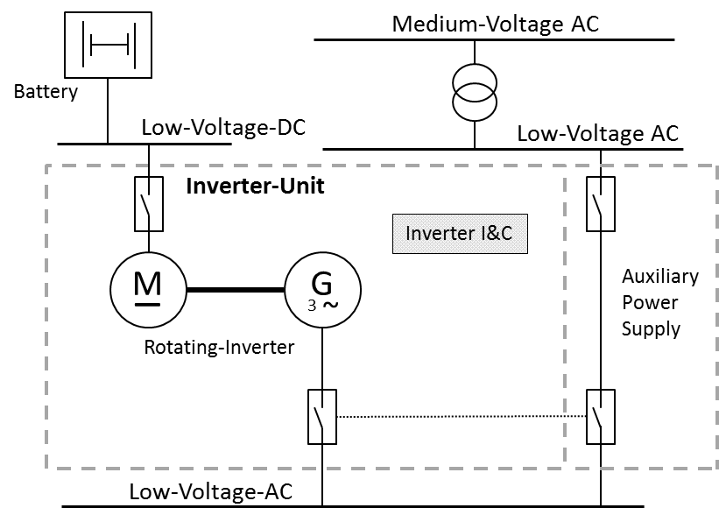

Figure 1. Component Boundaries for rotating inverters
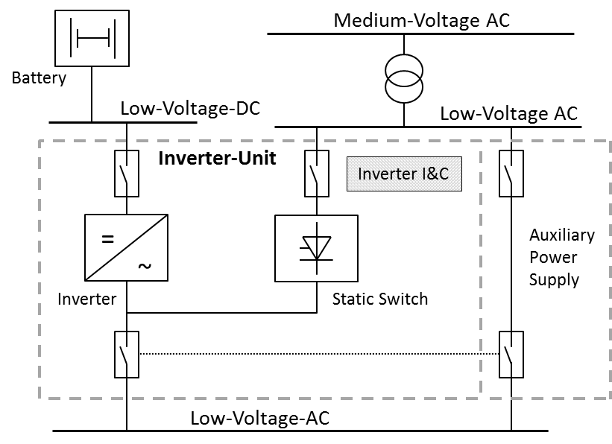

Figure 2. Component Boundaries for static inverters
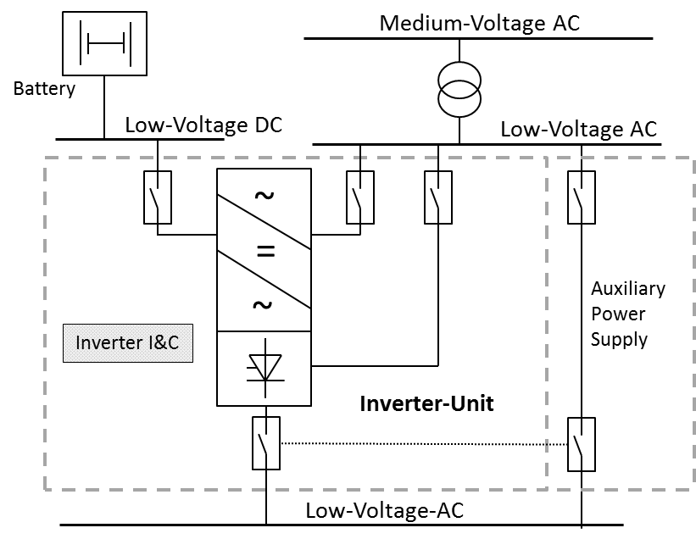

Figure 3. Component Boundaries for UPS

Event Boundary
Failure of an Inverter to perform its mission occurs if it fails to supply the objects with AC voltage without interruption, with the right voltage and frequency.

Basic unit for ICDE event collection
The basic set for Inverter data collection is the "observed population" (OP).
(If necessary the exposed population can be used (EP: set of components exposed to the same failure cause). The number of Inverter in an exposed population depends on the specific failure identified in the event analysis. In general the exposed population shall be in the same system for the components identified but could be modified depending on the linkage of CCF events by failure mechanism or causal factors. The elements of the exposed population will normally have similar test intervals. Similar in this context means a factor of not more than 2 between minimum and maximum. The determination of the exposed population is left to the event reviewer and the reviewer’s knowledge of the relation of system design, operation and testing.)

Time frame for ICDE event exchange
The period of exchange should cover events between the years 1990 to 2015.
The minimum period of exchange should cover a period of at least 10 years in the first exchange round.

Functional Fault Modes
Inverter malfunctions are defined as failures to operate on demand, the failure modes used when evaluating the data are:
The essential failure modes are (at least one)
- Failure to start (No voltage): the power provided at the start of the mission is not within specification, i.e. the rated AC power cannot be delivered at the time of the demand.
- Failure to run (Loss of performance): failure to maintain the rated AC power within specification for the duration of the mission.
For both aforementioned failure modes a failure of the “Inverter Unit” (see figures 1 to 3) is sufficient to rate an observed failure event as relevant for the data exchange. In case of a true demand it is assumed that the auxiliary AC power supply will be unavailable.

Coding Rules and Exceptions
- In general, the definition of the ICDE event given in section 2 of the General ICDE Coding Guidelines applies.
- Some reports discuss only one actual failure, and do not consider that the same cause will affect other INV, but the licensee replaces the failed component on all INVs as a precautionary measure. This type of event will be coded as incipient impairment (0.1) of the components that did not actually fail.
- In-operability due to seismic criteria violations will not be included, unless an actual failure has occurred.
- Administrative in-operability that does not cause the valve to fail to function was not included as failures. An example is a surveillance test not performed within the required time frame.
- The length of the impairment vector could be equal to the size of the exposed population; however, only the information on the impairment status of each failed component should be coded using the usual ICDE codes (C, D, and I).
- Administrative in-operability that does not cause the INV to fail to function will not be included as failures. An example is a surveillance test not performed within the required time frame.
- In-operability due to human error or erroneous calibration/set up will be included (in either ICDE or independent event coding).

Recommendations on OP descriptions
- The field G8 (OP Number) can be used to distinguish records if several OPs would have otherwise identical field G0 (OP Name)
- If equipment was changed during the data collection period it is reasonable to create two sets of OPs. The definition in G1 benefits from up-front description of changes made.
- Information about scope of tests is needed to decide about: is time factor high or low for two failures which are separated by time. An explanation should be given in the definition field G1 about the test interval (surveillance test or more thorough test with longer time interval). The coded test interval should be the shortest interval.
- Abbreviations in descriptions should be explained.

Recommendations on CCF event descriptions
- If a CCF event affected components that belong to 2 Ops, e.g. in twin units, then 2 event records should be made. Each event record should describe the observed impairments of the components of its corresponding OP.
- In order to be able to validate the impairment coding the event description field C5 should contain information that explains the impairment coding.
- Latent time (field C2-2) is put to 0 for monitored failures only. If components are not permanently monitored but are checked regularly (e.g. on walk downs), latent time is e.g. 1 day. It is possible that an event with latent time 0 has a time factor “High” (e.g. multiple failures to run during mission time). Latent time can be larger than the shortest test interval (which is indicated in field G5-1 of the OP record) if a failure cannot be detected in e.g. 3 monthly routine testing, only in e.g. 3 yearly intensive testing. This should be explained in the event description field C5.
- It has to be recognized that for some events the information given is all information available from the original records but description may not be clear enough to understand e.g. the detection means or the degree of impairment.
- Event cause coded in field C9 is a high level classification. The value list of field C9 does not represent “real” root causes. These are only described in the event description field C5.
- If not obvious, additional information is needed to understand number of exposed components.
- If available, event description should mention the safety consequences of the observed failure to the component, e.g. is the signal deflection to the high or low side
- If not obvious, event description should clarify reasoning for event cause coding, corrective action coding etc.

Recommendations on Component Impairments
Regarding event codification the following examples are given for the failure mode “Loss of supplied output”:
C – Complete failure. An inverter has completely failed and will not perform its function, e.g. the observed fault led or would lead to no supplied output on demand.
D – Degraded. An inverter is degraded if parts of the component which are relevant for its function are failed or degraded but the function of the component itself is not yet affected, e.g. if an inverter/converter is internally redundant and/or diverse and only part of this redundant equipment has failed.
I – Incipient. An inverter is incipiently degraded if deviations from the specified states of the components are present which have neither affected the availability of the component nor of internal function relevant modules of the component.
W – Working. The component is working according to specification.

Appendix A: CCF event interpretation (Field C7)
Recording of failure symptoms and mechanism in C7
The CCF event description (Text description /Compulsory/) shall describe the (subjective) rationale used by the analyst to classify the event as a CCF event. This is a proposal for description of the Failure Symptoms and Failure Mechanism
Failure Symptom (TBD based on trial exchange)
Failure Mechanism (TBD based on trial exchange)
Failure Cause categories for recording of MTO aspects in C7
‘Deficiencies in operation (O)’
O1 Deficient procedures for maintenance and/or testing
O2 Insufficient attention to aging of piece parts
O3 Operator performance error during maintenance/test activities
and the three hardware failure related options
D Deficiency in design of hardware
C/M Deficiency in construction or manufacturing of hardware
D-MOD Deficient design modifications
and ‘Deficiencies in design, construction, manufacturing (D/C/M)’.

Appendix B: Interface between the General and Component Coding Guideline
ICDE
Code | Source | Comment
1. Common Cause Component Group (CCCG) Identification Record
G0 CCCG identifier | GCG
G1 CCCG definition | CCG
G2 Plant(s) | GCG
G3 System type / function | CCG
G4 Component type | CCG
G5 Testing | GCG
G5-1 Test interval | GCG
G5-2 Test procedure | GCG
G6 Group size | GCG
G7 Manufacturer | GCG
G10 Exposed population | GCG
2. Common Cause Component Group (CCCG) Statistical Record
S1 Component failure modes | CCG
S2 Number of CCCGs | GCG
S3 Start of CCCG observation time (date of first entry for CCCG) | GCG | CCG time frame
S4 End of CCCG observation time (date of last entry for CCCG) | GCG | CCG time frame
S5 Number of independent failure events | GCG
S6 Time exposure | GCG
S7 Demand cycles/Number of demands | GCG
3. CCF Event Record
G0 CCCG identifier | GCG
C1 CCF event identifier | GCG
C2 Date(s) of event(s) | GCG
C2-1 / Date(s) and time(s) of detection | GCG
C2-2 / Latent time (Time from occurrence to detection) | GCG
C3 Failure mode | CCG
C4 Number of exposed components in the CCCG | GCG
C5 Event description | GCG
C6 Detection | GCG
C7 CCF event interpretation | GCG | CCG App A
C8 Component impairment vector | GCG | CCG App B
C9 Event cause | GCG

ICDE

International Common-Cause Failure Data Exchange ICDECG16

Title: | Coding Guidelines for Cross-Component Group CCF
Author(s): | Benjamin Brück, Mattias Håkansson
Issued By: | SG
Reviewed By: | AK, GH, MH, SG
Approved By: | -
Abstract: | This report defines the component specific coding rules for Cross-Component Group CCFs (X-CCF).
Doc.ref: | Coding Guidelines
Distribution: | SG
Revision control: | Version | Date | Initial | Action
 | 0.1 | 16.03.2017 | BB | First Draft
 | 0.5 | 10.04.2017 | BB, GJ, AK | Revised after comments from GJ and AK
 | 0.9 | 13.04.2017 | BB | First release to the SG
 | 0.91 | 04.07.2017 | BB, GJ, MH | Second release to the SG
 | 0.92 | 30.01.2023 | JS | Editorial changes

Table of contents
Component Coding Guidelines for Cross-Component Group CCFs 233
Terms and Definitions – Cross-component group CCF perspective 233
Background 234
Systems included in the collection 235
Component Boundaries 235
Event Boundary 235
Basic unit for ICDE event collection 235
Time frame for ICDE event exchange 236
Coding Rules and Exceptions 236
Affected OP-records 238
Recommendations on CCF event description 239
Appendix A: Interface between the General and Component Coding Guideline 240
Appendix B: (Fictitious) Example Event 241
Appendix C: Basic information regarding asymmetries in the electrical power supply system 243
Impact on the safety system of NPPs 244
Causes for asymmetric faults 246

Component Coding Guidelines for Cross-Component Group CCFs

Terms and Definitions – Cross-component group CCF perspective
Observed Population (OP): A group of similar or identical components that are considered to have a potential for failure due to a common cause. A specific OP contains a fixed number of components. In a NPP there are OPs consisting of components that are part of the plants safety system (e.g. the residual heat removal pumps) and OPs consisting of components that are not part of the plants safety system (e.g. the main feedwater pumps). In most cases, the OPs are identical with the common-cause component groups (CCCG).

OP-record: An OP-record is an element in the ICDE database. It comprises a set of statistical and technical information that is required to describe an OP to allow for data collection and CCF-quantification needs for all regular types of components. In the context of ICDE, OP-records are created for groups of components in safety-relevant systems only.

Common Cause Failure Event (CCF event): A dependent failure in which two or more component fault states exist simultaneously, or within a short time interval, and are a direct result of a shared cause. Regular CCF events affect one single OP; CCF events that affect multiple OPs simultaneously are called Cross-component Group CCFs (see below).

CCF event record: An ICDE CCF event record is an element in the ICDE database. The ICDE CCF event records (or ICDE events records) contains the factual event description, the event interpretation and the system influence. Each ICDE event record is attached to the specific OP-record, which contains the components affected by the CCF. Thus, CCF events recorded via a ICDE CCF event record affect only one single OP.

Exposed Population: The Exposed Population is a subset of an OP that contains all those components of the specific OP for which the observed CCF failure mechanism was relevant. The distinction between “Observed Population” and “Exposed Population” is especially important for semi-diverse OPs (e.g. a group of three pumps, two of them motor driven, one turbine driven.)

Cross-Component Group CCF event (X-CCF event): A CCF event, where a single failure mechanism simultaneously affects multiple OPs. X-CCF may affect multiple component groups of the same component type as well as different component types. These events are stored in the ICDE database via slightly modified ICDE CCF event records.

Cross-Component Group CCF event record: An ICDE Cross-Component Group event record is an element in the ICDE-database. It defines the structure for the description of a Cross-Component Group CCF event (see above). These records contain an event description and interpretation like the “normal” CCF event records. Additionally, these data elements contain the affected OP-records (see below), which describe the OPs/component groups involved in the event.

Affected OP-record: An affected OP-record is an element in the ICDE database. It is attached to a specific X-CCF event record and contains technical information about a specific OP and how it was individually affected by the X-CCF event. The difference between an “OP-record” and an “Affected OP-record” is the amount of the provided information and the different position in the database structure. Details are given in the section “Affected OP-records” and in Table 1.

Background
Data collection in the ICDE Project is basically based on Observed Populations, which are handled in the database with “Observed Population records” (or “OP-records”), and CCF events, which are handled with ICDE CCF event records. In most cases, the OP-records comprise the redundant, identical components of a system, all performing the same function. Thus, they are equal to the Common Cause Component Groups (CCCGs) explicitly modelled in many probabilistic safety analyses (PSAs), such as the parallel pumps in a multi-train safety injection system.
In the given structure of the ICDE database there is a “1:n” cardinality between OP-records and ICDE CCF event records – this means that an OP-record may have been affected by multiple CCF events (each of them with an individual ICDE CCF event record), but each CCF event affects only one individual OP-record. This basic structure of the ICDE database reflecting these assumptions is shown in Figure 1.

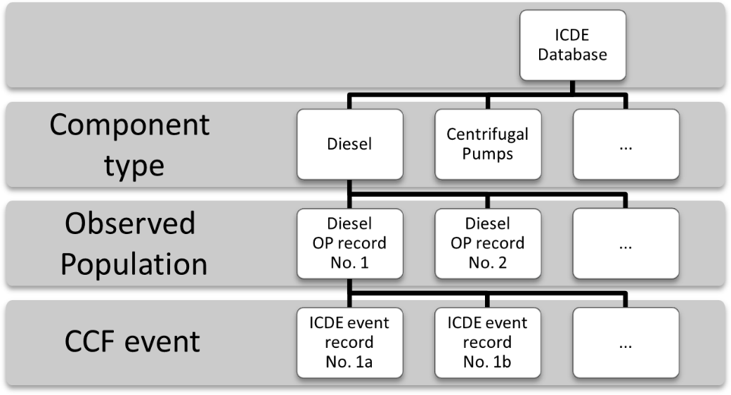
Figure 1: Established structure of the ICDE database
Thorough analysis of operational experience from NPPs suggests that there are numerous obvious or hidden dependencies between the individual OPs like common maintenance teams and procedures, piece parts that are used in multiple OPs, shared cooling water, superordinate I&C or internal and external factors that may affect multiple OPs simultaneously.
Prominent examples for such CCF events affecting multiple OPs are so called asymmetrical faults in the on-site power system of NPPs as they have been observed at Byron (USA) and Forsmark (Sweden) NPP. Events where similar piece parts of multiple diesel OPs showed simultaneous impairments are known from the German operating experience. Also events due to tsunamis (e.g. Fukushima) can be regarded as X-CCF events. Inter-dependencies as described above potentially affect all component types; some of the aforementioned mechanisms will only affect OPs of one specific component type; others may even affect OPs of different component types simultaneously.
Even though X-CCF are rare events (only a fraction of all failure events are CCF events and only a fraction of all CCF events are X-CCF events) it is worth to analyse such events in depth since they have the potential to cause severe impairments of the plants safety system.
Due to the “1:n” cardinality between OP-records and ICDE event records described above, it is not possible to integrate X-CCF events with the established data structure. Therefore, some additions to the established data structure are necessary, which are described in the following sections.

Systems included in the collection
The data collection for Cross-Component Group CCFs comprises all safety-related systems. In addition to that, also non-safety-related systems in a NPP are included in the data collection when they were affected by a failure mechanism, which simultaneously affected a safety-related system. Because of the new data structure that is used to describe the individual OPs (see section “Affected OP-records”) there is no necessity to create new OP-records.

Component Boundaries
Most of the component types that might be affected by Cross-Component Group CCFs are already included in the scope of the ICDE data collection. Therefore, for all these component types, the component boundaries described in their respective coding guide should be used. This refers analogously also to OPs that are not inside the scope of the regular ICDE data collection (e.g. for main coolant pumps the existing component boundaries for centrifugal pumps would be used). In case components are involved in the X-CCF event that are not covered by the existing component guides and the component boundaries described therein, appropriate boundaries should be described in a short form as part of the X-CCF event description.

Event Boundary
An event is regarded as Cross-Component Group CCF event and should be included in the scope of the ICDE data collection of cross-component CCFs if the two conditions listed below are met.
- A Common cause failure mechanism was observed that affected more than one group of redundant components (OPs) simultaneously and that affected more than one component in each group.
- At least one of the affected OPs is part of a safety-related system.

In Addition to this, the following remarks should be taken into account:
- Data collection via Cross-Component CCF event records should not be used to replace “normal”, OP-record specific reporting according to the ICDE coding guidelines. In case of events in which multiple component groups with existing OP-records were affected by a CCF according to the ICDE coding guidelines, reporting should be performed first on the basis of “normal” ICDE CCF event reporting for each affected OP-record individually. Afterwards a Cross-Component Group event record should be created that focuses on the “cross-component” aspects of the events.
- Consider if multi-unit impacts are present. Use the interesting event coding and/or correlated event field, as applicable.

Basic unit for ICDE event collection
Other than the structure of the data collection for “regular” CCF events the basic unit for the collection of X-CCF events is the specific event itself (and not the OP-record). Details are described in the sections “Coding Rules and Exceptions” and “Affected OP-records”.

Time frame for ICDE event exchange
The minimum period of exchange should cover a period of at least 5 years in the first exchange round.

Coding Rules and Exceptions
As described above, the basic unit of the data exchange is the X-CCF event itself, not the affected OPs. This deviation from the regular ICDE coding scheme requires some additional definitions regarding the structure of the data, which are listed below.
- In general, Cross-Component Group CCFs are handled by a new component type named “Cross-Component Group CCF”.
- Since the data collection for Cross-Component Group CCFs is based on events and not on Ops, only one (virtual) single OP-record is created to maintain the established database structure (see Figure 2). There is no need to create any new regular OP-record.
- The “General” Folder of the CCF Event item looks similar to the one used for regular CCF events. Apart from that, the fields “OP Id (G0)”, “OP Name (G0)”, “Number of exposed components (C4), “Population Size (G6)” and “Impairment Vector (C8)” are not used since they contain information that is related to an individual OP-record. The corresponding information for the multiple affected OPs stored in the “Affected OP-records (see section “Affected OP-records”).
- No event specifications according to the General Coding Guidelines (GCG) are provided, this information is stored in the affected OP-records (see below).
- To specify the individual OPs that were involved in the X-CCF event, a new data element called “Affected OP-record” is introduced. These data elements describe the OPs that were involved in the X-CCF event and how each specific OP was affected by the event. As far as possible, data and information that is already available in existing regular OP- and ICDE CCF event records is used. A detailed description of the Affected OP-records is given in the next section; an overview of the new database structure is given in figure 2. An example of a fictitious X-CCF with event description and attached affected OP-records is given in appendix B.

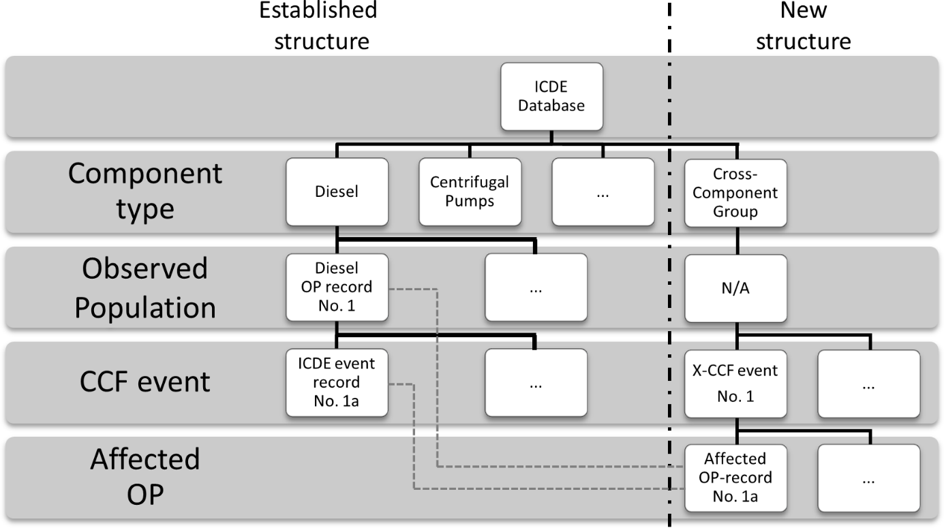
Figure 2: Extended ICDE data structure
- For the characterization of the X-CCF the field “X-CCF Failure Mode (C3)” is used, which replaces the field “Failure mode (C3)” of a regular CCF. The type describes which common effect or factor has caused the simultaneous impairment of the affected OPs. Based on the available operating experience, the types listed below have been identified:
- Piece Parts
Similar piece parts (sub-components) that were used in different OPs were affected by the same CCF failure mechanism. Examples for such X-CCFs are events where identical breakers that are used for pumps in different OPs showed failures or impairments.
- Maintenance Procedures
Erroneous maintenance procedures that are relevant for OPs caused failures or impairments in more than one of these groups.
- Internal events
This type comprises all events where the spatial separation between the redundant trains failed in a way that multiple components in more than one OP were impaired by an internal event. Examples for such events are internal fires or internal flooding.
- External events
This type is used for external effects – both natural and man-induced – that impaired multiple components in more than one OP. Examples for such events are earthquakes, external flooding (including tsunami), clogged water intakes, severe weather conditions or external explosion events.
- Power Supply (Asymmetrical Faults)
Asymmetrical Faults are described in detail in Appendix C.
- Power Supply (Other)
This type comprises all other effects that might lead to X-CCF due to the connection of the electrical redundancies during normal operation. Examples are fluctuations of the grid frequency or effects due to harmonic waves.
- The pull-down menus “Coupling Factor (C10)”, “Shared Cause Factor (C11)” and “Time Factor (C14)” should be used to describe the CCF correlations between the affected OPs, not between the individual components.

Affected OP-records
The information to describe the individual OPs that have been affected by an X-CCF event and how they have been affected is stored in “Affected OP-records.” The information is presented in a table where each line represents an affected OP. This table is split into a component/group specific section and an event specific section.

Component Specific Section:
- Component Type (e.g. Diesel, Centrifugal Pumps, MOVs, …)
Component type of the affected component in accordance with the GCG
- System (G3.1)
The system of the NPP where the affected components have been used. The IAEA nomenclature should be used in this field, regardless of whether the system is safety related or not.
- Population Size (G6)
The number of redundant components in accordance with the GCG
- Description
A short verbal description of the system and its task in the NPP. This information corresponds with the information given in den “Definition (G1)” field of regular OP-records.
- Plant (G2)
The name of the plant that was affected by the event in accordance with the GCG
- OP-Id (G0) | Observed Population Name (G0)
In case that the affected OP is already stored in the ICDE-database as regular OP-record, the OP-Id and the Observed Population Name of this OP-record is given here, otherwise this field is left blank. The field “Observed Population Name” is automatically filled once a valid OP-Id is given.

Event Specific section
- Date of Event (C2.1)
- Failure Mode (C3)
The failure mode field describes the OP specific failure mode of the affected group. It should be coded in accordance with the GCG or the CCG that is relevant for the component type of the affected group.
- Number of Exposed Components (C4)
The number of exposed components in according to the definitions given in the GCG/CCG.
- Impairment Vector (C8)
Coding of the affected components – both safety and non-safety related – according to the GCG/CCG.
- CCF event ID (C0)
In cases where the failure mode was already reported to ICDE as regular CCF(s) of an individual OP-record(s) the CCF event ID (C0) is given here, otherwise this field is left blank.
- Event Code (C1)
For events with an existing CCF event Id this field is automatically filled, otherwise any other (external) event reference can be given here.

Table 1 gives a short overview about the differences between the regular OP-records and the Affected OP-records.

Table 1: Comparison between regular "OP-records" and "Affected OP-Records"
 | Observed Population Record | Affected OP- Record
OP description level of detail | Detailed description including component sub type, details about testing (interval, procedure) and information about the manufacturer | Reduced set of information, limited to component type, plant name, system type, population size and a short verbal description
Statistical Records | Detailed statistical records with observation time, different failure modes and the number of the single failure events | No statistical record
CCF Event Information | No event specific information | Basic set of event information (date, failure mode, number of exposed components, impairment vector)

Recommendations on CCF event description
In the text fields “Description (C5)”, “Interpretation (C7)” and “Coding Justification (C13)” the relevant explanations given in the GCG should be applied. A detailed explanation of the event(s) is preferred since X-CCFs tend to be complex events comprising multiple components, systems and failures. The descriptions should be self-explanatory, even if they are linked to already existing regular CCF events in the “Affected OP-records” folder. The key question that should be answered by the text fields is:

“What failure mechanism caused the failures in more than one group of redundant components?”

Some X-CCF events like asymmetric faults or events with severe external effects may affect hundreds of components and accordingly dozens of OPs. In these cases, the number of Affected OP-records should be limited to a reasonable amount and only the most relevant and exemplary OPs should be included via an Affected OP-record, while the other impairments are mentioned in the “Description (C5)” field of the X-CCF event record.

Appendix A: Interface between the General and Component Coding Guideline
ICDE
Code | Source
1. Common Cause Component Group (CCCG) Identification Record
G0 CCCG identifier | -
G1 CCCG definition | -
G2 Plant(s) | GCG
G3 System type / function | GCG
G4 Component type | GCG
G4.1 Component sub type | -
G5 Testing | -
G5-1 Test interval | -
G5-2 Test procedure | -
G6 Group size | GCG
G7 Manufacturer | -
G8 OP Number | -
G10 Exposed population | GCG
2. Common Cause Component Group (CCCG) Statistical Record
S1 Component failure modes | -
S2 Number of CCCGs | -
S3 Start of CCCG observation time (date of first entry for CCCG) | -
S4 End of CCCG observation time (date of last entry for CCCG) | -
S5 Number of independent failure events | -
S6 Time exposure | -
S7 Demand cycles/Number of demands | -
3. CCF Event Record
G0 CCCG identifier | GCG
C1 CCF event identifier | GCG
C2 Date(s) of event(s) | GCG
C2-1 / Date(s) and time(s) of detection | -
C2-2 / Latent time (Time from occurrence to detection) | -
C3 Failure mode | CCG
C4 Number of exposed components in the CCCG | CCG
C5 Event description | CCG
C6 Detection | CCG
C7 CCF event interpretation | CCG
C8 Component impairment vector | GCG
C9 Root cause | CCG
C10 Coupling Factor | CCG
C11 Shared Cause Factor | CCG
C12 Corrective Actions | CCG
C14 Time Factor | CCG

Appendix B: (Fictitious) Example Event
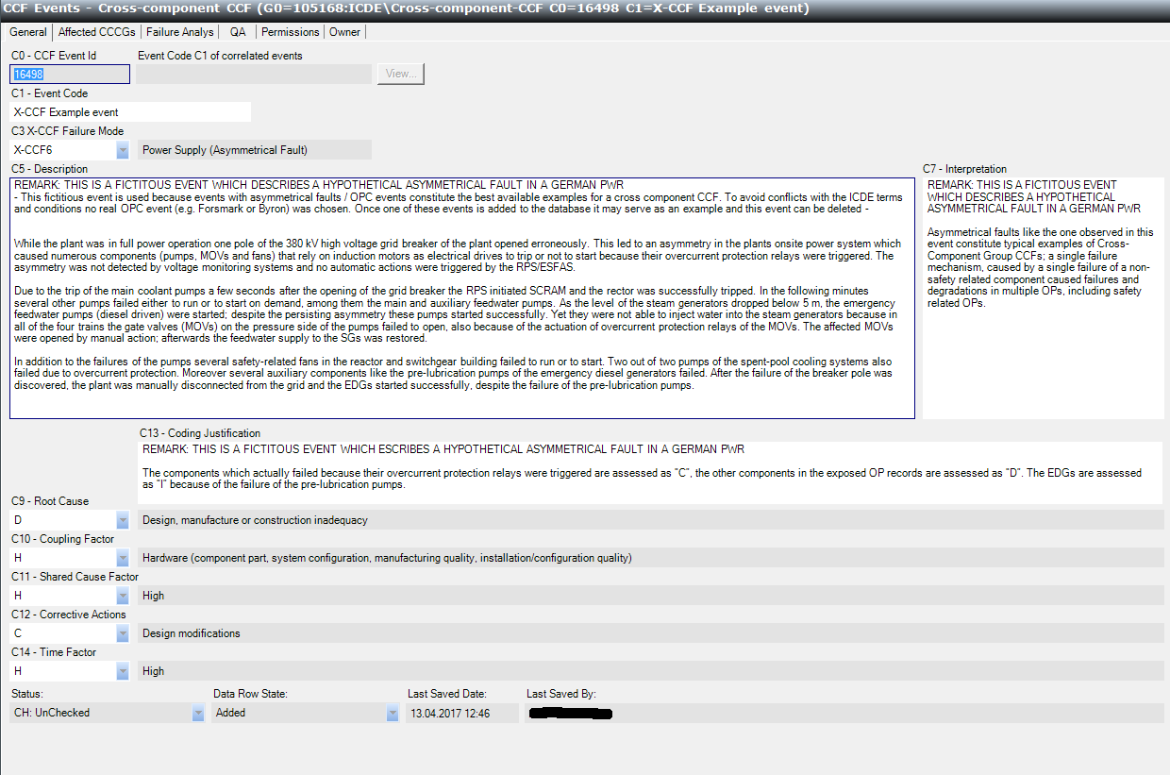
Figure 3: "General" Folder
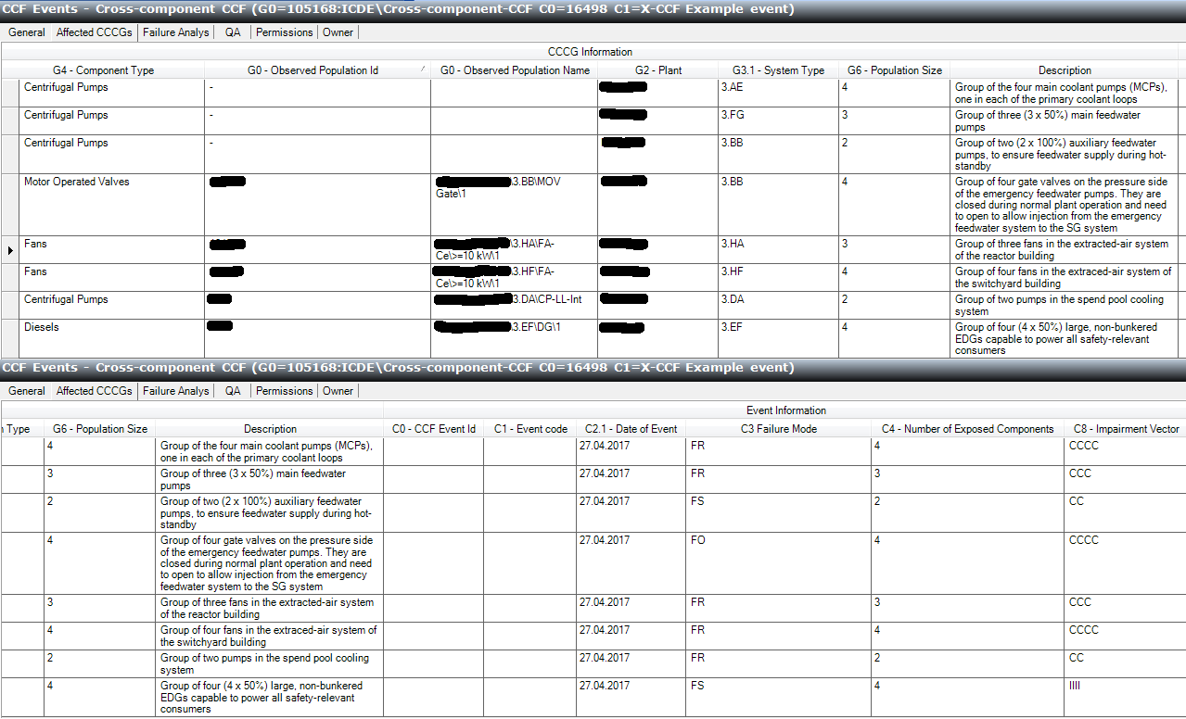
Figure 4: Affected OP-records

Appendix C: Basic information regarding asymmetries in the electrical power supply system
In general, electrical power distribution systems are designed as 3-phase alternating current (AC) systems. Such a 3-phase system consist of three live conductors, with a phase-voltage offset of 120° against each other and equal voltages under normal operation conditions. In this case the system is called “symmetric”. When an asymmetric fault occurs, at least one of these conditions is not fulfilled, so the phase voltages differ from each other and/or the offset between the phases is ≠ 120°.
Figure 5 shows an example of a symmetric 3-phase system with 10.5 kV RMS. The dashed lines show the line-to-neutral-voltages while the solid lines show the three line-to-line voltages. In Figure 6 an asymmetric system is shown where one line-to-ground voltage drops down to 60% of its default value. While only one line-to-ground voltage ist affected, two line-to-line voltages show divergent values. Additionally, the offset between the three phases differs significantly from 120°. The operating expierence has shown that asymmetric conditions in the plant’s onsite power system as presented in Figure 6 may have a significant impact on the plant’s safety system but will not trigger any automatic RPS/ESFAS-action and may therefore lead to unanalysed or even beyond-design conditions.

Figure 5: Symmetric 3-phase AC-system with 10,5 kV RMS (Source: GRS)

Figure 6: Asymmetric 3-phase AC-system with an initial voltage of 10,5 kV RMS and L1 at 60% of its initial value (Source: GRS)
While small electrical consumers like lighting, small motors or computers are supplied by only one of the three phases, larger induction motors like those that are used for pumps in NPPs are connected to all three phases and can only be operated with a symmetric voltage that corresponds to the specifications.
If such induction motors are supplied with an asymmetric voltage, their torque will drop while their current consumption will rise simultaneously. This increased current may trigger overcurrent-protection devices (protection relays) and thereby render the affected motors temporally unavailable or even destroy the motors by overheating if no overcurrent-protection devices are installed.

Impact on the safety system of NPPs
During normal plant operation the redundant trains of the electricity supply for the safety system are supplied by the plants on-site power supply. With regard to the electrical power supply there is no separation between the redundant trains of the safety system in this situation, since all trains are connected to the plants on-site power supply.

In Figure 7 an example of an electrical power system in a NPP is shown. Positions where an asymmetric fault may affect multiple trains of the plants safety system are marked with
a symbol.
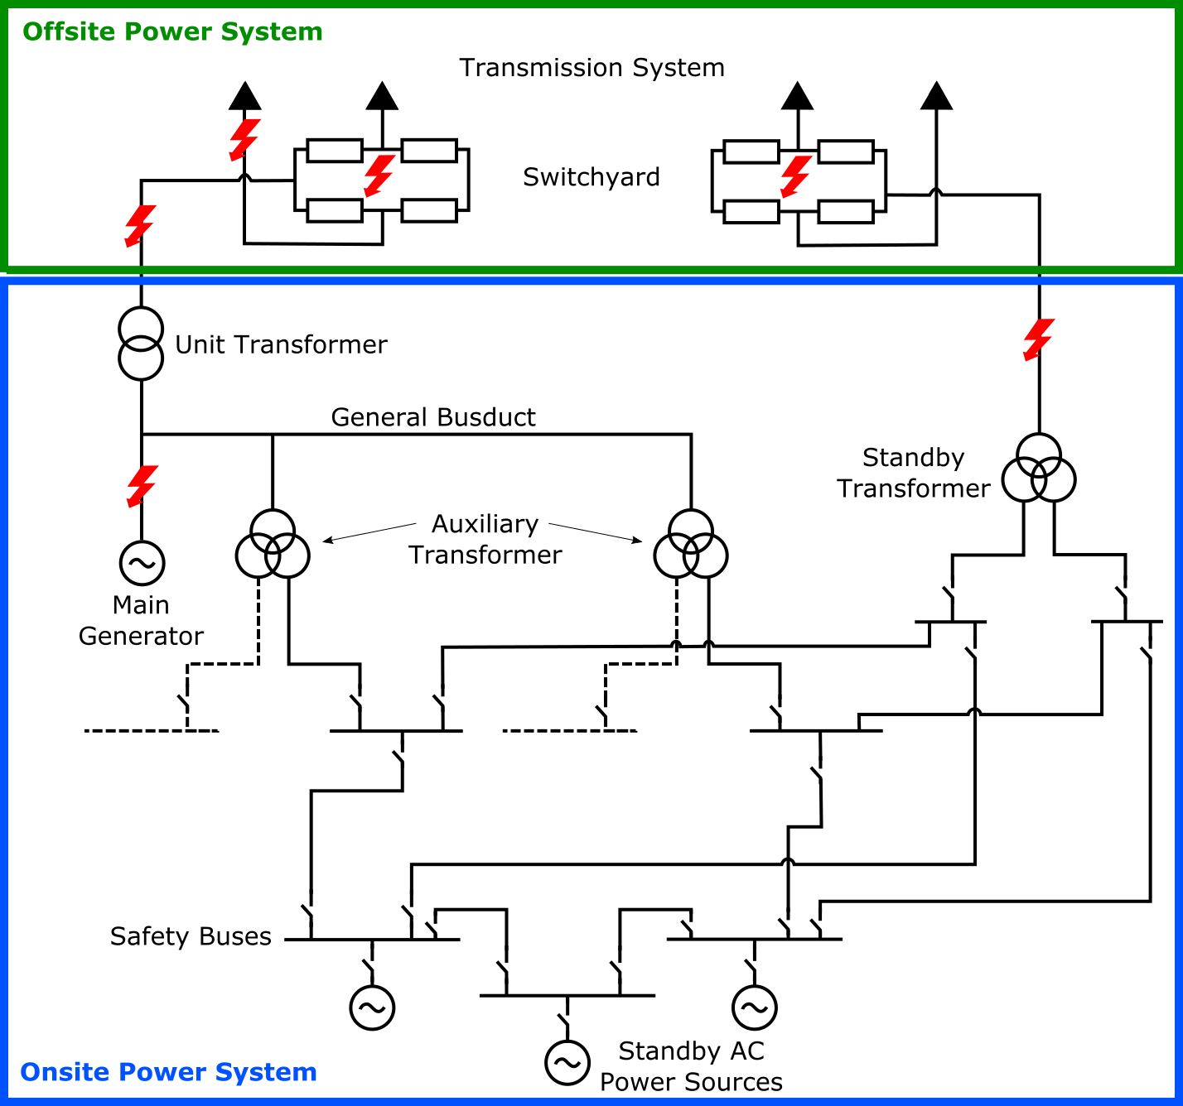
Figure 7: Example of a NPP electrical power system with fault-positions that may cause multiple component group CCFs (Source GRS and IAEA SSG-34)
When the fault position is located within the “upper part” (see Figure 7) of the electrical power system, all connected trains of the safety system are affected simultaneously by the asymmetric voltage. In this case, lots of safety relevant components (especially those with larger inductions motors like pumps and fans) suffer from the asymmetric voltage and may fail due to the activation of overcurrent-protection devices or overheating. Therefore, asymmetric faults are a possible reason for multiple component group CCFs.
While evaluating possible impacts of asymmetric faults on the safety system of NPPs it must be considered that overcurrent protection devices will protect “their” motor from being destroyed due to overheating, but the actuation of the protection device will also cause a temporally unavailability – even for RPS-demands – of the affected component by interrupting the components connection to its power supply.
In general, this protective action has to be reset manually by the plant staff in the switchgear building, which will take some time even after the situation has been identified correctly.

Causes for asymmetric faults
Asymmetric faults that may result in multiple component group CCFs are caused by interruptions of one or two phases within the high-voltage section (> 20-kV) of the plant’s power system. Two conditions must be fulfilled so that the asymmetric fault in the grid connection of a NPP may cause an X-CCF event:

- The affected line is either completely interrupted (“open-phase-condition”) or grounded with very high impedance so that the current in the affected line(s) is about zero. Ordinary low-impedance line-to-line or line-to ground faults will cause high fault currents, which will trigger the according protection devices of the high voltage bus bars within a very short amount of time and will thereby prohibit that the individual components are affected at all.
- There must be a transformer between the fault position and the safety-relevant components. Without a transformer, the voltage in the interrupted lines behind the fault position would drop significantly below RPS-thresholds, so the RPS/ESFAS would separate the safety busses from the rest of the on-site power system and supply them with the emergency diesel generators. Due to the magnetic coupling within the transformer the degraded voltage in the affected phase may remain above RPS thresholds so no automatic protection actions are triggered.

As shown in Figure 8 and Figure 9, the three phases of a high-voltage power connection consist of many passive and also active components that are directly connected to one single phase. Therefore, failures of these components will most likely only affect only one single phase. Examples of components that may cause line interruptions or high-impedance ground faults in case of a component failure are shown in the pictures below.
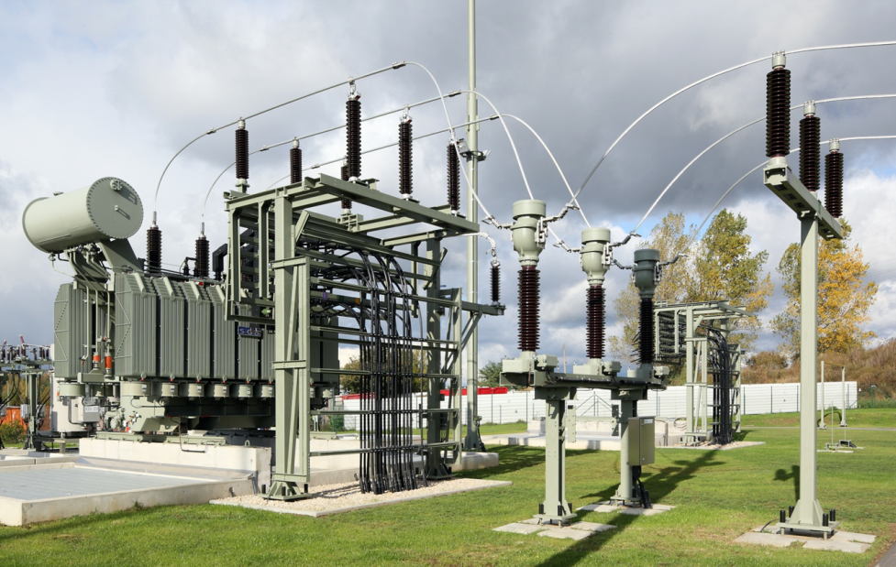
2
1
Figure 8: Isolators (1), Current Measurement Devices (2) and Feedthroughs (3) (Source: Wikipedia)
3
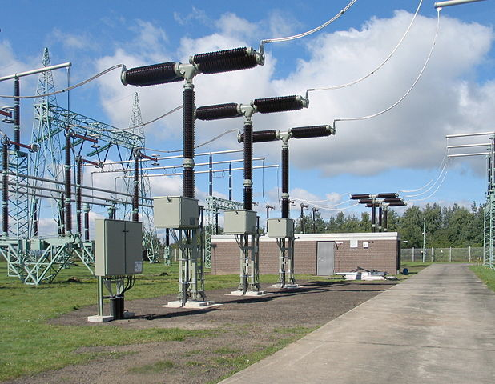
4
Figure 9: Breakers (4) (Source: Wikipedia)

- Isolators
- Current measurement devices
- Feedthroughs
- Breakers
Isolators, current measurement devices and feedthroughs can be regarded as passive devices with a pure mechanical support function for the line. In case of a failure of these components, most likely an interruption a of a single line will be the effect.

As shown in Figure 9, the component “breaker” of the 3-phase high-voltage connection – which is represented by a single symbol in the wiring diagram – consists of three independent devices that may fail individually due to mechanical or electrical problems or erroneous commands from the I&C. Depending on the position of the breaker at the moment of the failure, different types of asymmetric faults may occur; when the breaker should close and the device in one phase remains open a single line interruption will be the result, while in cases when the breakers should open and a single device remains closed a double-line interruption is the result.

* if occurrence time cannot be estimated.
Minor differences in the definitions can be observed across the component reports
See definitions of severity categories in section A1.6.
From the Work Note of action item 35-11.
See IAEA-TECDOC-1756 for more details
The original scope of the data collection focused on “those emergency core cooling system (ECCS) valves that are motor operated and are used for the purpose of establishing or isolating flow to or from the primary system”. In the context of the completeness statement this definition is still applicable, so as long as data for these aforementioned valves is provided, the completeness of the data collection is given,
For French plants, 48 V batteries, installed this following an incident at Bugey NNP. This system is part of the 48 V batteries for all NNP in France.
Motor Control Centre: a floor mounted assembly of one or more enclosed vertical sections having a common horizontal power bus and principally containing combination motor starter units. These units are mounted one above the other in vertical sections. The sections may incorporate vertical buses connected to the common power bus, thus extending the common power supply to the individual units. Units may also connect directly to the common power bus by suitable connections.
Reactor Trip Breakers correspond to some PWR plants (Westinghouse, Babcock&Wilcox, Combustion Engineering and similar design).
SF₆: Sulphur Hexafluoride, a gaseous dielectric for high and medium voltage power application, used as an insulator and/or interrupting medium. The highly stable SF₆ molecule consists of one central atom of sulphur (S) surrounded by 6 atoms of Fluorine (F).
CVCS is both a safety and operational system in Swedish Westinghouse PWR plants, and CS system is part of the PWR PSAs
In some plants limitation systems provide an intermediate I&C system between RTS/ESFAS and the operational I&C.
RMS = Root Mean Square of the sinusoidal voltage
The exact value of the voltage in the affected phase is influenced by many factors like configuration of the transformer, loading of the transformer, connected consumers etc.

